FEA STUDIO
User Manual
Finite element analysis for design engineers – strength, fatigue, bolts and welds, 3D printing, heat transfer

VERSION 1.4
CalculiX · Gmsh · NGSolve
Edition November 11, 2026

Contents
Chapters are links (Ctrl+click). The full table of contents with page numbers and sections is created when fields are updated (F9); headings are also in the Navigation Pane (View → Navigation Pane).
01 Overview and workflow
02 Examples and tour
03 Testing (problems with known results)
04 Controls and keys
05 Model
06 Export from CAD (SolidWorks, Inventor, Fusion…)
07 Materials
08 3D printing
09 Joints (bolts, welds)
10 Motion (mechanisms)
11 Heat
12 Loads
13 Dynamics
14 Mesh
15 Solve
16 2D section analysis
17 Shell model
18 Results
19 Print detail (voxels)
20 Fatigue
21 Word report
22 Automation (CLI, MCP, REST, CAD)

FEA Studio – Help
Strength analysis of parts and assemblies: linear statics, contacts and nonlinear analysis, natural frequencies, buckling, dynamics (vibration, random vibration, shock), topology optimization (BESO), load combinations (EN 1990), mechanisms, bolted and welded joints, 3D-printed parts, beam structures (Timoshenko), heat conduction and thermal stress, fatigue (S-N and ε-N). Solver CalculiX, mesher Gmsh, Exudyn for mechanisms. A few functions are available only through the MCP server or the Python API, not in this window – see below.

Getting started
1. Examples with a guided tour (fastest): Example 1 – printed bracket, Example 2 – steel + print assembly, Example 3 – flange joint (VDI 2230), Example 4 – welded boom, Example 5 – electronics heat sink. The tour opens the example and explains each step – Examples and tour.
2. Testing: seven problems with known results – Testing the program.
3. Your own model: Ctrl+O, a STEP file from CAD (Fusion, Onshape, SolidWorks…), then the phase tabs left to right. Optional analyses (3D printing, Contacts, Beams, Motion, Heat, Dynamics, Fatigue) are added with + after the step tabs (or View → Optional workflow steps).
Tip: F1 = help for the element under the cursor or the current step; Shift+F1 = interactive “What's this?” mode. Language (🇨🇿 Čeština / 🇬🇧 English) and appearance: View menu.

Workflow (phases and steps)
Five phases group the steps: Model (Model, Materials, 3D printing), Assembly (Joints, Contacts, Beams), Conditions (Supports, Motion, Heat, Loads, Dynamics), Calculation (Mesh, Solve), Results (Results, Fatigue). Steps of a phase are tabs above the right-hand panel. A new study shows eight core steps; others activate by study content or with +. Panels have collapsible sections. Step dot: green = done, orange = warning or in progress, red = required input missing, gray = not used. The study tree (top right) shows the same; click an item to open its step.
Step | What you specify
1. Model | loading STEP, geometry check, parts
2. Materials | library material per part (metals, plastics, printing), grade converter
3. 3D printing | printed parts: build direction, perimeters, infill, failure criterion, calibration, creep
4. Joints | bolts (VDI 2230, EN 1993-1-8) and welds (EN 1993-1-8/-1-9, IIW)
5. Contacts | frictionless, frictional (μ from the friction library), interference, compression only, perfect heat conduction across closed pairs; nonlinear steps (optional)
6. Beams | nodes, members (Timoshenko), EN cross-sections, supports, EN 1993-1-1 check (optional; also without CAD)
7. Supports | fixed, displacement, symmetry, cylindrical, remote, elastic (compression-only support is in Contacts)
8. Motion | bodies, joints (also from geometry), drivers, animation, joint reactions, transfer to FEA (optional)
9. Heat | steady-state / transient heat conduction, radiation to the surroundings (optional)
10. Loads | load cases: force, pressure, gravity, remote force, bearing load, temperature, rotation, inertia from a mechanism, member loads, EN 1990 combinations
11. Dynamics | damping, harmonic and transient response, random vibration (ASD), shock, added mass (optional)
12. Mesh | element size, local refinement, mesh quality
13. Solve | readiness check, solver, natural frequencies, buckling, 2D section, shells, analysis, stopping while keeping results
14. Results | stress, displacements, safety factor, stress linearization (ASME VIII-2 Annex 5-A), sections, probes, maxima, reactions, members, modes, contact pressure and status, dynamic response, BESO topology optimization, STL export
15. Fatigue | load history, rainflow, S-N, Miner, life (also from a step sequence with contact)

See also: Word report (Ctrl+P), Controls and keys, Automation (command line, MCP, REST, CAD adapters).

What the program computes and what it does not
- Linear: elasticity (small deformations, isotropic and orthotropic / printed), superposition of load cases, fatigue, heat conduction and thermal stress, bolts as preloaded beams, welds as solids, beams (Timoshenko), 2D section, shells, natural frequencies, linear buckling, EN 1990 combinations (STR/GEO, EQU, SLS).
- Nonlinear and advanced (no superposition; always CalculiX): contact (separation, friction, interference, compression only; perfect heat conduction across closed pairs), bolted-joint interfaces as contact (opening, slip), large deformations, topology optimization (BESO with sensitivity filtering and penalization), step sequence with prescribed motion (force–travel curve).
- Dynamics: harmonic and transient response, random vibration, shock, sine sweep and spectral fatigue by modal superposition (linear model, no contact), added mass.
- Mechanisms: rigid-body kinematics and dynamics (Exudyn) – joint reactions, drivers, friction, animation, transfer of an instant or the whole history to FEA; optionally flexible bodies (Craig–Bampton) and body contact (Chrono module).
- Calculators without FEA (Tools menu): beams, friction, Hertzian contact, press fit, snap-fit, mechanisms, damping from measurement, drop – see Controls.
- Only via the MCP server / Python API (not in this window): material plasticity (bilinear and multilinear hardening – material property plastic, e.g. custom_props of fea_materials_assign) and its assessment (EN 1993-1-5 Annex C plastic strain, ASME VIII-2 local failure – fea_plasticity_assess); submodeling (fea_core.submodel, Python API only); thermal contact conductance (ContactPair.conductance) and radiation between faces in a cavity (CavityRadiation) – Python API / study file only; measured ε-N parameters (FatigueSettings.en_params); implicit dynamics of a step sequence with contact (LoadStep.dynamic, Python API / study file only). See Automation.
- Not included: modal (superposition) dynamics with contact, velocity-dependent friction in FEA contact (Coulomb only), gyroscopic effects and spin softening in the Campbell diagram.
Note: stress above yield in a linear analysis is not real – it only means yielding starts (real plastic deformation needs a plastic material – MCP / Python API). Peaks in sharp inner corners, at edges of fixed supports and under point forces are singularities (they grow with refinement; the maxima table marks them). Contact stiffness K and friction μ are estimates, damping has sensitivity ±50 %: check results by sensitivity.

Units
mm, N, MPa, t (tonne), s; steel density 7.85·10⁻⁹ t/mm³, g = 9810 mm/s². Heat: °C, W, W/m², W/(m·K), J/(kg·K). Moment N·mm, frequency Hz.

Files
- .fea: project (zip: STEP model + input study.json + results); Ctrl+S saves.
- .step / .stp: CAD geometry (assembly with part names, colours, layers, attributes).
- User material library, friction library, print presets: %APPDATA%\FEAStudio.

Examples and guide
Ten ready-made projects showing the program's capabilities. The guide opens them and explains step by step what is set and why.

Starting the guide
- Example 1 – printed bracket: a single PLA part; 3D printing and creep (14 steps).
- Example 2 – steel + print assembly: bolts, welds, heat, all kinds of supports and loads (12 steps).
- Example 3 – flange joint: pipe with cover, 4× M10 bolts, internal pressure 2.5 MPa, VDI 2230 (7 steps).
- Example 4 – welded boom: S355, 5 a4 fillet welds, 5000 N, weld fatigue per EN 1993-1-8 and IIW (7 steps).
- Example 5 – electronics heat sink: finned aluminium + stainless module, 40 W, convection, steady and transient heat, thermal stress (6 steps).
- Example 6 – hall frame of beams: beams without CAD, EN sections, snow and wind, natural frequencies, EN 1993-1-1 (5 steps).
- Example 7 – dynamics of a PCB fixture: point and surface mass, natural frequencies, harmonic 1 g, random vibration (ASD), probes (9 steps).
- Example 8 – crank mechanism: bodies from CAD, joints from geometry, drive, animation, reactions, transfer of the maximum instant to FEA (8 steps).
- Example 9 – bolted column base (contact): frictional contact at the bolted interface, preload, joint opening, nonlinear sequence (8 steps).
- Example 10 – bracket, topology optimization: lightening with BESO, final shape and density in 3D, STL export (7 steps).
The guide is the panel on the right: Show in app switches the program to the state the step describes, Next / Back page through the steps, Help for the step opens the detailed page. You can work freely between steps.
Tip: the guide opens a copy in %LOCALAPPDATA%\FEAStudio\ukazky; Ctrl+S does not overwrite the original.
Without the guide: Ctrl+O → examples in the installation → example1_bracket.fea to example10_bracket_topology.fea.

Example 1 – printed bracket
PLA bracket (Bambu Basic), build direction Z: a vertical plate 60×40×6 mm with two Ø5 screw holes, a horizontal arm 64×24×8 mm, and at its end a boss with an Ø8 eye (load pin) and a triangular rib.

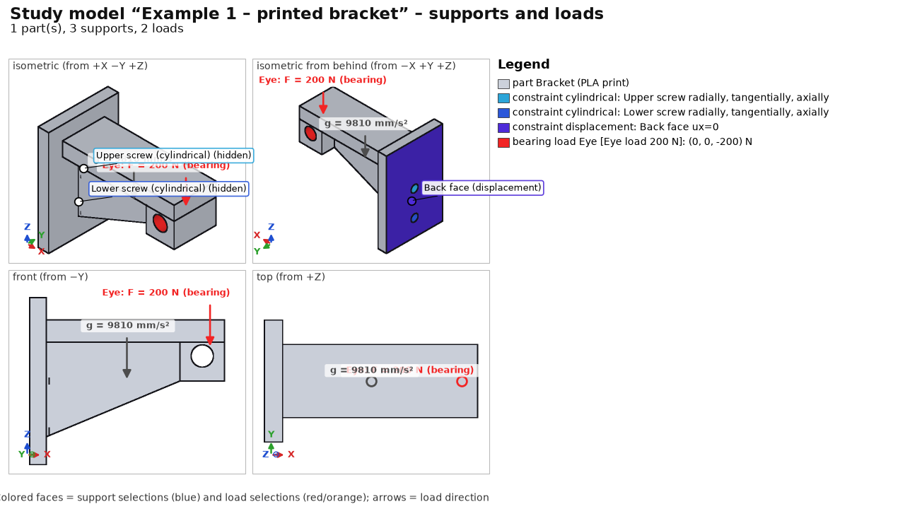
Step | Specification
Materials | Print PLA Bambu Basic (E 2680 / E_z 2160 MPa, Rm 39 / Rm_z 35 MPa)
3D printing | build Z, layer 0.2 mm, line 0.42 mm, 3 perimeters, 5/3 solid layers, gyroid 20 %; Tsai-Wu; creep 1000 h at 30 °C for the Eye load case
Supports | cylindrical support of each screw hole (Upper screw, Lower screw), back face ux = 0
Loads | Eye load 200 N (bearing load, downward); Self-weight
Mesh | 2.5 mm, tet10
Fatigue | sine 0–1 × Eye load (pulsating 0–200 N), 100 000 repetitions

Example 2 – steel + print assembly
Steel base plate 180×70×10 mm (S235) with 4 anchor holes Ø9, column 10×70×90 mm welded by two a4 fillet welds, and a printed PLA arm bolted to the plate with 2× ISO 4017 M6 x 30 - 8.8, ISO 7089 washers and ISO 4032 nuts.

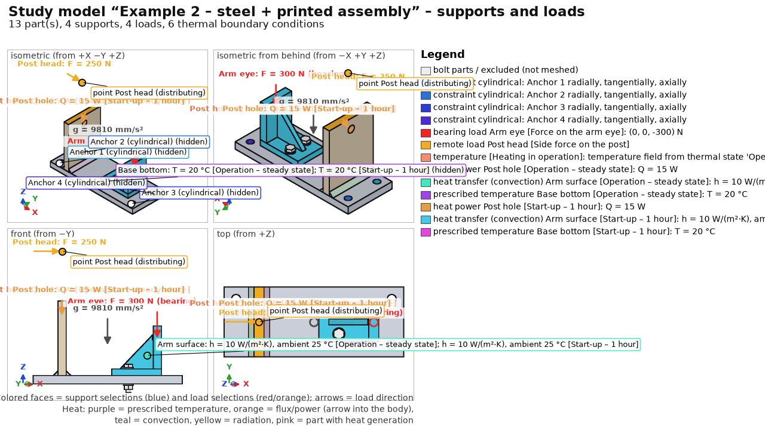
Step | Specification
Materials | Steel S235 (default), arm Print PLA Bambu Basic
3D printing | arm: 3 perimeters, gyroid 25 %, creep 2000 h / 30 °C for Force on the arm eye
Joints | 2 M6 8.8 bolts, automatic preload (Bolt preload case); 2 a4 fillet welds (EN 1993-1-8, fatigue of root and toe)
Supports | cylindrical support of the 4 anchor holes
Heat | 15 W into the column hole; arm convection 10 W/(m²·K) to 25 °C; base plate bottom 20 °C; steady state and 1 h transient ramp-up
Loads | Force on the arm eye 300 N (bearing); lateral force 250 N on the column at remote point [35; 35; 150]; Self-weight; Heating in operation (thermal stress from the steady state)
Mesh | 4 mm; local refinement of the arm eye 1.5 mm
Fatigue | two sine channels shifted by 90° (non-proportional), 200 000 repetitions

Example 3 – flange joint
Pressure pipe Ø50/36 with a welded flange Ø120 and a solid cover, connected by 4× ISO 4017 M10 × 45 8.8 bolts with washers and nuts. It verifies the preload computation and the VDI 2230 assessment.

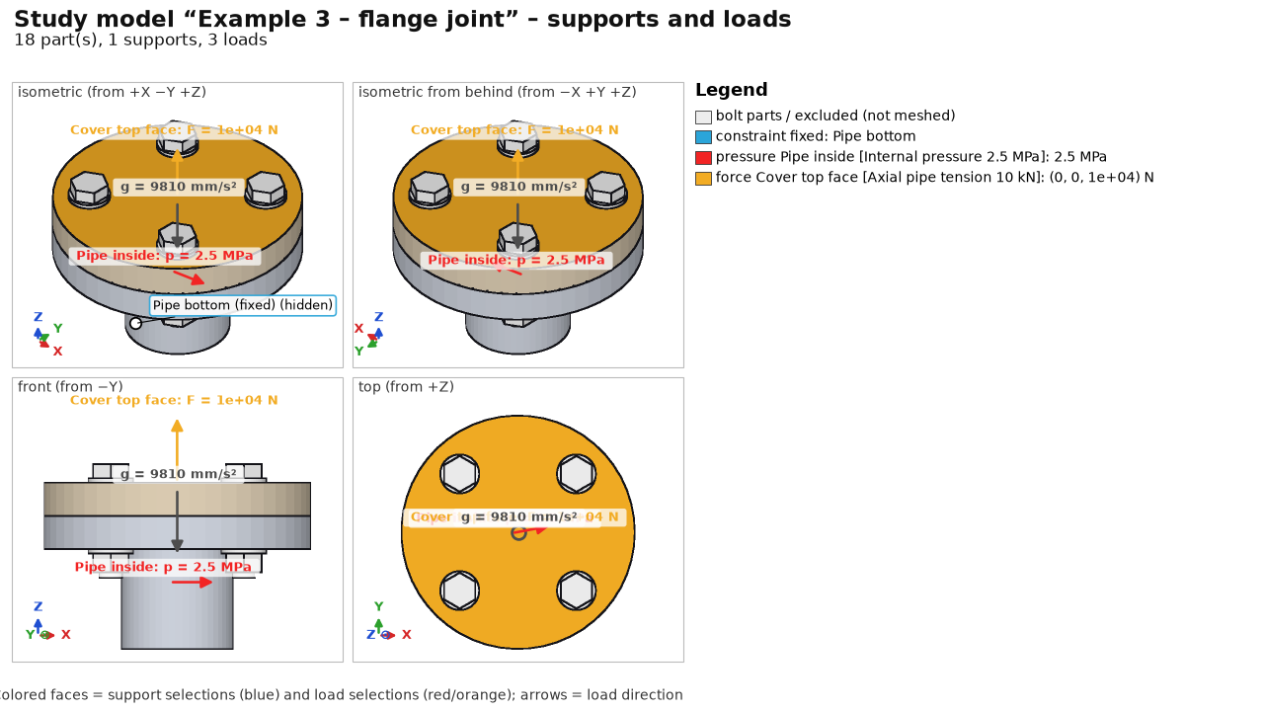
Step | Specification
Materials | Steel S355 (default for flange and cover)
Joints | 4 M10 8.8 bolts, automatic preload (tightening factor alpha_A = 1.6, friction μ = 0.12)
Supports | fixed support on the bottom end face of the pipe
Loads | internal pressure 2.5 MPa on the inner cylinder; axial tension 10 kN on the top end face of the cover; Self-weight; Bolt preload
Mesh | 5.0 mm, tet10
Assessment | VDI 2230: assembly preload, tightening torque, safety against yielding and joint opening

Example 4 – welded boom
Welded cantilever boom: anchor plate with 4 holes Ø13, horizontal arm 50×60 × 220 mm with an eye for the 5000 N load pin, triangular rib 12 mm thick and 5 a4 fillet welds.

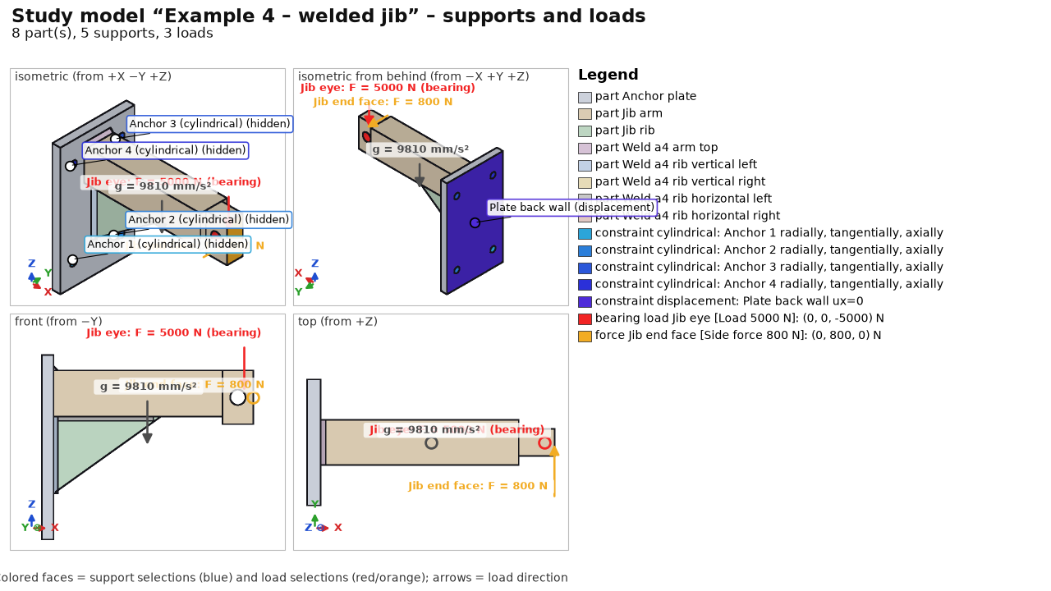
Step | Specification
Materials | Steel S355 (default)
Joints | 5 a4 fillet welds (arm to plate at the top, rib welds to the plate and arm)
Supports | cylindrical support of the 4 anchor holes; back wall of the anchor plate ux = 0 (resting against a wall)
Loads | load 5000 N in the eye (bearing load); lateral force 800 N on the arm end face; Self-weight
Mesh | 6.0 mm, tet10
Fatigue | cyclic lift 0–5 kN (200 000 cycles) shifted against the lateral force; IIW and EN 1993-1-8

Example 5 – electronics heat sink
Aluminium finned heat sink 90×80×30 mm with 6 fins and a stainless power module 30×30×4 mm dissipating 40 W.

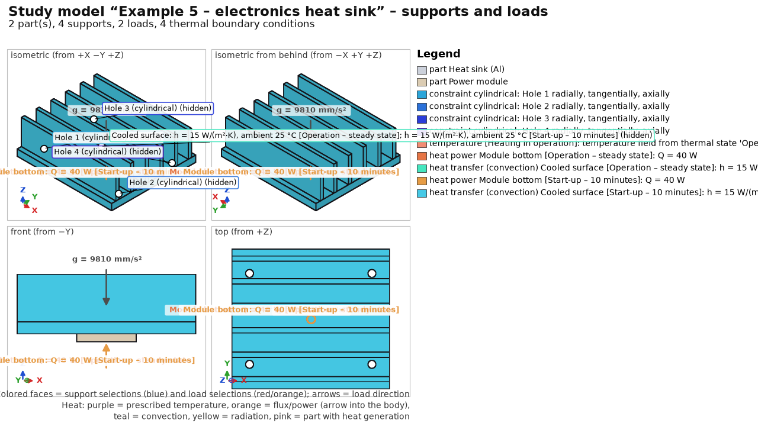
Step | Specification
Materials | Aluminium EN AW-6082 T6 (heat sink, k = 170 W/(m·K)); stainless steel 1.4301 (module, k = 15 W/(m·K))
Supports | cylindrical support of the 4 mounting holes Ø4.5 mm
Heat | 40 W into the module; natural convection h = 15 W/(m²·K) on the fins to 25 °C; steady state and 10 min transient ramp-up
Mechanics | Heating in operation (temperature field from the steady state → bimetallic bending and stress); Self-weight
Mesh | 4.0 mm, tet10

Example 6 – hall frame of beams
Steel hall made of beams only (study without STEP geometry): two frames, purlins and bracing. Results are not stored in the example; they are computed in seconds.

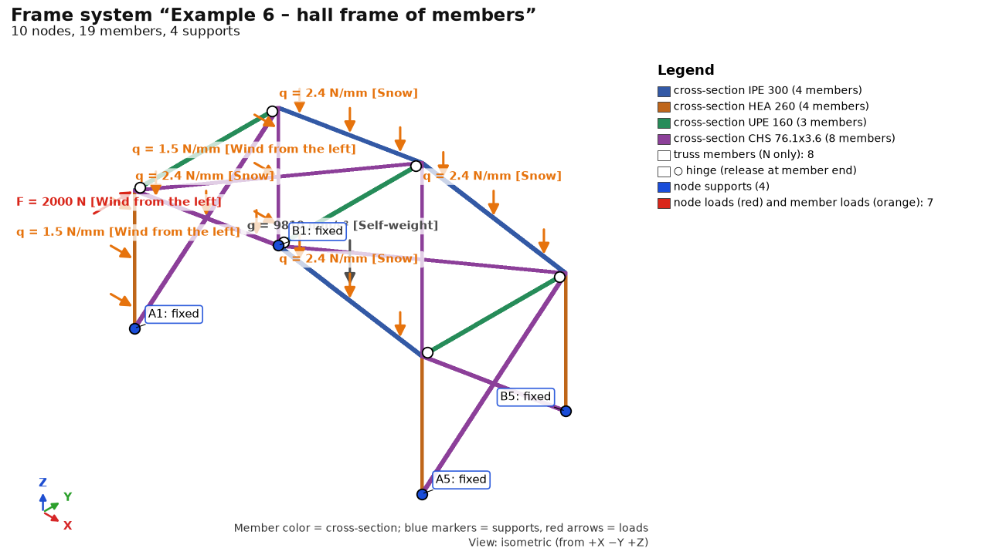
Step | Specification
Beams | columns HEA 260, rafters IPE 300 (span 12 m, gable roof), purlins UPE 160 pinned, bracing CHS 76.1×3.6 (axial only), fixed column bases; EN 1993-1-1 (column buckling lengths)
Loads | Self-weight; snow 0.8 kN/m² on rafters; wind from the left on columns + 2 kN in the gable
Solution | statics + 6 natural frequencies (1st ~4.8 Hz)

Example 7 – dynamics of a PCB fixture
Aluminium bracket clamped to a shaker table, 100×70×1.6 mm FR-4 board on 4 brass standoffs Ø6, an 80 g transformer and the board population.

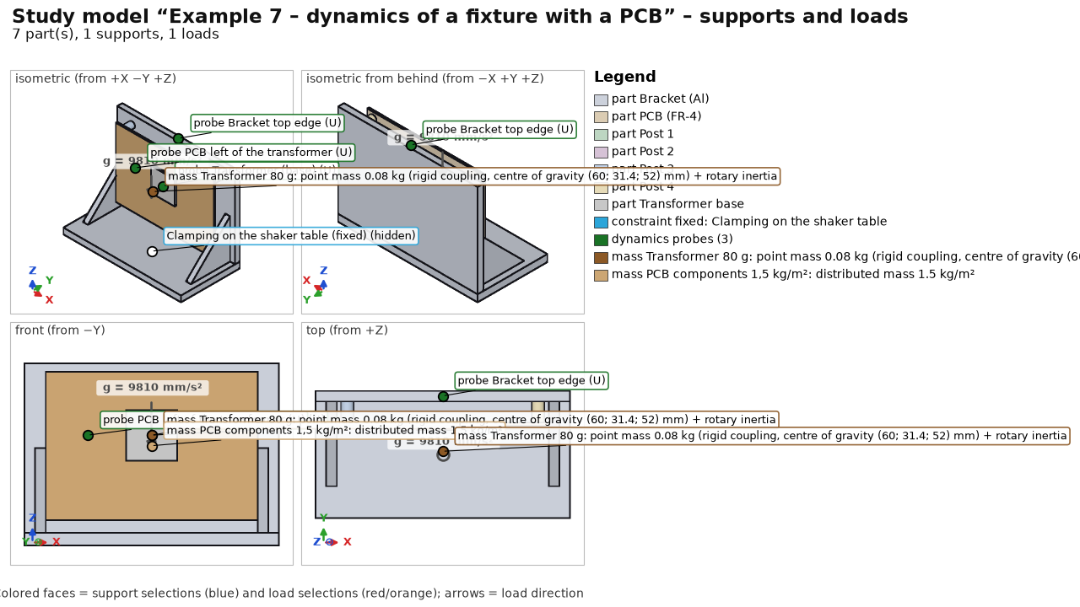
Step | Specification
Materials | Aluminium EN AW-6082 T6; brass CuZn39Pb3; custom “DPS FR-4 (orientačně)” (E 22 GPa, ρ 1,900 kg/m³)
Supports | fixed bottom face of the base (= excited base)
Dynamics | 80 g point mass with rotary inertia (rigid coupling to the footprint); 1.5 kg/m² surface mass on the board; 20 modes, ζ = 3 %; harmonic sine 1 g in Y 10–2,000 Hz; random ASD 20 Hz 0.008 → 50–500 Hz 0.02 → 2,000 Hz 0.005 g²/Hz (4.8 g_{rms}, 0.5 h, Dirlik) – an EXAMPLE in the structure of IEC 60068-2-64, not values from the standard; probes on footprint, board and bracket
Mesh | 6 mm, 3 mm at the board (local refinement), tet10, 32 k nodes; about 1 min

Example 8 – crank mechanism
Frame with a bearing and a guide; crank r = 25 mm, connecting rod l = 100 mm, piston (slider); motor 3,000 rpm, gas force 3,000 N.

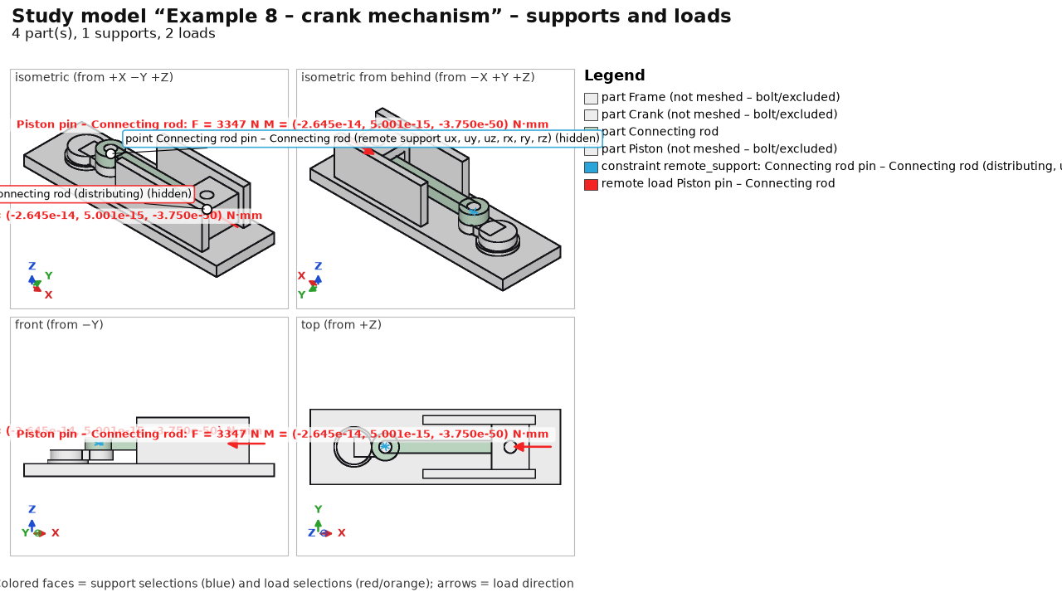
Step | Specification
Materials | Steel C45 +N (frame, crank, piston); connecting rod Steel 42CrMo4 +QT
Motion | 4 bodies (fixed frame); 3 revolute joints proposed from geometry – the rod pins changed to ball + universal (non-redundant set); sliding guide of the piston; drive at constant 314.16 rad/s; 3,000 N on the piston; gravity; kinematics of 1 revolution, 121 outputs
Transfer to FEA | instant of maximum reaction in the piston pin → load case of the rod: remote load on eye B, inertia (Inertia), eye A on a distributing remote support (inertia relief); frame, crank and piston excluded
Mesh | 2 mm, connecting rod only

Example 9 – bolted column base (contact)
Column base plate 100×60×10 with a 24×24 column on a 120×60×15 base plate, 2× ISO 4017 M10 × 45 8.8 with washers and nuts.

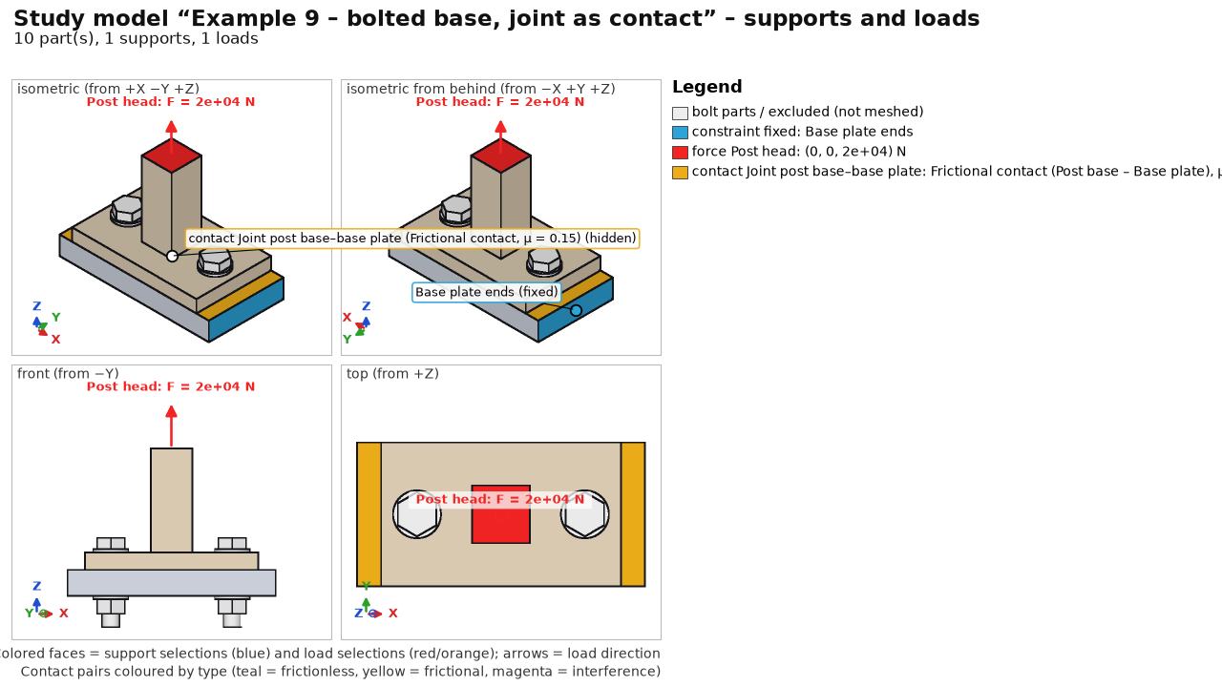
Step | Specification
Joints | 2 bolts M10 8.8, automatic preload (VDI 2230)
Contacts | bolted interfaces as frictional contact μ = μ_T = 0.15 (penalty K = 10·E); nonlinear, as a sequence: bolt preload → tension 20 kN
Supports | base plate fixed at the ends x = ±60
Loads | tension 20 kN on the top of the column (z = 70)
Mesh | 6 mm, tet10, conformal mesh with a split interface

Example 10 – bracket, topology optimization
Full steel plate 160×90×12 mm (S235) as the design space: two Ø11 holes for M10 bolts into a wall (x = 15 mm, z = 15 and 75 mm) and an Ø14 eye at the free end (x = 142 mm, z = 45 mm). Topology optimization removes lightly loaded material and keeps a shape that carries the load at the given volume.

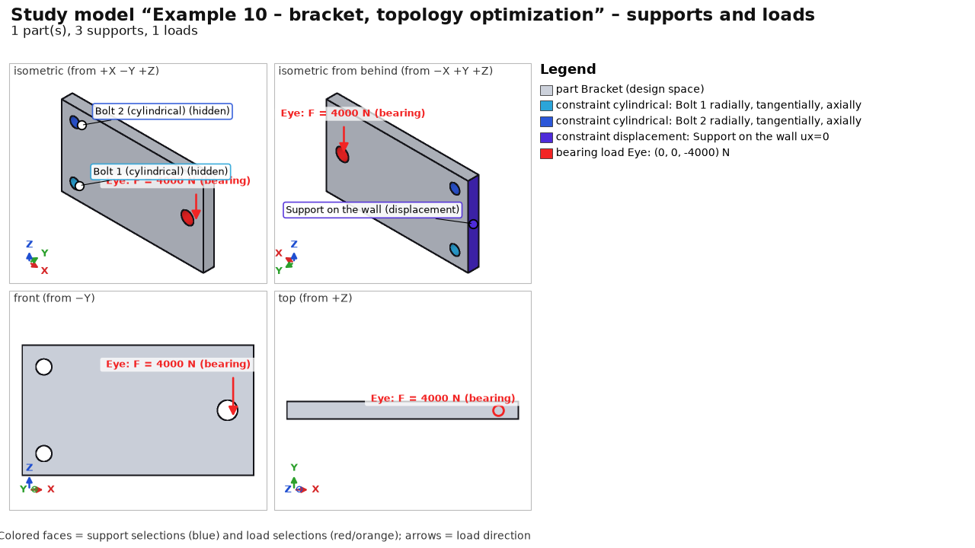
Step | Setup
Materials | Steel S235 (isotropic elastic – a requirement of topology optimization)
Supports | cylindrical support of the holes Bolt 1 and Bolt 2; face Support at wall ux = 0
Loads | case Load 4 kN – bearing load in the eye, downward
Mesh | 4 mm, tet10
Results | statics of the full design and the result (quantities Topology – density, Topology – final shape)
Topology (BESO) | target 40 % volume, filter R 8 mm, ER 4 %/step, at most 60 iterations, all selections protected (holes, eye, wall support); see Results – Topology optimization; result: 40 iterations, volume 40.0 %, compliance 2.2× the full design

Recreating the examples
A script creates the examples (geometry via OCCT in Python, the study via the program core):
.venv\Scripts\python.exe -m examples.create --solve
.venv\Scripts\python.exe -m examples.create --solve --only 8 (one example only)
.venv\Scripts\python.exe -m examples.create --solve --only 10 (example 10: topology, dozens of ccx runs)
.venv\Scripts\python.exe -m examples.frames (example 6)
Without --solve only the input is saved. examples\create.py is also a template for building studies from Python – see Automation.

Testing the program
Ten test problems with a known result (analytical solution or code-based calculation) and the example tours. Each has a procedure and a table of expected values.

Preparation
- Launch: the FEA Studio desktop shortcut or FEA Studio.bat in the program folder.
- Test models: examples\user_tests in the installation (T1_…step to T10_…step); recreate with .venv\Scripts\python.exe -m examples.user_tests.
- Guided examples: Help → Example tour (see Examples and tours).
- Verification of the whole program without the GUI (about 10 minutes): .venv\Scripts\python.exe -m verification.run_all. The output must end with VÝSLEDEK: všechny kontroly prošly (RESULT: all checks passed; the console is in Czech).
Tip: FEA values differ from analytical ones by the mesh error; each value has a tolerance. Displacements within ~3 %, stresses away from singularities within ~5 %. Larger deviations are errors – send the .fea project and a description.

Recommended order
1. Example tour 1 (printed bracket), about 1 min analysis.
2. Example tour 2 (assembly: bolts, welds, heat, fatigue), about 3 min.
3. Tests T1–T7, 5–10 minutes each.
4. Dynamics, contacts and mechanisms: example tours 7–9 and tests T8–T10.
5. Your own STEP model – follow the step bar; F1 = help.
6. Word report (Ctrl+P) and manual (Help → Example tour → Manual).

T1 – cantilever: statics, deflection and stress
Steel beam 200 × 20 × 10 mm, fixed at one end, 100 N force at the other, perpendicular to the 10 mm height.

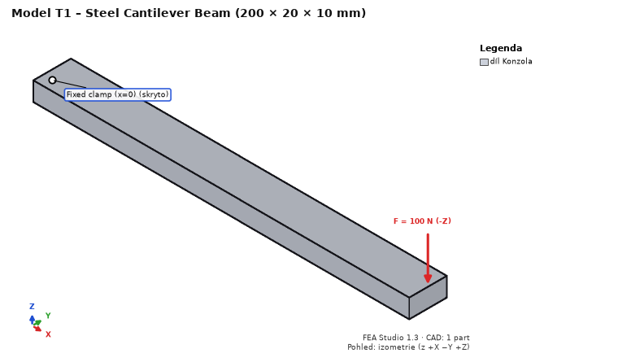
1. Ctrl+O → T1_cantilever.step.
2. Material of part Konzola: Steel S235 (E = 210 000 MPa, ν = 0.3).
3. Supports: face x = 0 → Fixed support.
4. Loads: face x = 200 → Force (0; 0; −100) N.
5. Mesh: element size 2.5 mm → Generate mesh; Solve → Run analysis.
Quantity | Expected value | Where to read
Tip deflection (displacement Z) | 0.763 mm (Timoshenko), FEA ~0.76 mm (±3 %) | Results → Displacement Z, summary
σx at mid-length, top / bottom face | +30 / −30 MPa (±5 %) | Stress σx, click at x = 100
Reaction Fz at the support | 100 N | summary – reactions
Max. von Mises | at the support, marked as singularity (support edge) | Highest stresses

Fatigue on the same model: Fatigue step → channel of the force case: sine, mean 0, amplitude 1, 1000 cycles per block, 100 blocks, signed von Mises, steel S-N: SD = 20 MPa, ND = 10⁶, k = 5, k2 = 0. At a node on the top face at x = 100: amplitude 30 MPa (±5 %), damage over 100 blocks ≈ 0.74, safety factor ≈ 1.06.

T2 – plate with a hole: stress concentration and symmetry
One eighth of a plate (width 100, thickness 5 mm, hole Ø10, tension 100 MPa): a 150 × 50 × 2.5 mm model with a quarter hole in the corner.

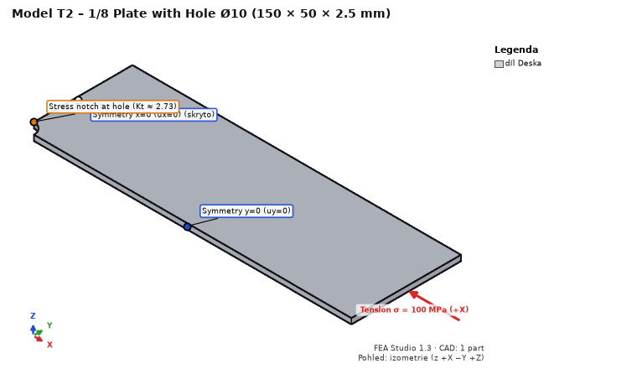
1. Open T2_plate_with_hole_eighth.step, Steel S235.
2. Symmetry supports (Prescribed displacement of one component): face x = 0 → ux = 0; face y = 0 → uy = 0; bottom face z = 0 → uz = 0.
3. Loads: end face x = 150 → Pressure −100 MPa (negative = tension).
4. Mesh 4 mm; local refinement of the hole face (Hole filter H) to 0.35 mm.
Quantity | Expected value | Where to read
σx max at the hole edge (x = 0, y = 5) | ≈ 303 MPa (Kt,n = 2.729 × 111.1 MPa, ±5 %) | Stress σx
Reaction Fx in the plane x = 0 | 12 500 N (100 MPa × 50 × 2.5) | summary – reactions
Classification of the maximum | real location (not a singularity) | Highest stresses

T3 – thick-walled tube: Lamé, heat and thermal stress
Quarter of a ring, ri = 20, ro = 40 mm, height 10 mm.

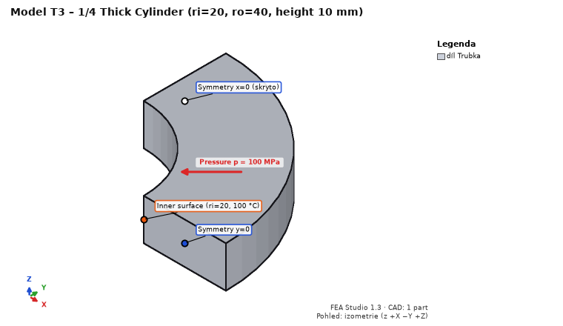
1. Open T3_pipe_quarter.step, Steel S235.
2. Supports: face x = 0 → ux = 0; face y = 0 → uy = 0; bottom face z = 0 → uz = 0.
3. Loads: inner cylindrical face (R 20) → Pressure 100 MPa. Mesh 2.5 mm; run.
Quantity | Expected value
σθ (hoop) at ri / ro | 166.7 / 66.7 MPa (±5 %)
von Mises at ri | 233.3 MPa (±5 %)
Radial displacement of the inner face | 0.01873 mm (±3 %)

Heat on the same model: Heat step → new steady-state case: inner face Temperature 100 °C, outer face (R 40) 20 °C. Results (case “Heat: …”), S235, λ = 53.3 W/(m·K):
Quantity | Expected value
Temperature at r = 30 mm | 53.2 °C (logarithmic profile)
Heat flux |q| at r = 30 mm | ≈ 205 000 W/m²
Heat through the inner face | ≈ 96.6 W (boundary condition heat table), balance within 0.1 %

T4 – shaft: torsion through a remote point
Shaft Ø20 × 200 mm, fixed at x = 0, torque 100 N·m on the other end.

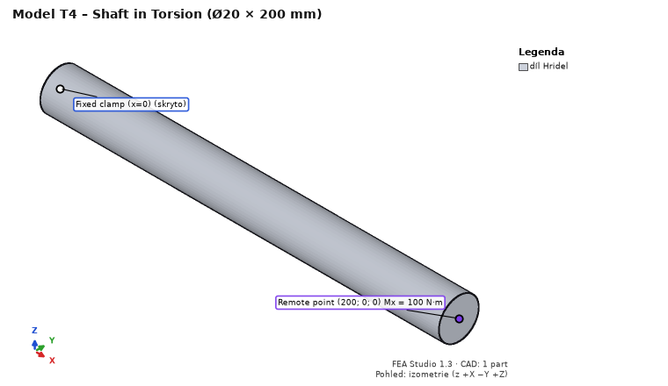
1. Open T4_shaft.step, Steel S235; fixed support on face x = 0.
2. Loads: face x = 200 → Remote force / moment, point (200; 0; 0), moment Mx = 100,000 N·mm, distributing coupling.
3. Mesh 2.5 mm; run.
Quantity | Expected value
Shear stress at the surface (τ = T/Wk) | 63.66 MPa; von Mises ≈ √3 · 63.66 = 110 MPa
Twist of the end | 0.903° (end circumference ≈ 0.158 mm)
Reaction moment at the support | 100,000 N·mm

T5 – M10 bolted joint: detection, preload, checks
Two lap-jointed 10 mm plates, ISO 4017 M10 8.8 bolt with washers and nut (names from CAD).

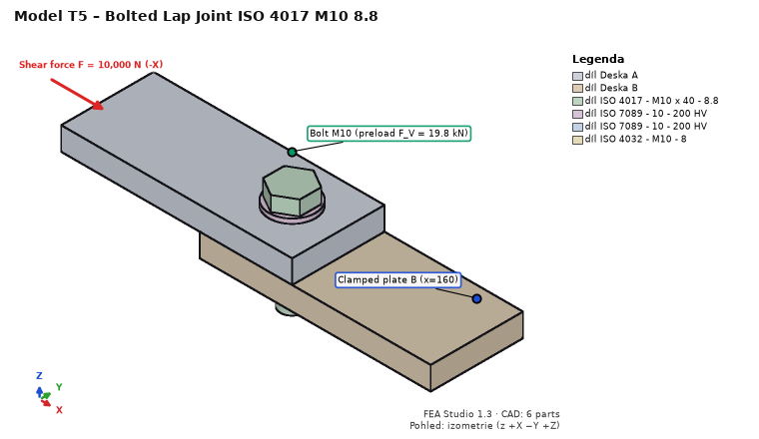
1. Open T5_joint_M10.step, plates Steel S235.
2. Joints → Detect joints… → confirm the bolt (M10 8.8, with nut, washers).
3. Supports: end face of plate B at x = 160 → Fixed support. Loads: end face of plate A at x = 0 → Force (−10,000; 0; 0) N.
4. Mesh 5 mm; run (CalculiX – other solvers do not support bolts).
Quantity | Expected value | Where
Bolt preload case – bolt force | F_V = 19 760 N | Joints – utilization dock
VDI 2230 F_M,zul (μ_G = 0.12) | 29 603 N | bolt check
EN 1993-1-8 F_v,Rd (shear in thread) | 22 268 N | bolt check
EN 1993-1-8 F_b,Rd (bearing, e1 = e2 = 20) | 43 636 N | bolt check
Shear through interface + bolt | 10,000 N | joint forces

T6 – T-joint with a5 fillet welds
Flange 10 mm, web 10 × 100 mm, two a5 fillet welds of length 100 mm (bodies “Svar …”).

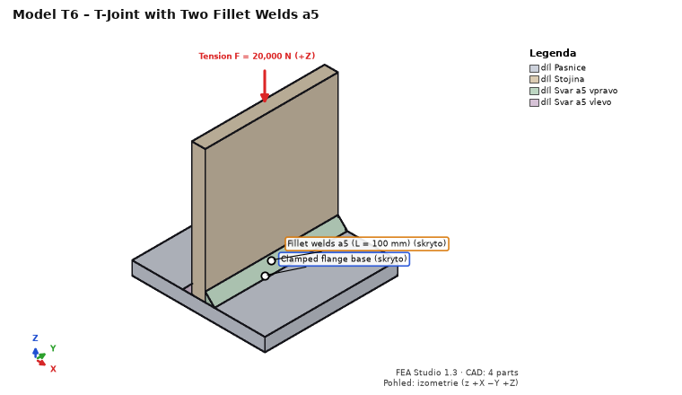
1. Open T6_t_joint_welds_a5.step, Steel S235. Joints → Detect joints… → confirm 2 welds.
2. Supports: bottom face of the flange (z = −10) → Fixed support.
3. Two load cases: “Tah” (tension): top face of the web (z = 100) → Force (0; 0; 20,000) N; “Podélný smyk” (longitudinal shear): same face → Remote force at (0; 50; 0), force (0; 10,000; 0) N.
4. Mesh 5 mm; run.
Quantity | Expected value
Effective throat a / weld length from the mesh | 5.0 mm / 100 mm
Tension: sum of segment forces of both welds | 20,000 N
Longitudinal shear: mean τ∥ = F / (2·a·L) | 10 MPa

T7 – 3D printing: orthotropy by build direction
Two 100 × 10 × 10 mm PLA bars: one printed upright (layers perpendicular to the length), the other lying flat.

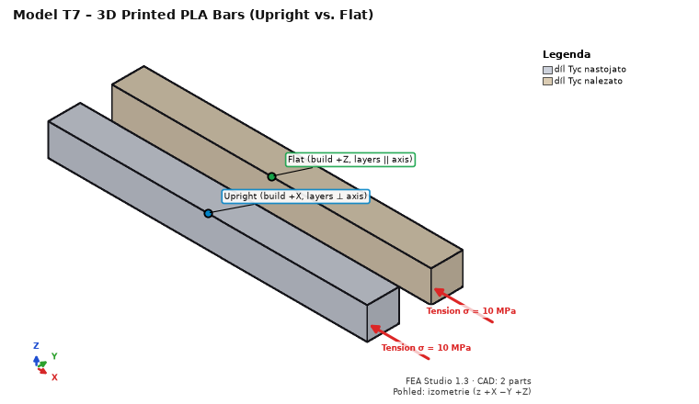
1. Open T7_printed_bars.step. Material of both parts Print PLA Bambu Basic.
2. 3D printing: part “Tyc nastojato” (upright) – build direction +X; “Tyc nalezato” (flat) – +Z; for both turn off “shell + infill” (whole part solid) → Apply to selected parts. Failure criterion Tsai-Hill.
3. Supports: end faces x = 0 → ux = 0; side faces y = 0 and y = 20 → uy = 0; bottom faces z = 0 → uz = 0.
4. Loads: both end faces x = 100 → Pressure −10 MPa. Mesh 3 mm; run.
Quantity | Expected value
Elongation of the upright bar (perpendicular to layers) | σL/E_z = 0.4630 mm
Elongation of the flat bar (in the layer plane) | σL/E_xy = 0.3731 mm
Safety factor (Tsai-Hill) | upright 3.50 (Rm_z/σ), flat 3.90 (Rm/σ)
Reaction Fx | 2,000 N

Then turn on “shell + infill” (3 perimeters, infill 20 %): stiffness and safety both drop; the Shell / core section shows the solid shell share.

T8 – cantilever: natural frequencies and harmonic response
Steel beam 100 × 10 × 10 mm fixed at one end, harmonic force 100 N at the free end (verification Y2).

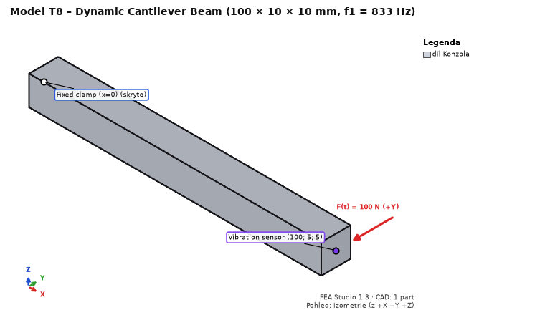
1. Open T8_cantilever_10x10x100.step, Steel S235.
2. Supports: face x = 0 → Fixed support. Loads: face x = 100 → Force (0; 100; 0) N, load case named “Síla Y 100 N”.
3. Step Dynamics: compute dynamics, 10 modes; modal damping ζ = 2 %; compute harmonic response, 10–2 000 Hz; excitation force – load case Síla Y 100 N (Add excitation); probe at (100; 5; 5).
4. Mesh 2.5 mm; run (about 20 s).
Quantity | Expected value | Where to read
1st and 2nd natural frequency (bending in y and z) | 833 Hz (Euler–Bernoulli 835.5 Hz, Timoshenko 0.3 % lower; ±1 %) | Dynamics – table of modes
Sum of effective masses of both modes in y | 61 % (E–B 61.3 %); a square section may split it between the two modes | table of modes
3rd and 4th mode (2nd bending), 5th (torsion), 6th (axial) | ≈ 5,000 Hz (E–B 5,236 Hz), ≈ 7,390 Hz, ≈ 12,970 Hz | table of modes
Static tip deflection (Síla Y 100 N) | 0.190 mm (E–B FL³/3EI = 0.1905 mm) | Displacement Y, summary
Peak |u_{y}| at the probe (resonance) | 4.62 mm = 24.2 × static (E–B 0.9707/(2ζ) = 24.27; ±2 %) | Dynamics – FRF plot, probe
|u_{y}| at 10 Hz | 0.190 mm (quasi-static) | FRF plot

With ζ = 1 % the peak doubles (resonance response ∝ 1/damping).

T9 – contact of two blocks: contact pressure
Two steel blocks 20 × 20 × 10 mm stacked, 10 MPa on the top face, frictionless contact (verification K1, “patch test”).

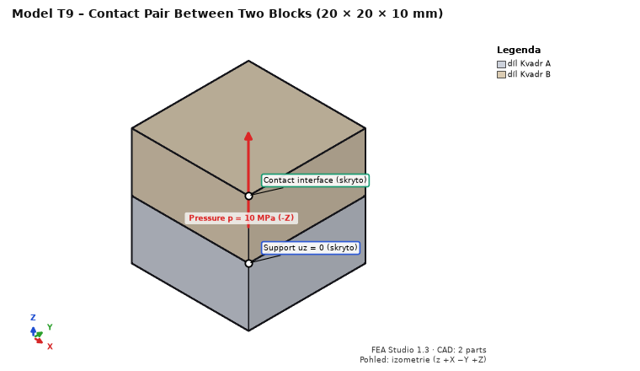
1. Open T9_contact_blocks.step, Steel S235.
2. Supports (sliding): bottom face z = 0 → uz = 0; faces x = 0 (both blocks) → ux = 0; faces y = 0 → uy = 0.
3. Loads: top face z = 20 → Pressure 10 MPa.
4. Step Contacts: Find touching parts → pair Kvadr A – Kvadr B, Frictionless contact → Add. The analysis is nonlinear (CalculiX).
5. Mesh 2.5 mm; run (about 20 s).
Quantity | Expected value | Where to read
Contact – pressure | 10.0 MPa uniform (±0.5 %) | Contact – pressure
Normal force of the pair | 4,000 N (10 MPa × 400 mm²) | Contacts tab
Displacement of the top face | −0.000953 mm (2ph/E + p/K, K = 50·E) | Displacement Z
Contact – opening, status | 0 mm, whole face in contact | contact quantities

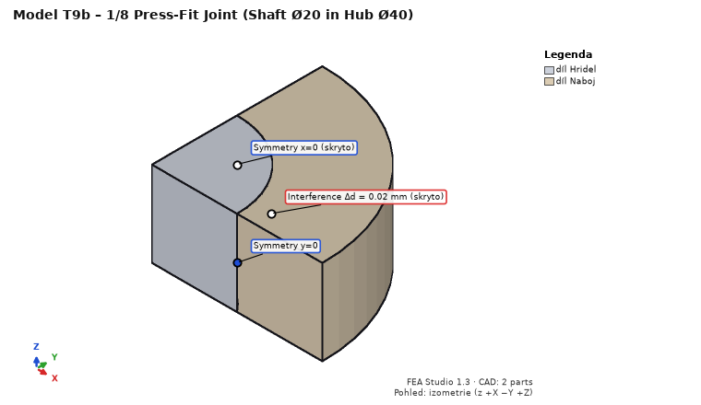
T9b – press fit (T9b_press_fit_eighth.step, K4): one eighth of a Ø20 shaft in a Ø20/40 hub, length 2 × 10 mm. Symmetry supports x = 0 → ux = 0, y = 0 → uy = 0, z = 0 → uz = 0. Empty load case “Lis”. Contacts: pair Hridel – Naboj, Interference (press fit), interference −0.01 mm (Δd = 0.02 mm). Mesh 1.25 mm (about 1 min). Expected (Lamé): contact pressure 78.75 MPa (FEA mean ~80 MPa), hub hoop stress at the bore 131.3 MPa, radial displacement of the hub bore +7.4 µm, of the shaft −2.6 µm.

T10 – crank mechanism: kinematics and drive torque
Crank r = 20 mm, connecting rod l = 80 mm, piston; crank at 100 rad/s; 1,000 N on the piston against the X direction (verification MB1).

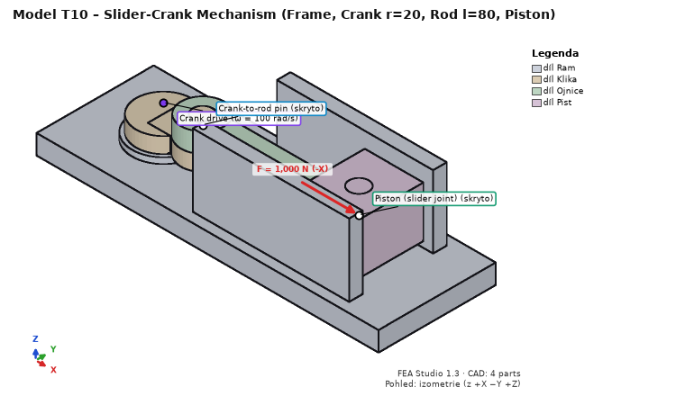
1. Open T10_crank_r20_l80.step, Steel S235 for all parts.
2. Step Motion, tab Bodies: Body for each part (the first part Ram = frame).
3. Tab Joints: Suggest from geometry → accept 3 revolute joints (frame–crank, crank–rod, rod–piston). Add a Slider frame – piston, origin (100; 0; 13), axis (1; 0; 0).
4. Tab Drivers and forces: driver of frame–crank, angular velocity 100 rad/s; load on body Pist, force (−1,000; 0; 0) N at (100; 0; 13); gravity off.
5. Tab Analysis: kinematic, 0.0628319 s (one revolution), 360 outputs → DOF check (0 DOF with drivers, 3 redundant constraints) → Run motion.
Quantity at t = 0.010472 s (crank at 60°) | Expected value
Piston position x (centre of mass = pin axis) | 88.102 mm (r·cos φ + √(l² − r²·sin² φ))
Piston velocity v_{x} | −1,953.8 mm/s
Piston acceleration a_{x} | −75,022 mm/s²
Drive torque without inertia (set mass 0.001 kg and zero inertia manually) | |M| = F·|v|/ω = 19,538 N·mm
Drive torque with CAD mass (steel) | |M| ≈ 19,250 N·mm (inertia of rod and piston)
Body equilibrium, power balance | ≈ 0 (motion result summary)

The sign of velocity and torque depends on the crank joint axis (+z = counter-clockwise seen from above). Then try Transfer to FEA… for the connecting rod (instant of maximum pin reaction), as in example 8.

What else to try
- Solvers: Solve → Solver section: CalculiX / NGSolve + PARDISO / NGSolve + hypre; T1 displacement must agree to 4 significant digits. NGSolve solvers come with the Full profile (modules ngsolve, hypre, and on Windows Microsoft MPI); in the standard install they are greyed out (“not installed”) – install with Install solvers… (Tools → Program modules…) and restart, or skip.
- Undo / Redo (Ctrl+Z / Ctrl+Y); save Ctrl+S and reopen (results are saved with the project).
- Word report (Ctrl+P) – compare the numbers with the tables.
- Section in results (top bar: Section → axis and slider) and a probe by clicking into the model.
- Automation: command line, MCP, REST, e.g. python -m fea_core run study.json.

Reporting bugs
Send the saved .fea project (Ctrl+S), the text of the Solver log dock (Ctrl+A, Ctrl+C), what you expected and what happened; for a crash also the command-line window contents, if open.

Controls and keys
Window layout, interactive help (What's this?, setup guide), mouse control in the 3D window (as in Onshape), selection of faces and parts, section view, views, undo/redo and saving. At the end: all keyboard shortcuts.

Window layout
- Top – one header row: menus File (Open, Save, Save as, Report, Replace geometry), Edit (Undo, Redo), View (Fit, view direction, optional steps, Appearance – system / light / dark, Language), Tools and Help (F1 help, What's this? Shift+F1, How to set up a simulation, guided tours, manuals). In the middle are the phase tabs Model, Assembly, Conditions, Calculation, Results; on the right the study and file name, the phase button (Model: Replace geometry…; Assembly: Detect joints…; Calculation: Mesh convergence…; Results: Export CSV / VTU and Generate report) and Run analysis (F5 – opens Solve and runs). A phase tab opens the step used last in that phase. In a narrow window the document name disappears first, then the Replace geometry button (it stays in File).
- Above the 3D window – the view bar: description by step (load case, joints, mesh, displayed quantity), material colour legend, what a click does; by phase: Model Color (part / material), Assembly Transparent, Conditions Shaded (with edges, without, wireframe), Mesh Show: Mesh / Parts and Color: element quality (1 = regular tetrahedron), Results Quantity and Mesh edges; then Select (Face P, Body B, Hole H, Edge E, Point V), View (isometric, front, top, right), Section (plane normal to an axis or to a selected face; position slider; flip) and Fit (F).
- Left – tool shelf: commands of the current step in headed groups (e.g. Model: GEOMETRY Load, Replace, Check; PARTS Show, Isolate, Hide, Exclude; Loads: LOADS Force, Pressure, Moment, Bearing, Weight, Add; CASES New case, Combinations; Results: Along line, Isosurface, Section force, Animate, Export; Heat: Temperature, Flux, Convection, Radiation; Contacts: Find, Add pair; Members: Node, Member, Section, From wires; Motion: Body, Joint, Driver, Play). In a low window only icons remain; names are in tooltips.
- Centre – 3D window.
- Right – at the top the Study tree (parts with material, 3D printing, joints, contacts, beams, supports, mechanism, heat, load cases, dynamics and added mass, mesh, results, fatigue). A click switches to the item's step and selects it. Below the tree are the step tabs of the phase with a status dot: green = done, orange = warning or unfinished, red = error or missing input, gray = not used. A new STEP study shows only the eight required steps (Model, Materials, Joints, Supports, Loads, Mesh, Solve, Results); optional steps (3D printing, Contacts, Members, Motion, Heat, Dynamics, Fatigue) appear when the study uses them, or pin with + (also View → Optional workflow steps). Ctrl+PgDown / Ctrl+PgUp switch steps. Below the tabs: the Properties – selected item card (part: volume, mass, Show / Analyse, material with E, ν, ρ, Re, Rm; bolt: designation, preload, clamped parts, utilization; support and load: where it acts, area, value; Mesh and Solve: analysis state with the duration of each phase, solver, size, quality, equilibrium). A bolt's size, class and preload and a force's X / Y / Z components can be changed here. The divider between tree and panel can be moved.
- Bottom – tables in tabs with row counts: Model – Parts (Show, Analyse and Material editable), Study materials, Geometry check, Coordinate systems; Joints – Bolts, Welds, Part connections, Excluded parts; Supports and Loads – loads × cases matrix, Load cases, Combinations; Heat, Contacts, Members, Motion, Dynamics; Mesh – Mesh by part, Refinement; Results – Load case results, Highest stresses, Safety by part, Reactions, Joints – utilization. In tables you can change: parts Show, Analyse, Material; bolt size, class and preload mode; load components Fx / Fy / Fz (double-click) and the case matrix (ticking copies a load into a case, unticking in its own case deletes it); + Row adds a load on the selected faces or a bolt in the selected hole. Actions on the right of the tab row (Show all, Isolate, Filter, Assign material…, Duplicate, Delete, Show in model, Copy to Excel). The Messages dock (errors, warnings, information; double-click switches to the step), the Solver log (everything the program reports, including CalculiX output) and Joints – utilization are here too.
- Status bar – left: probe value, edge description or selected parts; right: “Faces selected: n A = … mm²” and the model summary: readiness check, result equilibrium (✓ in green when the imbalance is below the limit), element count, time of the last solve and units (mm · N · MPa).

Interactive help
Control | What it does | Note
Tooltips (hover) | Every button, field, menu and list has a one-line tooltip; details (units, typical values, limits) are in the second level. | A form row's label shows its field's description; F1 over an element or the ⓘ button in a section header opens the details.
Panel sections | Step panels have collapsible sections with a header (arrow, title, gray summary). Right-click for Expand all / Collapse all. | A section with a calculate checkbox expands when ticked; the guide and What's this? expand collapsed sections.
What's this? Shift+F1 | Explanation mode: the element under the mouse is outlined; a click shows a bubble with details and a link to the step's help page. Clicks are not passed to the elements. | Esc, right button or Shift+F1 again = exit
How to set up a simulation | Step-by-step guide to your simulation: switches the progress step, highlights controls with numbers ①②③ and shows what is done and what is missing (refreshed after each change). | Start the guide · “Show in app” repeats the highlight
Example tour | Opens a finished example and guides you through it. | Examples

Mouse in the 3D window
Control | What it does | Typical value / note
Left button – click | Selection: face / part / hole / edge by step and filter; in Results the probe (value at a point). | A click on empty space clears the face selection.
Right button – click (no drag) | Context menu: Show all, Zoom to selection, Clear selection, View, 3D mouse…
Left double-click | Selects the face / part and zooms to the selection. | In Results it does not change the view.
Right button – drag | Rotation about the model point under the cursor. | Outside the model: about the view centre.
Middle button – drag, or Ctrl + right button | Pan.
Wheel | Zoom toward the point under the cursor. | One notch = 1.2×
View cube (top right) | A click on a face, edge or corner rotates the view. | Front, Back, Top, Bottom, Left, Right (Z up)
Arrows / Shift+arrows | Rotate the view by 15° / 90°. | Only when the 3D window has focus.

Bottom left is the scale (ruler in mm), which adapts to zoom.

Selection
What a click selects depends on the step:
- Model, Materials, 3D printing, Solve, Fatigue – whole parts. Ctrl+click adds / removes a part.
- Joints, Contacts, Beams, Supports, Motion, Heat, Loads, Dynamics, Mesh – faces. A click adds a face, a second click removes it (no Ctrl needed); a click on empty space clears the selection. The face under the cursor is light blue; selected faces are orange. The selection carries over between Supports, Loads and Mesh.
- Results – a click shows the value of the displayed quantity (probe) and a marker in 3D.

Selection filter
Control | What it does | Typical value / note
Face P | A click adds / removes a single face. | Default
Body B | A click adds / removes all faces of the part. | e.g. convection from the whole surface
Hole H | A click on a cylindrical face selects the whole hole or pin – all coaxial cylindrical faces of the same radius. | Switching to Hole also extends selected cylinders to whole holes (formerly the “Whole hole” button).
Edge E | A click on an edge shows its type, length and (for a circle) radius, centre and axis in the status bar and the log; in face-selection steps it adds / removes the edge (force on an edge). A click on empty space clears the edge selection; the face selection does not change. | Use circle center / Use edge center in the status bar
Point V | A click on a vertex (exact) or a face (point projected onto the CAD face) adds / removes a point (force at a point); a click on empty space clears the points. | Coordinates in the status bar

Use circle center copies the centre to the clipboard and enters it into the Point [mm] field of the open form (“Force at remote point”, “Moment (remote point)”), clearing “face center”. This enters a point on a hole axis without retyping coordinates.

Views
Control | What it does | Typical value / note
All F | Shows the whole model.
View: Isometric, Front, Top, Right | Standard views (Z up), showing the whole model. | Other sides via the view cube.

Section
Control | What it does | Typical value / note
Section: off / X / Y / Z | Section by a plane perpendicular to the axis.
Section: face | Section by the plane of the first selected face (normal and position from the face). | Select a face first (e.g. in Supports), then choose “face”.
Slider | Position of the plane within the model envelope.
flip | Shows the other half.

In input steps the section cuts the geometry display. In Results a colour section is shown through the inside of the mesh with an outline; the probe works on the section face too.

3D mouse (3Dconnexion)
SpaceMouse, SpaceNavigator and other 3Dconnexion devices are read directly from Windows (the 3DxWare driver may run at the same time). Push right = model right, pull = zoom in, twist and tilt = rotation about the model point in the window centre. Fit shows the whole model; on SpaceMouse Pro / Enterprise the view buttons and Roll also work. The Menu button is handled by the driver.
Right-click in the 3D window → 3D mouse (3Dconnexion) dialog: Control the 3D view with the 3D mouse, Speed (0.25× to 4×), Rotation, Pan and zoom, Dominant motion only (dominant axis), and inversion of single axes. The bars show the cap deflection live – useful to check the device is communicating.

Tools menu
Item | What it does | Note
Beam calculator… | Closed-form beam formulas, curved bar, buckling, EN 1993 check. | Beams
Calculators (friction, Hertz, press fit, snap-fit)… | Calculations without FEA for a quick estimate and a check – tabs below. | Default values = verification examples.
New frame (no CAD) | A study made of members only. | Beams
Mesh convergence… | Analyses on refined meshes, Richardson and GCI. | Results
Program modules… | What is installed; install / remove optional parts (motion, chrono, hypre – large-model solver). | Automation

Calculators
Tab | What it computes
Snap-fit | Snap-fit hook of rectangular section (Bayer), also tapered: assembly and separation force, strain check.
Press fit | Shaft + hub (Lamé, plane stress): pressure, stress, displacements, transmitted torque and force, heating for assembly.
Hertz | Hertzian contact: sphere, cylinder, gearing (ISO 6336-2), cam with roller, impact of a sphere.
Machine element friction | Friction in joints and machine elements – torque, self-locking, efficiency.
Friction library | Friction coefficients of material pairs with sources (μ_min / μ_max by purpose), your own values – see Friction and damping.
Mechanisms | Analytical benchmarks: crank, four-bar, cam, pendulum, run-down, stick-slip, rolling, axis drive.
Damping from measurement | Damping ratio from the −3 dB bandwidth or logarithmic decrement, Rayleigh α, β, conversions ζ ↔ Q ↔ η.
Drop | A drop as an equivalent half-sine acceleration pulse (input for shock in Dynamics).

Calculator units: mm, N, MPa, t, s (g = 9810 mm/s²). Each result states its formula and source.

Undo / redo
Ctrl+Z reverts the last study change (material, support, load, mesh, print settings, joints, fatigue…), Ctrl+Y redoes it. Up to 200 steps are kept; the history clears when another file opens. View, face selection and section are not recorded.
Note: reverting an input change discards the results (and the mesh, if it concerns geometry, selections, joints or printing). Changing fatigue settings does not discard static results.

Files
- Open… Ctrl+O – STEP (.step, .stp) = new study, or a .fea project. Also python -m fea_gui file.fea.
- Save Ctrl+S – the .fea project holds the STEP model, inputs and results (portable to another computer). A new study asks for a name.
- Save as… Ctrl+Shift+S.
- Unsaved changes show as an asterisk in the title; closing or opening another file asks first.

Keyboard shortcuts
Key | Action | Note
Ctrl+O | Open STEP or .fea project
Ctrl+S | Save project
Ctrl+Shift+S | Save as…
Ctrl+P | Report to Word | Report
Ctrl+Z / Ctrl+Y | Undo / Redo
F | Show the whole model
P B H E V | Selection filter Face / Body / Hole / Edge / Point
arrows, Shift+arrows | Rotate the view by 15° / 90° | The 3D window must have focus.
Ctrl+PgDown / Ctrl+PgUp | Next / previous shown step
F1 | Details of the element under the mouse, otherwise help for the current step | In the help window: Ctrl+F search, Alt+← / Alt+→ back / forward
Shift+F1 | What's this? – explanation of an element after a click | Exit with Esc

Tip: single-letter shortcuts do not work while typing in a text or number field – click into the 3D window first.

In the examples
- Example 1 – printed bracket: in Supports turn on the Hole filter (H) and click a screw hole – the whole Ø5 hole is selected. Section Y at the middle (y = 20 mm) passes through both hole axes, the Ø8 eye and the rib; in Results the same section is coloured by the stress inside the part.
- Example 2 – assembly: the Edge filter (E) and a click on the arm eye edge shows a circle R 5 mm on the eye axis; Use circle center enters it as the remote force point. Section Y through the bolt axis shows the clamped stack with washers and nut; in Results, section Y across the post shows the triangular sections of both fillet welds and the stress in them.

Troubleshooting
- Arrows and letter shortcuts do not respond – the focus is in a form field. Click into the 3D window.
- “For a section along a face plane, first select a face (e.g. in the Supports step), then choose “face”.” – in Model and Materials parts are selected, not faces. Go to Supports, select a face, then choose the section “face”.
- “Hole filter: click the cylindrical face of a hole or pin.” – you clicked a planar face or a non-cylindrical fillet (cone, torus). Click the cylindrical wall.
- The “Solver log” or “Messages” panel disappeared (closed with the cross) – right-click the toolbar and show it again.
- “Meshing, analysis or report generation is in progress – wait for it to finish or cancel the analysis (Solve / Mesh step).” – a file cannot be opened during an analysis. Wait, or press Cancel.
- Results disappeared after Ctrl+Z (“Study changed – results discarded, recomputation needed.”) – results belong to the original inputs. Run the analysis again; Ctrl+Y redoes the change but does not restore results.

1. Model
Loads a STEP file or a .fea project, checks the geometry and lists the parts. Later steps refer to parts by name and faces by shape and position.
Preparing the model in CAD: Export from CAD (STEP settings, Send to FEA Studio for Fusion, SOLIDWORKS and Inventor, materials from CAD).

Opening a model
Control | What it does | Typical value / note
Open STEP / project… (panel)  Open… Ctrl+O | a STEP file (.step, .stp) creates a new study; a .fea file opens a saved project with results | afterwards Materials opens (a project with results opens Results)
Dropping a file onto the window | a .step, .stp or .fea file dragged from Explorer (or onto the shortcut, or Send to → FEA Studio) opens as with Open | unsaved changes: asks to save
Model overview (panel) | file name, number of bodies, table Show / Analyze / Part / Status / Volume [cm³] / Material | units: mm, N, MPa, t, s

A new study from STEP gets:
- material Steel S235 for all parts (change in Materials); CAD metadata (<same name>.json) next to the STEP give parts the CAD material if it is in the library (Export from CAD);
- element size ≈ model diagonal / 30, rounded down to 1 / 2 / 2.5 / 5 × 10ⁿ mm (240 mm model → 5 mm);
- an empty Load case 1.

Frame structure without CAD
New frame (no CAD) (also in Tools) creates a study from members only (frame, truss, beam). 3D printing, Joints, Supports, Heat and Mesh are disabled; define the structure in Members. A .fea without STEP opens like any other (example 6).

What a STEP file should contain
- Solid bodies: faces and shells without volume are ignored.
- Assembly with part names: name from the instance or component (Fusion: “Deska:1”; several bodies “Deska:1_1”, “Deska:1_2”). Generic names (“SOLID”, “Body1”…) are replaced by the component name; duplicates get “ (2)”, “ (3)”.
- Units: converted to mm.
- Bolts, nuts, washers with a standard name (“ISO 4017 - M8 x 30 - 8.8”) become Joints. Welds as separate bodies (name “Svar…”, colour or layer).
- Hidden bodies are not exported from Fusion.

Geometry check
Checked on loading; problems appear in a window and the log (“Geometry check: …”). The analysis is not blocked but may fail or be inaccurate.
Message | Meaning | What to do
The STEP file contains faces or shells without volume (ignored…) | faces that are not a body (e.g. imported surface) | knit into a body in CAD, or leave – not analyzed
Part '…': the body is not topologically valid (BRepCheck) | faulty edges or faces | heal in CAD, export again; meshing may fail
Part '…': zero or negative volume | inverted faces or an open body | fix in CAD
The STEP file contains no body (solid) | only faces exported | export bodies, not faces

Parts in the study tree
The Parts branch lists all parts; Info shows material or status:
- bolt (beam) – bolt, nut or washer: not meshed, a beam replaces it (Joints);
- excluded – excluded from the analysis;
- no material (red).

Assemblies: touching parts are bonded (without a contact pair)
The mesh is continuous: parts touching by a face share nodes and are rigidly connected (no friction, no gap). The table Connected parts (shared mesh) in Joints lists them (Part A / Part B / Contact [mm²]). Parts touching only by an edge or point are not reliably connected – check them.
For separation, friction, press fit or compression only, define a pair in Contacts (Find touching parts scans the assembly); pair parts are meshed separately and the analysis is nonlinear. Bolted-joint interfaces: check box bolted joint interfaces as contact (Contacts).

Switching bodies on and off: Show / Analyze
- Show – visible in 3D. Display only (analysis, mesh, results unchanged); a hidden body cannot be picked (to see inner parts). Saved in the project; Ctrl+Z undoes it.
- Analyze – in the analysis. A switched-off body (magnet, pin, cable, bought part) is not meshed or analyzed and is transparent in 3D. Discards the mesh; selections, supports and loads of other bodies remain.
A tick in a selected row applies to all selected rows. Right-click the table: hide / show, Show only the selected bodies, Show all, Include all in the analysis, By name (e.g. bolt, M6*, *magnet*; without an asterisk part of the name suffices). The buttons below the table and the right-click menu of a part in the tree do the same.
Bodies hidden in CAD (Fusion assembly from .f3d / .f3z, metadata "hidden": true) load hidden and excluded. Parts can also be excluded in Joints (group Parts excluded from the analysis).

Face selection and selectors
Supports, loads, thermal conditions and refinement use face selections. A selection stores a selector (part name, face type, area, centroid, a point with normal, envelope), not a face number, so a project survives a new export of the same model.
- Names follow purpose and sequence: “Fixed support 1”, “Displacement 2”, “Cylindrical support 1”, “Force 3”, “Pressure 1”, “Bearing load 1”, “Refinement 1”… Results reactions use them.
- A face is found only on a nearly exact match (area, centroid, envelope within 0.01 % of the face size); a changed face (size, position, split) is not found.
- Replace faces of an existing support or load with Faces from selection in its step.

Colours in 3D
Colour | Meaning | Note
light alternating colours | parts | CAD colours are only read for weld detection (Joints)
light blue | face / part under the cursor
orange | selected faces
blue with a label | supports (cylindrical support also shows the axis) | Supports, Loads, Solve
red with arrows | forces (components, bearing, remote) | current case
purple | pressure
turquoise | local mesh refinement | Mesh
magenta | selected edge (Edge filter)
transparent | parts excluded from the analysis

In the examples
- Example 1 – printed bracket: one part “Drzak (tisk PLA)” – wall plate 60×40×6 mm with Ø5 screw holes, arm with a Ø8 eye, a rib. The geometry check reports nothing.
- Example 2 – assembly: 13 parts – Patka (base plate), Sloupek (post), Svar a4 vlevo (left weld), Svar a4 vpravo (right weld), Rameno (tisk PLA, arm), two bolts “ISO 4017 - M6 x 30 - 8.8:1/:2”, four washers “ISO 7089 - 6 - 200 HV”, two nuts “ISO 4032 - M6 - 8”. Bolts, washers and nuts show “bolt (beam)” and are not meshed. The arm sits on the base plate by its flange and is bonded in the mesh (Connected parts table); welds are separate bodies.

Common problems
- “The file cannot be opened: Cannot read STEP …” – invalid or damaged STEP; export again (AP214 / AP242).
- “Some selected faces were not found in the model (did the model change?)” – faces changed (size, split, renamed part). Select again and press Faces from selection on the item. During the analysis it reads “Some selected faces, edges, or points were not found”.
- A renamed part got a different material – materials follow part names; a new name gets the default. Check the Material column, reassign in Materials.
- “The volume mesh was not generated – the geometry probably self-intersects or parts touch tangentially (cylinder in a slot, coincident faces).” – parts overlap or touch along a line (pin in a slot). Remove the overlap in CAD or exclude the part.
- “Some parts are not connected to a support (free bodies – the problem would be singular)” – the part touches nothing by a face and is neither bolted nor welded. The program offers to exclude it; otherwise fix the geometry or add a joint.
- “Selection '…': part '…' is excluded (not meshed)” – a support or load lies on an excluded part (or bolt). Move it to a load-carrying part or include the part.

Export from CAD (SolidWorks, Inventor, Fusion…)
How to get a model from CAD into FEA Studio: export to STEP with the right settings, or for Fusion, SOLIDWORKS and Inventor use the Send to FEA Studio button, which also transfers the part materials.

Quick overview
CAD | Easiest way | Materials transferred?
Autodesk Fusion | add-in – the Odeslat do FEA Studia (Send to FEA Studio) button in the FEA STUDIO panel | yes
SOLIDWORKS 2020–2025 | FEAStudio_Export macro (toolbar button) | yes
Autodesk Inventor 2021–2026 | FEAStudio_Export iLogic rule (ribbon button from 2023) | yes
others (Solid Edge, Creo, CATIA, NX, Onshape, FreeCAD, Rhino…) | manual STEP AP214 export → drag it onto the FEA Studio window or Send to → FEA Studio | no – assign them in Materials

The SOLIDWORKS macro and the Inventor rule have not yet been tried in real SOLIDWORKS or Inventor (only their logic was verified outside CAD). On first use check that the STEP file was saved and FEA Studio opened; if not, use the manual export.

What FEA Studio needs
Requirement | Note
STEP (.step, .stp), protocol AP214 or AP242 | AP203 works but has no colours. AP242 only with precise geometry (B-rep), not tessellated. Other formats are not opened.
Solid bodies, not surfaces or wireframe | FEA computes the volume. A surfaces-only STEP creates a shell model (you enter the thickness).
The whole assembly in one file, parts in their real position | Turn off “each part to its own STEP file”.
Part names | Materials, bolts and face selections are bound to the part name; a renamed part is a different part for the study.
Bolts, nuts and washers with a standard name | E.g. “ISO 4017 - M8 x 30 - 8.8”, “ISO 4762 M6 x 20:1”, “ISO 4032 - M8”, “DIN 125-1 A 8,4”. Library parts (Toolbox, Content Center) usually have them. Joints → Detect joints…
Welds as separate bodies | Name “Svar…” / “Weld…”, a layer or attribute with svar / weld, or a uniform colour (Weld color in CAD in Joints).
Only the parts to be analysed | Suppress unneeded parts in CAD – hiding is not enough. Fusion and Onshape do not export hidden parts; Inventor and SOLIDWORKS may write them depending on version, and FEA Studio would mesh them. Or exclude them in Joints → Parts excluded from the analysis.
Any units | Converted to mm on loading (inches, metres). mm recommended; check part volumes in the model overview.
No interferences | Touching parts are bonded in the mesh. Overlapping parts either fail to mesh or give the common volume to one part (warning “Parts … overlap” in Mesh) – the analysis then runs on wrong geometry. Remove interferences in CAD.

Details on part names and the geometry check: 1. Model.

How to open a STEP file in FEA Studio
Way | Procedure
Open | Model step → Open STEP / project…, or Ctrl+O
Drag and drop | Drag a .step / .stp (or .fea) from Explorer onto the window – anywhere, including the 3D view – or onto the FEA Studio shortcut.
Send to | Right-click the STEP → Send to → FEA Studio (Windows 11: Show more options, or Shift + right-click). The installer creates the shortcut.

- Shortcut, Send to or a macro always opens a new window; dropping onto an open window replaces its model (unsaved changes → a question).
- Only the first of several dropped files opens; nothing opens during an analysis.

Inventor parts and assemblies and Fusion designs without STEP export (module native)
With the optional module native (Tools → Program modules…) you open an Inventor part .ipt, assembly .iam and Fusion design .f3d / .f3z directly – no CAD and no STEP export needed (Open, drag onto the window, Replace geometry). The program reads the exact ShapeManager geometry and converts it to solids; it is cached as STEP, so everything else works the same.
- Every solid is checked (valid topology, positive volume). What cannot be converted reliably (thread helices without a stored approximation, elliptic cylinders) stops with an explanation – then use STEP.
- Inventor assemblies .iam carry only references and positions: the .ipt (and subassembly .iam) files must lie next to the assembly in the same folder structure (copying the whole project folder is enough). Parts are placed at occurrence positions, including subassemblies; body names as in Inventor (Plate:2, several bodies Plate:2_1…). Positions are checked against the assembly and the graphics stored by Inventor. Verified on an assembly of 21 occurrences with a subassembly (no interference, volumes = Inventor STL to 0.05 %). Bolts, nuts and washers (by name, including Content Center) are not loaded but replaced by virtual bolts with a joint assessment – see Joints. Not yet supported: renamed and suppressed occurrences (clear error); hidden occurrences load as visible.
- Fusion assemblies (.f3d with components, .f3z with nested documents): the component tree, positions and visibility are built. Bodies hidden in Fusion (light bulb off) load as hidden and excluded – switch them on in Model with the Show / Analyze columns. Names as in Fusion / STEP (Plate:1, Plate:1_1…). Verified against a Fusion STEP export (nested document, rotated occurrences, hidden bodies: positions and volumes to 1e-14). If the tree cannot be read, the program warns and loads bodies in component coordinates.
- Materials are not transferred from native files (the Fusion add-in sends them in metadata).
- This is unofficial reading of Autodesk formats: for important models compare with a STEP export (volume, dimensions).

Materials from CAD – a JSON file next to the STEP file
STEP does not carry the part material. The Fusion add-in and the SOLIDWORKS and Inventor tools therefore write a file with the same name and the .json extension next to the STEP (e.g. Drzak_20261015_101500.step + Drzak_20261015_101500.json). When FEA Studio opens the STEP (any way above), it:
1. matches STEP parts to records by name (case and occurrence suffixes “:1”, “<1>”, “ (2)”, “_2”, SOLIDWORKS “-1” do not matter);
2. assigns a material only if it is in the library: exact name (also from your library), or the same grade by the grade converter. A temper in the CAD name (T6, O, +QT…) must match;
3. leaves other parts on the default Steel S235 and reports them.
The summary is in the Messages dock (source “CAD import”; double-click opens Materials) and the Solver log. Nothing is blocked; no window opens.
Material in CAD | In FEA Studio
S235JR, St 37-2, 1.0038 | Steel S235
AISI 304, 1.4301:X5CrNi18-10 / AISI 316L | Stainless 1.4301 / Stainless 1.4404
6061-T6 (SS), Aluminum 6061 | Aluminum EN AW-6061 T6
42CrMo4, C45 | Steel 42CrMo4 +QT, Steel C45 +N
EN AW-5083 O/H111, 5083-O | Aluminum EN AW-5083 H111 (O and H111 are one temper)
6061 Alloy (SOLIDWORKS – annealed temper) | not assigned: a temper other than T6
1060 Alloy, 1060-H12 (SOLIDWORKS – aluminium 1060) | not assigned: aluminium 1060 is not in the library (not mistaken for steel AISI 1060)
Steel, Plain Carbon Steel, Ocel, měkká, ABS, PLA | not assigned: a generic name without a grade

Save a material you use often in CAD in Materials with Save to my material library under the same name as in CAD (e.g. “Plain Carbon Steel”); it is then assigned automatically.

Your own JSON (another CAD, a script)
Any program can write the file: UTF-8, only the parts list is required. names = further names for matching; material_props (Re_MPa, Rm_MPa) optionally confirm the temper:
{"source": "My CAD", "document": "Bracket", "units": "mm",
"parts": [{"name": "Plate", "material": "S235JR"},
{"name": "Console-1", "names": ["Console"], "material": "AISI 304"}]}
The JSON is read only for a new study from STEP (a .fea project keeps its materials). Colours and units from the JSON are not used – the STEP file applies.

Autodesk Fusion

The “Odeslat do FEA Studia” add-in (recommended)
1. Installation: the FEA Studio installer adds the add-in if Fusion is on the computer. Otherwise, in the FEA Studio folder: .venv\Scripts\python.exe installer\fea_setup.py fusion (removal: fusion --remove). Restart Fusion.
2. In the Design workspace the SOLID, SURFACE, SHEET METAL… tabs have the FEA STUDIO panel (between INSERT and SELECT) with Odeslat do FEA Studia; also in UTILITIES → ADD-INS.
3. In the dialog choose Co odeslat: Celý design (whole design), or Vybrané díly / podsestavy (selected parts / subassemblies – select beforehand; the selection is prefilled). Parts keep their assembly position.
4. The add-in saves STEP + JSON to %TEMP%\FEAStudio\export and opens FEA Studio; with the REST server running, it sends the files through it (see Automation).
- Parts are named after the occurrence (“Deska:1”); several bodies “Deska:1_1”, “Deska:1_2”.
- Hidden bodies are not exported – make everything to be analysed visible.
- T-Spline (Form) and mesh bodies are not written to STEP – convert them to solids.
- The Vybrané díly / podsestavy option has not yet been tried in live Fusion.

Manual export
File → Export → type STEP Files (*.stp, *.step) → location → Export. Open the STEP in FEA Studio. Materials are not transferred this way.

SOLIDWORKS

Manual export
1. File → Save As (3DEXPERIENCE: Save to This PC) → type STEP AP214 (*.step; *.stp) → Options….
2. Set the options per the table → OK → Save.
Option | Setting
Output as: Solid/Surface geometry | yes
Export face/edge properties | yes (colours)
Export appearances (from 2023) | yes (colours)
Split periodic faces | no (a hole stays one face)
Export 3D Curve features | no
Export assembly components as separate STEP files (from 2023) | no – otherwise several files
Output coordinate system | default

SOLIDWORKS writes AP242 only with the MBD add-in, not needed for analysis. Default option values: Tools → Options → System Options → Export.

The FEAStudio_Export macro (button)
Macro file: adapters\solidworks\FEAStudio_Export.bas in the FEA Studio folder. Installation (once):
1. Tools → Macro → New → name FEAStudio.swp (not FEAStudio_Export) in the adapters\solidworks folder → Save. The VBA editor opens.
2. In the editor File → Import File… (Ctrl+M) → FEAStudio_Export.bas.
3. Remove the empty default module (right-click → Remove… → No).
4. Debug → Compile VBAProject, save (Ctrl+S), close the editor.
5. Button: Tools → Customize → Commands → category Macro → drag New Macro Button to a toolbar. Macro: FEAStudio.swp, Method: FEAStudio_Export.main, image FEAStudio_Export.bmp.
When clicked, the macro sets AP214, solid/surface geometry, face/edge properties, unsplit periodic faces and no 3D curves for the export (then restores them), saves STEP + JSON (material, configuration, occurrences) to %TEMP%\FEAStudio\export and launches FEA Studio. Check the options added in 2023 – separate STEP files (off), Export appearances (on), Output coordinate system (default) – once manually; the macro does not change them.
- STEP from SOLIDWORKS has no occurrence names (“Deska-1”): parts are named after the part file (“Deska”, “Deska (2)”), and “Deska_Configuration” for a non-default configuration. The JSON still matches them.
- Accented names are written correctly only from SOLIDWORKS 2024 SP02; in older versions use names without accents.
- Detailed description (Czech): adapters\solidworks\README.md.

Autodesk Inventor

Manual export
File → Export → CAD Format → type STEP Files → Options…: Application Protocol 214 (AP242 only for parts, not assemblies), turn off Include Sketches → Save.

The FEAStudio_Export iLogic rule
Rule file: adapters\inventor\FEAStudio_Export.iLogicVb in the FEA Studio folder. Installation (once):
1. Tools → Options → iLogic Configuration → External Rule Directories → + → the adapters\inventor folder → OK.
2. Running: Manage → iLogic → iLogic Browser → External Rules → right-click FEAStudio_Export → Run Rule.
3. Button (Inventor 2023+): right-click the ribbon → Customize User Commands → Ribbon → filter iLogic rules → add FEAStudio_Export (Part and Assembly separately). Inventor 2021–2022 has no button for a rule – run it from the iLogic Browser.
4. Inventor 2025+ may ask about security on the first run (the rule starts another program) – allow it.
The rule saves STEP AP214 without sketches + JSON to %TEMP%\FEAStudio\export and launches FEA Studio.
- Inventor library material names are generic and localised (“Steel, Mild”, “Ocel, měkká”) and are not assigned; grades such as “1.4301” or “S235JR” are.
- Depending on the version, hidden components may go to STEP – suppress unneeded parts.
- Inventor writes the Windows login name into the STEP header – keep this in mind when sharing files.
- Detailed description (Czech): adapters\inventor\README.md.

Where the macro and the rule find FEA Studio
In order: the FEA_STUDIO_HOME environment variable → %APPDATA%\FEAStudio\install.json (written by the installer) → %LOCALAPPDATA%\Programs\FEA Studio → a constant in the macro. If none is found, a message gives the path of the saved STEP – drag it onto the window. Set the variable via Start → “Edit environment variables for your account” → New…: name FEA_STUDIO_HOME, value = the FEA Studio folder (e.g. D:\Programs\FEA Studio).

Other CAD systems
Export STEP manually and open it (Open, drag and drop, Send to); assign materials in Materials. The procedures follow vendor documentation; FEA Studio has not been tried in these systems and labels may differ by version.
CAD | Procedure | Watch out
Siemens Solid Edge | Save As → type STEP (*.stp) → Options: Export AP214, Solid Bodies → Export To: Class VI Manifold Solids, Export Units: millimeters | the setting is remembered – Surface Models or Wireframe must not remain
PTC Creo Parametric | File → Save As → Save a Copy → Type STEP → Options: protocol ap214_is; the assembly as one file | default ap203_is has no colours; ap242 with annotations writes parts as triangle meshes
CATIA V5 | Tools → Options → General → Compatibility → STEP → Export: AP214; then File → Save As → type stp | requires the ST1 licence; load the assembly fully (not visualisation mode only)
CATIA 3DEXPERIENCE | Export → Format STEP (AP214 or AP242) | one file; STEP option locations differ by release
Siemens NX | File → Export → STEP: Export From Displayed Part, Export As AP214 (or AP242), Data to Export Entire Part, precise geometry | AP242 takes only visible layers; selecting single bodies flattens the assembly and loses part names
Onshape | right-click the Part Studio / Assembly tab → Export → Format STEP, Use custom units: Millimeter, leave “Export unique parts as individual files” unchecked → Download | suppressed parts are not exported, hidden only with “Include hidden instances in export”; without units the file is in metres (converted)
FreeCAD 0.21 / 1.0 | Edit → Preferences → Import-Export → STEP: Units Millimeter, Scheme AP214, turn off “Export invisible objects”; select only the final Body / Part → File → Export (Ctrl+E) → STEP | Select all (Ctrl+A) also selects inner features of a Body → duplicated bodies
Rhino 7 / 8 | ShowEdges / SelOpenPolysrf – no open polysurfaces (close with Join, Cap); select solids → Export Selected → STEP → schema AP214AutomotiveDesign | an open polysurface is written as a surface, not a solid

Unsuitable formats and tools
- STL, OBJ, 3MF, PLY – triangle meshes without precise surfaces (STL also without units). Not opened.
- Converting a mesh to a solid (FreeCAD “Convert to solid”, STL → STEP) gives a faceted solid with a face per triangle: slow meshing, holes and cylinders cannot be selected, and false stress peaks appear on facet edges. Last resort only – remodelling is better.
- IGES usually carries surfaces only and is not opened. Native CAD files (.sldprt, .ipt, .f3d…), Parasolid and ACIS are not either – always export STEP.
- SketchUp, Blender and other polygon modellers have neither precise solids nor STEP export.

Troubleshooting
Problem | Cause | What to do
Parts named “SOLID”, “Teleso”, “Body2” or similar | CAD did not write part or occurrence names (FEA Studio replaces generic body names with the component name) | Name the parts in CAD; split multi-body parts into separate parts
“The STEP file contains faces or shells without volume”, “The STEP file contains no body” | surfaces or open bodies were exported | Export solids (Solid / Manifold Solids), close or knit them in CAD; surfaces-only STEP can be computed as a shell
“CAD material … is not in the library” | a generic name or a different temper (e.g. annealed) | Assign it in Materials; permanently: save to your library under the CAD name
“Parts without an entry in the CAD metadata” | part name in STEP does not match the JSON (renaming, accents in older SOLIDWORKS, STEP and JSON from different exports) | Export again with the button; use file names without accents
No “CAD metadata” summary | no JSON next to the STEP (manual export), or a different name | Always name STEP and JSON the same way, or assign materials manually
A bolt was not detected | the name lacks standard and size (“Sroub-1”, an item number) | Joints → Detect joints… offers parts by shape; or rename in CAD to “ISO 4017 - M8 x 30 - 8.8”
A part was marked as a weld | the name contains “weld” / “svar” (e.g. “Weldment…”) | Rename it in CAD, or untick it in Detect joints…
A hidden part is analysed | depending on the version Inventor and SOLIDWORKS may write hidden parts | Suppress it in CAD, or Joints → Parts excluded from the analysis
Dimensions 25.4× or 1000× off | wrong units in the STEP header | Export again in mm; check the volume in the model overview
Meshing long or failing | unnecessary details, interferences | Simplify the model (below); remove interferences in CAD
Macro / rule did not launch FEA Studio | program folder not found | Set FEA_STUDIO_HOME, or drag the STEP from the message onto the window
Drag and drop does not work | FEA Studio runs as administrator (Windows blocks dropping from a non-administrator Explorer), a different extension, or an analysis is running | Start FEA Studio normally; drag only .step, .stp, .fea

Simplifying a large model
- Suppress parts that carry no load (cables, electronics, covers, labels).
- Turn off modelled threads (helices); remove cosmetic threads, logos and text.
- Remove small fillets, chamfers and holes far from stressed areas – they refine the mesh needlessly.
- Use symmetry (half or quarter model with supports in the symmetry plane, Supports).

2. Materials
Assigns materials from the built-in or your own library to parts, edits their properties, and converts steel and alloy designations between standards (ČSN, EN, W.Nr., DIN, AISI…).

Procedure
1. Select parts in the parts list (Ctrl / Shift = several), or click parts in 3D (Ctrl+click adds).
2. Choose a material in the drop-down list – its properties load into Properties. Or type the designation from the drawing into the Converter, which selects the matching material.
3. Optionally edit the properties (for a modified material also change the Name).
4. Assign to selected, or Assign to all.
The parts list shows each part's material in square brackets. A part without its own assignment uses the default material of the study – Steel S235 in a new study; Assign to all sets a new default.

Controls
Control | What it does | Typical value / note
Parts list | Selects parts for assignment; they are highlighted in 3D. | “Base plate [Steel S235]”
Materials list | Built-in library, your library and the study's materials; selection loads the properties.
Converter (field “ČSN / EN / W.Nr. / AISI / JIS… designation”) | Finds the designation, shows equivalents in other standards and an identical or similar library material. | 12050, 11 373, St 52-3, 1.4301, AISI 304, SAE1045, 6061
Material properties… | Opens the form: name, E, ν, ρ, Re, Rm, λ, α, c_p, source, orthotropic constants; a summary shows below the converter. | The window can stay open; parts can still be picked in 3D.
Assign to selected / Assign to all | Selected parts (or all, as default) receive the material from the form under the entered name.
Save to my material library | Saves the material to your library. | File path in the tooltip

Material properties
Field | Meaning and use | Typical value / note
Name | Name under which the material is stored in the study. | A different name = a new material
E [MPa] | Young's modulus – stiffness. | steel 210 000, Al 70 000, PLA 2 700–3 500
ν | Poisson's ratio. | steel 0.30, Al 0.33, plastics 0.36–0.38; max. 0.499
ρ [kg/m³] | Density – self-weight, mass, transient heat (stored internally in t/mm³). | steel 7 850
Re (Rp0.2) [MPa] | Yield strength – the Safety factor to Re result, welds, bolts. | 0 = not specified (plastics)
Rm [MPa] | Tensile strength – S-N estimate for fatigue, weld f_u, printed parts (XY layer plane).
λ (conductivity) [W/(m·K)] | Required for every meshed part when the study has a thermal case. | steel 53, stainless 15, Al 170, PLA 0.13; 0 = not specified
α (expansion) [·10⁻⁶/K] | Required for the thermal load. | steel 12, stainless 16, Al 23.4, PLA 68
c_p (heat capacity) [J/(kg·K)] | Only for transient heat (with ρ). | steel 440, Al 900, PLA 1 800
Source | Where the values come from (standard, data sheet, test); goes into the report.

λ, α and c_p at 0 show “not specified”. They matter only for heat and thermal loads; the readiness check reports a missing value.

Printed materials
“Print …” materials are orthotropic: E and Rm apply in the layer plane (XY), the rest perpendicular to the layers. Below the form: “Printed material (E, Rm = XY layer plane): E_z … MPa, Rm_z … MPa”. E_z, ν_xz, G between layers, Rm_z and compressive and shear strengths are edited in the 3D printing step (“Printed material – solid extrusion (100 % infill)”) and kept when editing here.

Orthotropic material
Three mutually perpendicular symmetry axes (wood, composite, laminate). In Material properties… tick Orthotropic material (axes 1, 2, 3) and enter:
Constants | Meaning
E1, E2, E3 [MPa] | Moduli along axes 1, 2, 3 (E and ν above are then unused; E = E1, ν = ν12).
ν12, ν13, ν23 | Poisson's ratios: ε_{j} = −ν_{ij}·σ_{i}/E_{i} (CalculiX / Abaqus convention).
G12, G13, G23 [MPa] | Shear moduli.
α1, α2, α3 [10⁻⁶/K] | Optional thermal expansion along the axes; isotropic = α of the material.

Material axes come from a coordinate system (Systems…, as for loads): global axes (1, 2, 3 = x, y, z), a local Cartesian system, or cylindrical (1 = radial, 2 = tangential, 3 = axial – pipes, wound parts, trunks). Fill isotropically from E, ν prefills the constants. The constants must give a positive-definite matrix – checked in Solve.
Note: the safety factor to Re and von Mises do not apply to orthotropic materials – evaluate stress components in material axes against their strengths (results are in global axes). Orthotropic materials are solved by CalculiX (automatic choice). For 3D printing use 3D printing.

Built-in library
An extensive catalogue with values from international standards (EN, ISO, ASTM), manufacturer data sheets (Bambu Lab, Prusament, EOS, SSAB Hardox, Renishaw, AddUp and 3D Systems for L-PBF powders) and composite literature (MIL-HDBK-17, Daniel & Ishai, Wood Handbook).

Structural, High-Strength, Wear-Resistant & Tool Steels
Material | E [MPa] / Re / Rm [MPa] | Source & Highlights
Steel S235, Steel S275, Steel S355 | 210 000 / 235, 275, 355 / 360, 430, 470 | EN 10025-2; heat EN 1993-1-2
Steel S690QL | 210 000 / 690 / 800 | EN 10025-6 (high-strength quenched & tempered, e.g. Weldox 700)
Steel S960QL | 210 000 / 960 / 1 050 | EN 10025-6 (ultra high strength, mobile cranes)
Steel Hardox 450 | 210 000 / 1 200 / 1 450 | SSAB TDS (abrasion resistant plate 450 HBW)
Steel C45 +N | 210 000 / 340 / 620 | EN ISO 683-1 (unalloyed medium carbon steel)
Steel 16MnCr5 | 210 000 / 600 / 850 | EN 10084 (case-hardening; core properties)
Steel 42CrMo4 +QT | 210 000 / 900 / 1 100 | EN ISO 683-2 (quenched and tempered Cr-Mo)
Steel 34CrNiMo6 +QT | 210 000 / 800 / 1 000 | EN ISO 683-2 (heavy dynamic parts, crankshafts)
Steel 51CrV4 | 210 000 / 1 100 / 1 350 | EN 10089 (spring steel, quenched & tempered)
Steel 100Cr6 | 210 000 / 1 700 / 2 000 | EN ISO 683-17 / ČSN 14 109 (bearing steel)
Steel 1.2379 | 210 000 / 1 650 / 1 950 | EN ISO 4957 (X153CrMoV12 / AISI D2; cutting dies, 60 HRC)
Steel 1.2343 | 215 000 / 1 300 / 1 520 | EN ISO 4957 (X37CrMoV5-1 / AISI H11; hot-work dies)

Steel values apply to thicknesses up to 16 mm unless stated. For thicker parts or other heat treatments define custom materials.

Stainless Steels, Superalloys & Cast Irons
Material | E [MPa] / Re / Rm [MPa] | Source & Highlights
Stainless 1.4301, Stainless 1.4404 | 200 000 / 210, 220 / 520, 530 | EN 10088-3 (austenitic, AISI 304, 316L)
Stainless 1.4016 | 220 000 / 260 / 450 | EN 10088-3 (AISI 430, ferritic)
Stainless 1.4057 | 215 000 / 600 / 800 | EN 10088-3 (AISI 431, martensitic +QT800)
Stainless 1.4542 | 196 000 / 1 000 / 1 070 | EN 10088-3 (17-4 PH / AISI 630, H1025)
Stainless 1.4462 | 200 000 / 460 / 700 | EN 10088-3 (duplex 2205)
Inconel 718 | 205 000 / 1 030 / 1 240 | AMS 5662 / ASTM B637 (nickel superalloy 2.4668, to 650 °C)
Gray cast iron EN-GJL-150 | 100 000 / – / 150 (comp. 600) | EN 1561 (GG-15, good vibration damping)
Gray cast iron EN-GJL-250 | 115 000 / – / 250 (comp. 800) | EN 1561 (GG-25; brittle in tension)
Ductile iron EN-GJS-400-15 | 165 000 / 250 / 400 | EN 1563 (GGG-40, A = 15 %)
Ductile iron EN-GJS-500-7 | 170 000 / 320 / 500 | EN 1563 (GGG-50, high toughness)

Light & Non-Ferrous Alloys (Aluminum, Magnesium, Titanium, Copper, Bronze, Brass)
Material | E [MPa] / Re / Rm [MPa] | Source & Highlights
Aluminum EN AW-6082 T6 | 70 000 / 260 / 310 | EN 755-2 (structural AlSi1MgMn)
Aluminum EN AW-6061 T6 | 69 000 / 240 / 290 | EN 755-2 / ASTM B221 (AlMg1SiCu)
Aluminum EN AW-6060 T6 | 69 000 / 150 / 190 | EN 755-2 (AlMgSi0.5 extrusions)
Aluminum EN AW-7075 T6 | 71 700 / 480 / 540 | EN 754-2 (aircraft alloy AlZn5.5MgCu)
Aluminum EN AW-2024 T3 | 73 000 / 290 / 440 | EN 755-2 (duralumin AlCu4Mg1)
Aluminum EN AW-5083 H111 | 70 000 / 125 / 275 | EN 755-2 (marine, AlMg4.5Mn0.7)
Aluminum EN AC-43000 | 75 000 / 230 / 340 | EN 1706 (AlSi10Mg casting, T6)
Magnesium AZ91D | 45 000 / 150 / 230 | ASTM B94 / EN-MC21120 (die casting, ρ = 1.81 g/cm³)
Titanium Grade 5 (Ti-6Al-4V) | 114 000 / 830 / 900 | ASTM B348 / ISO 5832-3
Titanium Grade 2 | 105 000 / 275 / 345 | ASTM B348 (commercially pure)
Copper Cu-ETP | 115 000 / 200 / 260 | EN 13601 (CW004A / E-Cu58, R250)
Bronze CuSn8 | 115 000 / 300 / 450 | EN 12163 (CW453K / ČSN 42 3123, springs and bushings)
Aluminum bronze CuAl10Fe3Mn2 | 110 000 / 350 / 700 | EN 12163 (CW306G / ČSN 42 3046, sliding)
Brass CuZn40 | 105 000 / 250 / 440 | EN 12164 (CW509L)
Brass CuZn39Pb3 | 105 000 / 250 / 420 | EN 12164 (CW614N / ČSN 42 3213 / Ms58)

3D Printing – FDM / FFF / SLS Polymers & Filaments
Solid extrusion / sintering (100 % infill). Build-axis Z values in parentheses (transverse isotropy in the 3D printing step):
Material | E [MPa] (XY / Z) | Rm [MPa] (XY / Z) | Source & Highlights
Print PLA Bambu Basic | 2 680 / 2 160 | 39 / 35 | Bambu Lab TDS PLA Basic V2.0 (ISO 527)
Print PLA generic (Z 60 %) | 3 000 / 2 500 | 45 / 27 | literature (interlayer reduction 50–70 %)
Print PETG (approximate) | 2 000 / 1 700 | 45 / 30 | approximate average (ISO 527)
Print ASA Prusament | 1 600 / 1 700 | 42 / 11 | Prusament ASA TDS (interlayer 11 MPa)
Print ABS Bambu | 2 200 / 1 960 | 33 / 28 | Bambu Lab TDS ABS (to 90 °C)
Print PC Blend Prusament | 1 900 / 2 000 | 63 / 63 | Prusament PC Blend TDS (Tg 115 °C)
Print PLA-CF Bambu | 4 200 / 2 300 | 52 / 28 | Bambu Lab TDS PLA-CF
Print PETG-CF Bambu | 2 460 / 1 340 | 35 / 29 | Bambu Lab TDS PETG-CF
Print PAHT-CF Bambu | 3 860 / 2 180 | 92 / 47 | Bambu Lab TDS PAHT-CF
Print TPU 95A Bambu | 80 / 65 | 30 / 23 | Bambu Lab TDS TPU 95A (Shore 95A)
Print PEEK | 3 800 / 2 700 | 95 / 45 | ThermaX PEEK TDS (ISO 527, Tg 143 °C, Tm 343 °C, annealed 200 °C)
Print PEI Ultem 9085 | 2 400 / 2 000 | 68 / 40 | Stratasys Ultem 9085 TDS (ASTM D638, aerospace thermoplastic FAR 25.853)
Print SLS PA12 | 1 650 / 1 550 | 48 / 42 | EOS PA 2200 MDS (quasi-isotropic)
PLA print XY, PETG print XY (approximate) | 3 500, 2 000 (isotropic) | 50, 45 | isotropic estimate, kept for older studies

Metals for 3D Printing (L-PBF)
Laser powder bed fusion (L-PBF, formerly SLM / DMLS). The program treats them as isotropic: the 3D printing step (perimeters, infill) is meant for FDM plastics, so a metal part is printed solid. Printed metal properties depend strongly on heat treatment (as-built has residual stress and, for Ti-6Al-4V, low ductility), on the build direction (usually lower in Z; for 17-4PH the XY plane is weaker) and on the machine. The library takes the lowest value of the cited sources for Re and Rm (usually Z); the name gives the condition: as-built = no heat treatment; annealed / stress-relieved / aged / hardened / HIP = after that treatment.
Material | E [MPa] / Re / Rm [MPa] | Source & Condition
Ti-6Al-4V L-PBF as-built | 111 000 / 1 100 / 1 250 | AddUp MDS Ti6Al4V ELI (as-built, A 10 %)
Ti-6Al-4V L-PBF annealed | 115 000 / 900 / 1 010 | Renishaw RenAM 500 MDS (800 °C/4 h); Gao et al. 2025, Materials 18:3475
Ti-6Al-4V L-PBF HIP | 115 000 / 810 / 910 | Gao et al. 2025 (HIP 920 °C/150 MPa); AddUp MDS (940 °C/4 h); ASTM F2924
AlSi10Mg L-PBF as-built, stress-relieved | 70 000 / 230, 155 / 395, 260 | Renishaw RenAM 500 MDS (as-built; 275 °C/2 h)
316L L-PBF as-built, annealed | 190 000, 185 000 / 495, 395 / 595, 625 | Renishaw RenAM 500 MDS (as-built; 900 °C/2 h)
17-4PH L-PBF hardened H900 | 165 000 / 890 / 1 115 | Renishaw RenAM 500 MDS (1040 °C + 480 °C/1 h)
Inconel 718 L-PBF as-built, aged | 170 000, 190 000 / 585, 1 160 / 950, 1 385 | Renishaw RenAM 500 MDS (as-built; 980 °C + 720/620 °C)
Inconel 625 L-PBF as-built, annealed | 170 000, 180 000 / 585, 505 / 860, 825 | Renishaw RenAM 500 MDS (as-built; 1048 °C/1 h)
Maraging 1.2709 L-PBF as-built, aged | 160 000, 175 000 / 820, 1 850 / 975, 1 915 | Renishaw RenAM 500 MDS M300 (as-built; 490 °C/6 h)
CoCrMo L-PBF as-built, annealed | 220 000, 230 000 / 685, 560 / 1 190, 1 065 | Renishaw RenAM 500 MDS Co28Cr6Mo (as-built; 1050 °C/2 h)
Steel 1.2344 (H13) L-PBF hardened | 198 000 / 1 485 / 1 760 | Renishaw RenAM 500 MDS (1020 °C + 560 °C)
Scalmalloy L-PBF | 70 000 / 470 / 500 | 3D Systems Certified Scalmalloy (A) (325 °C/4 h)
CuCrZr L-PBF aged | 120 000 / 470 / 495 | Xie et al. 2023, J. Mater. Res. Technol. 23:3322 (λ 255 W/(m·K) in Z)

Caution: values are indicative. For load-bearing parts print test specimens on the same machine with the same parameters, build direction and heat treatment (ISO 6892-1 / ASTM E8) and enter the measured values as a custom material. As-built roughness (Ra 5–15 µm) and pores greatly reduce fatigue strength; for fatigue use an S-N curve for the actual surface condition (HIP and machining improve it).

Orthotropic Continuous Fiber Composites & Wood
9 independent elastic constants in material axes (axis 1 = fibre or grain direction):
Material | E1 / E2 / E3 [MPa] | G12 / G13 / G23 [MPa] | ν12 / ν13 / ν23 | Strength Rm / Rc [MPa] | Source & Architecture
Composite CFRP UD | 140 000 / 10 000 / 10 000 | 5 000 / 5 000 / 3 500 | 0.30 / 0.30 / 0.40 | 1 500 / 1 200 | MIL-HDBK-17-2F / Tsai-Hahn (AS4/3501-6)
Composite CFRP HM | 210 000 / 7 000 / 7 000 | 4 500 / 4 500 / 3 000 | 0.30 / 0.30 / 0.40 | 1 800 / 1 000 | Toray M40J / epoxy (high modulus)
Composite CFRP fabric 2D | 65 000 / 65 000 / 10 000 | 5 000 / 3 800 / 3 800 | 0.05 / 0.30 / 0.30 | 600 / 550 | Daniel & Ishai (2D twill fabric)
Composite GFRP UD | 43 000 / 11 000 / 11 000 | 4 500 / 4 500 / 3 500 | 0.28 / 0.28 / 0.42 | 1 000 / 700 | MIL-HDBK-17-2F (E-glass/epoxy UD)
Composite GFRP fabric 2D | 24 000 / 24 000 / 10 000 | 4 200 / 3 500 / 3 500 | 0.13 / 0.30 / 0.30 | 380 / 320 | Barbero: FEA of Composites (balanced glass fabric)
Composite AFRP UD (Kevlar 49) | 76 000 / 5 500 / 5 500 | 2 300 / 2 300 / 1 800 | 0.34 / 0.34 / 0.40 | 1 400 / 280 | MIL-HDBK-17-2F (aramid/epoxy)
Spruce wood | 11 000 / 750 / 450 | 700 / 600 / 50 | 0.38 / 0.45 / 0.55 | 80 / 40 | DIN 68364 / Wood Handbook (L, R, T at 12 % moisture)
Beech wood | 14 000 / 1 600 / 900 | 1 200 / 850 / 250 | 0.45 / 0.50 / 0.70 | 120 / 60 | DIN 68364 / Wood Handbook (hardwood, 12 % moisture)

Friction between materials
The friction coefficient belongs to a pair of surfaces, not to one material, so the form does not have it. For contacts (μ = 0 in the pair form = from the library) and joint friction in mechanisms the program takes μ from the friction library by material pair and purpose: for force transmitted by friction (joint slip, press fit) the lower bound μ_min; for mechanism resistance the upper bound μ_max. Values and indicative damping: Friction and damping; your own measured values go to Tools → Calculators… → Friction library.

Your material library
File %APPDATA%\FEAStudio\materials.json. Save to my material library adds the form's material; a material with the same name is replaced. Built-in materials cannot be overwritten. Your materials are offered in all studies; a study keeps its own copy of the materials it uses, so it opens on a computer without your library.

Grade converter
Enter the designation in any system – ČSN (11 373, 12 050.1, 17 240), EN (S235JR, C45E), W.Nr. (1.0503), DIN (St 52-3, Ck45), AISI/SAE, UNS, ASTM, JIS, KS, GB, GOST, PN, AFNOR, BS. It also knows the new library materials (1.4542 / 17-4 PH, 100Cr6 / AISI 52100, 1.2379 / AISI D2, CuZn39Pb3 / CW614N) and the metals for 3D printing (2.4856 / Inconel 625, 1.2344 / H13, Co28Cr6Mo, CuCrZr / CW106C, Scalmalloy). It shows:
- the material group and family (“approximate match only” = not exact, marked “≈”);
- designations in other standards, and possibly other groups (“Also:”);
- In library: an identical library material (selected at once), or similar ones with the difference (composition, Rm) – a click selects it;
- the number of S-N records in the PragTic database (for the Fatigue step).
Note: the converter maps designations, not properties of a particular heat. What counts are the standard values for your condition and thickness (yield strength falls with thickness; +N / +QT / +C differ).

Editing and a new material
- Select the closest material, edit the values, change the Name (e.g. “S355 t = 40 mm”) and assign.
- Assigning under an existing name overwrites the study material for all parts that use it.
- Materials no part uses after the assignment (and that are not the default) are removed from the study.
- To keep it for other studies, use Save to my material library.
Tip: assigning a material does not delete the other study materials (a calibrated printed material, materials of print variants); unused materials are not listed in the report.

In the examples
- Example 1 – printed bracket: the only part has Print PLA Bambu Basic (the study default). The form shows E_z 2 160 MPa and Rm_z 35 MPa; shell, infill and build direction are in the 3D printing step. Re is not specified, so the safety factor is taken from “3D printing – safety factor”, not “Safety factor to Re”.
- Example 2 – assembly: base plate, post and welds have the default Steel S235; the arm has Print PLA Bambu Basic. Both have λ, α and c_p, so steady and transient thermal cases and thermal stress all run. Bolts take their strength class (8.8) from the part name, not from the material.
Tip: type “11 375” into the Converter – Steel S235 is selected; “12050” shows the group C45 (1.0503, AISI 1045, S45C…) and selects Steel C45 +N.

Troubleshooting
- “Part '…' has no material assigned” – no own and no default material (script-built study or hand-edited study.json). Select the part and Assign to selected, or Assign to all.
- “Material '…' (part '…') has no thermal conductivity k [W/(m·K)]” / “… has no density or specific heat c_p (required for a transient case)” – the study has a thermal case. Fill in λ (and for transient ρ and c_p) and assign again.
- “Material '…' (part '…') has no coefficient of thermal expansion α [1/K] (thermal load)” – fill in α (in 10⁻⁶/K) and assign.
- “A built-in material cannot be overwritten – choose a different name.” – save to your library under your own name.
- “The user material library … cannot be read …” – materials.json is corrupted (manual editing). The program does not overwrite it, so no data is lost; fix or rename it.
- Safety factor to Re of a plastic part is 10 everywhere – the material has no Re. For printed parts use “3D printing – safety factor”; for other plastics enter Re (yield or allowable stress) in your own material.
- “Spectral fatigue: material without Rm and without S-N (…) – fatigue is not computed” – fill in Rm (S-N estimate) or enter an S-N curve in Fatigue; see Dynamics.

3. 3D printing
Sets the print method for FDM/FFF parts: perimeters, solid layers, infill and build direction. A printed part is analyzed as a shell of solid extrusion around an infill core. The result gives a safety factor (Tsai-Wu or Tsai-Hill) and an indicative creep estimate.
Warning: infill properties, anisotropy ratios, creep parameters and print S-N curves are INDICATIVE (sparse literature data, own estimates). For a critical part calibrate them with your own tensile tests (see Calibration) and treat results as comparative.

How the program models a printed part
A part is printed when a printed material is assigned: separate properties in the layer plane (E, Rm) and normal to the layers (E_z, Rm_z). All material values are for solid extrusion (100 % infill); the infill and shell effect is computed by the program.
- Shell = solid material at the surface. Vertical walls: perimeters, thickness perimeters × line width (2 × 0.42 = 0.84 mm). Horizontal faces: top and bottom solid layers, layers × layer height (5 × 0.2 = 1.0 mm top, 3 × 0.2 = 0.6 mm bottom). On inclined faces the larger contribution governs. A face touching another part is also a print surface.
- Core = infill with homogenized properties from the pattern and density (Gibson–Ashby type: E_core = E · k · ρ^{n}); single infill ribs are not modeled.
- Shell fraction per element: 32 points are sampled on the shell boundary of each element (0 = infill, 1 = solid), rounded to tenths. Stiffness is a mix of shell and core with the same strain (isostrain); mass is computed the same way.
- Build direction (printer Z) gives the material axes: 1 and 2 in the layer plane, 3 normal to the layers (transversely isotropic).
- Line anisotropy in perimeters: the line runs along the contour, so along the line the material is stiffer and stronger than across it. The line direction is the wall tangent in the layer, rounded to 5°. With r = across/along, the value along the line is 2/(1 + r) · XY and across it r × that. Default PLA (r = 0.55 for strength): Rm = 39 MPa gives 50 MPa along the line and 28 MPa across. Solid top and bottom layers are isotropic in the plane.
Tip: in bending the shell carries most of the load, so more perimeters usually help more than more infill. Change Perimeters and watch the “Shell / Core” line.

Procedure in the step
1. Select the printed parts in the part list (Ctrl / Shift). The status in brackets shows e.g. [material; 2× perimeter, infill 15 % Grid; Z = +Z], [Steel S235 – not printed] or [bolt / omitted].
2. Choose the printed material and press Assign.
3. Enter the slicer parameters and press Apply to selected parts (nothing is saved before).
4. Choose the Failure criterion. For sustained loads turn on Creep and check the long-term cases.
5. After meshing (Mesh), check the shell distribution with Shell / core.

Controls

Parts and material
Control | What it does | Typical value / note
Part list | Selects parts for a material or print settings; clicking loads the part's settings. | Bolts and omitted parts are not printed.
Material list + Assign | Assigns a printed material (library or study). A part without settings takes the form values. | Only materials with E_z are offered.

Print settings of the selected parts
Control | What it does | Typical value / note
shell + infill (otherwise the whole part is solid) | Turns the shell + infill model on. Off = solid extrusion, still orthotropic by build direction. | Off for 100 % infill.
Build direction (printer Z) | +Z (usual), −Z, ±X, ±Y or a custom vector. The sign decides which faces get top and bottom layers. | Depends on how the part lies on the bed.
Layer height | Thickness of one layer. | 0.2 mm (0.02–2 mm)
Line width | Width of the extruded perimeter line. | 0.42 mm (0.4 mm nozzle)
Perimeters | Number of contour walls. | 2–4
Solid layers – top / bottom | Solid layers on top and bottom faces. | 5 / 3
Infill | Density in %; from 99 % the core is solid. | 15–25 %
Infill pattern | Changes core stiffness and strength in XY and Z (table below). | Grid, Gyroid…
Apply to selected parts | Saves the settings to all selected parts.
Preset + To form / Save as… / Delete | Built-in “3D print standard” or your own presets. To form only fills the form (build direction stays); Apply saves it. | Standard: 2 × 0.42 mm, 5/3 × 0.2 mm, grid 15 %. A faulty presets file gives an orange warning and is not overwritten.
solid infill of thin regions + width limit [mm] | Thin ribs and walls that sparse infill cannot fill are solid (as in slicers). Limit 0 = auto (2 × line width). | On. Thin regions are magenta in Shell / core.
Build direction from face | Click the button, then a planar face on the bed in 3D. The build direction is the opposite of its outward normal for the selected parts; other settings stay. Click again to cancel. | An orange arrow and the bed outline show in 3D.
Advanced (▸) | bins: shell fraction rounded to 1/bins. samples: points per boundary element. line_bins: line direction classes of 180°/line_bins. | 10 / 32 / 36 (5°). A change needs a new computation; the mesh stays.
“Shell: … / Core: …” line | Shell thicknesses (walls, top, bottom) and effective E_xy, E_z, Rm_xy, Rm_z of the core with percentages of solid extrusion. | Quick check of infill effects.

Tolerance (surface loss) [mm]: the part is printed smaller by δ on every free face (undersized walls, rounded beads, shrinkage). Free surface nodes move inward by δ in the analysis; faces with a support or load stay. The mesh does not change. Typically 0.05–0.2 mm (safe side).

Effective infill properties
Indicative core-to-solid ratios at 20 % infill; for other densities they are rescaled with a power of the density.
Infill pattern | Core E XY / Z | Core strength XY / Z | Note
Grid, Triangles, Triangles-hexagons | 6–7 % / 20 % | 6–7 % / 18 % | Vertical walls carry Z load across the section.
Rectilinear, Aligned rectilinear, Zig-zag | 7 % / 4.5 % | 7 % / 4.5 % | Layers only cross in Z.
Gyroid | 6.5 % / 6.5 % | 7.2 % / 7.2 % | Nearly isotropic.
Cubic, Adaptive cubic | 3.7 % / 3.7 % | 3.7 % / 3.7 %
Crosshatch, 3D honeycomb | 2.7 % / 2.7 % | 2.7 % / 2.7 %
Honeycomb | 1.2 % / 20 % | 2 % / 18 % | Flexible in bending in the plane.
Concentric | 10 % / 20 % | 10 % / 18 %
Lightning – non-structural | 0.1 % | 0.1 % | Supports only the top layers.

Printed material – solid extrusion (100 % infill)
Editing creates a new study material. Thermal properties (λ, α, c_p) are edited in Materials.
Control | What it does | Typical value / note
Name | Material name; a built-in material cannot be overwritten.
E in layer plane (XY) / E normal to layers (Z) | Moduli of solid extrusion. | PLA 2700–3500 / 2100–2500 MPa
ν in plane / ν_xz (0 = as ν) | Poisson's ratios. | 0.36
G between layers (0 = estimate) | Interlayer shear modulus; 0 = E_z/(2(1 + ν)). | Usually 0
ρ | Density of solid material. | PLA 1240 kg/m³
Rm tension XY / Rm tension Z (layer bond) | Tensile strength in the layer plane and normal to layers. | Z is usually 50–70 % of XY.
compressive strength XY (0 = Rm) / Z (0 = Rc) | Compressive strengths. | PLA ~60 MPa
in-plane shear (0 = Rm/√3) / interlayer shear (0 = Rm_z/√3) | Shear strengths. | Usually 0 (estimate)
Source | TDS, own test; stated in the report.
Save and assign to selected | Saves to the study and assigns to selected parts (none selected → parts already using a material of that name). | E and E_z required.
To my library | Saves to the user library (%APPDATA%/FEAStudio). | Available in other studies.

Built-in printed materials
Material | E XY / Z [MPa] | Rm XY / Z [MPa] | Source
Print PLA Bambu Basic | 2680 / 2160 | 39 / 35 | Bambu Lab TDS PLA Basic V2.0, ISO 527, 100 % infill, annealed 55 °C / 8 h; Rc = 60 MPa, ν and shear estimated.
Print PLA generic (Z 60 %) | 3000 / 2500 | 45 / 27 | Literature, Z strength 60 % of XY; calibration necessary.
Print PETG (approximate) | 2000 / 1700 | 45 / 30 | Indicative; calibration necessary.

Warning: the 90 % Z/XY ratio of “Print PLA Bambu Basic” applies to annealed specimens. Non-annealed parts from an ordinary printer usually reach 50–70 % of XY in interlayer strength; without test data use “Print PLA generic (Z 60 %)”. “PLA print XY (approximate)” and “PETG print XY (approximate)” in Materials are isotropic and do not turn on the print model.

Assessment and calibration
Control | What it does | Typical value / note
Failure criterion | Tsai-Wu (default) distinguishes tension and compression with one quadratic criterion. Tsai-Hill takes the tensile or compressive strength per component by its sign. | Tsai-Wu
Calibration from ISO 527 tests… | Dialog computing solid extrusion properties from tensile tests. | See below.
Shell / core, section X / Y / Z, slider | Section through the printed parts coloured by shell fraction (1 = shell, 0 = infill). The image redraws when the slider is released. | Needs the mesh from Mesh.

Editing a printed material keeps its other properties (Re, λ, α, c_p). Study materials not assigned to any part (e.g. calibrated ones) are kept when another material is assigned.

Refine mesh at critical locations and recompute
After the analysis, the mesh around the locations with the lowest print safety factor (1–8 locations) is refined in spheres to about the shell thickness and the study is recomputed (two-step refinement). Refining the whole surface would be too expensive. Below the button the min. safety before and after, and node counts are shown; you can then adopt the spheres into the study (Mesh step) and the new results.
If the minimum after refinement lies at a sharp inner edge it is a singularity: the value falls with each refinement and has no finite limit. Add the real corner radius in CAD, or evaluate away from the edge; the program then also states the lowest safety factor outside the singularity.

Print detail (voxels)
In Results, Print detail (voxels)… computes a small region around the critical location from individual beads (perimeters, layers, infill) – see Print detail (voxels). Indicative.

Print safety factor and failure index
The strain at the 4 Gauss points of each element is taken from the displacements and converted to print axes (line axes for perimeters). Shell and core share the strain but have stresses σ = C·ε; each is assessed with its own strengths, and the worse governs the element.
- Safety factor λ (“3D printing – safety factor (Tsai-Wu/Hill)” in Results): the factor by which all loads of the case must be multiplied to reach criterion 1. λ = 2 = failure at twice the load. For Tsai-Wu this is not a simple stress/strength ratio (linear terms differ for tension and compression).
- Failure index = 1/λ (“3D printing – failure index”): 1 = failure, 0.5 = half utilization.
- At a node the worst surrounding element is shown, without averaging across material jumps. Non-printed parts show λ = 10 and index 0.
- The results info panel and the bottom of the step list, per case and part, the min. safety factor, location, region (shell, perimeter (line axes, across, Z) or core (infill)) and σ11 σ22 σ33 τ12 τ13 τ23 in print axes. σ33 shows whether tension between layers governs.
Warning: “Safety factor to Re” does not assess printed parts (plastics have no yield strength); use “3D printing – safety factor”. Each load case is assessed separately; put simultaneous loads in one case. The report rates the print PASS already at λ ≥ 1; judge the margin yourself (for uncalibrated data rather 2–3).

Calibration from ISO 527 tests
Specimens have a shell and infill like parts. The Printed material calibration – ISO 527 dialog back-calculates the solid extrusion with the same model the analysis uses, so parts with other print settings match.

How to test
- ISO 527-2 type 1A/1B specimens (gauge b = 10 mm, h = 4 mm). xy = lying flat (tension in the layer plane); z = standing upright (tension normal to layers).
- Print with 100 % infill if possible; at least 3 specimens per direction (the dialog gives the coefficient of variation).
- Measure modulus with an extensometer; crosshead travel includes machine and grip compliance and gives a much lower modulus.

Dialog controls
Control | What it does | Typical value / note
Specimen table | Specimen, Direction (xy / z), E [MPa], Rm [MPa], b [mm], h [mm], Perimeters, Line [mm], Top, Bottom, Layer [mm], Infill [%], Pattern. E and Rm are measured values for the whole b × h section. | Decimal comma or point.
Add XY / Add Z | Adds a row with the print settings from the step form.
Remove | Deletes the selected row.
Load curve (CSV)… | Loads the record for the selected row; fills E (secant between ε = 0.05 % and 0.25 %, ISO 527-1) and Rm (maximum stress). Asks for extensometer gauge length L0. | L0 = 50 mm; 0 = second column is strain in %.
Default material | Source of ν, compressive and shear strengths (scaled as tension) and of the Z/XY ratio if Z tests are missing.
Result name | Name of the calibrated material. | “PLA – calibration”
also save to my material library | Also saves the result to the user library. | On
Calculate | Table of φ_E, φ_R, solid E and R per specimen, and E_xy, E_z, Rm_xy, Rm_z with coefficients of variation and the Z/XY ratio.
Create material | Creates the material and assigns it to the selected parts (none selected → only added to the list). Tests are saved to the study.

CSV file format
Two numeric columns: force [N] and elongation [mm] (or strain [%] with L0 = 0). Separator comma, semicolon, tab or space; decimal comma allowed. Text rows (header) are skipped; at least 5 numeric rows. Stress = force / (b · h).
Force [N];Elongation [mm]
0;0
120,5;0,021
...

What is computed
For each specimen the load-bearing fraction is φ = (A_perimeters · c + A_solid layers + A_core · k)/A, where k is the infill ratio in the direction and c = 2/(1 + r) (perimeters of an XY specimen are loaded along the line; r = across/along line ratio; c = 1 for Z specimens). Hence the solid E_xy comes out slightly lower than the measured average, and the analysis then returns exactly the measured stiffness. Line ratios of the default material (Apply to material) are inherited. Solid extrusion: E_solid = E_meas/φ_E and R_solid = Rm_meas/φ_R, averaged per direction.

Perimeters, creep and fatigue of the material
The Perimeters, creep and fatigue of the material (indicative, printing.props) box holds extra properties of the selected printed material. Defaults come from the polymer family guessed from the name (PLA, PETG, ABS/ASA; unknown = PLA); the Family (defaults) line shows which.
Control | What it does | Default PLA / PETG / ABS
Line: E across / along | Ratio of moduli across and along the line in perimeters (1 = none). | 0.8 / 0.85 / 0.85
Line: Rm across / along | Ratio of tensile strengths across and along the line. | 0.55 / 0.6 / 0.6
Creep: a [h^-n], Creep: n | Findley law φ(t) = a·t^{n} (t in h, 23 °C); long-term modulus E_c = E/(1 + φ). | a 0.04 / 0.03 / 0.03; n 0.4 / 0.4 / 0.35
Long-term strength: β | Strength drop k_R = 1 − β·log10(1 + t), at least 0.3. | 0.10 / 0.08 / 0.08
S-N: SD / Rm | Fatigue amplitude at ND as a fraction of Rm (XY). | 0.1
S-N: SD (priority) | Amplitude in MPa; if entered, it overrides the ratio. | “from ratio”
S-N: ND | Cycles at the knee. | 2·10⁶
S-N: slope k / slope k2 below knee | Slopes above and below the knee (plastics have no true endurance limit). | 5.5 / 10
S-N: SD_z / SD_xy | Interlayer to in-plane fatigue ratio. | “= Rm_z/Rm”
Apply to material | Saves the values to the study for this material.
Default (literature) | Removes the override, restores family defaults.

Below the table, a creep temperature table (temperature, k_E, k_φ) with its limit, and the check “1000 h at 23 °C”: for PLA φ = 0.63, E_c/E = 0.61, strength × 0.70.
Family | Temperature table (T: k_E, k_φ) | Valid up to
PLA (Tg ≈ 55–60 °C) | 23 °C: 1; 1 · 30 °C: 0.97; 1.5 · 40 °C: 0.92; 3 · 45 °C: 0.85; 5 | 45 °C
PETG (Tg ≈ 78–80 °C) | 23 °C: 1; 1 · 40 °C: 0.95; 1.6 · 50 °C: 0.9; 2.5 · 60 °C: 0.8; 4.5 | 60 °C
ABS/ASA (Tg ≈ 105 °C) | 23 °C: 1; 1 · 50 °C: 0.92; 2 · 70 °C: 0.8; 4 | 70 °C

Sources (all INDICATIVE): line anisotropy: Song et al., Mater. Des. 123 (2017); Khosravani et al., Sci. Rep. 12 (2022) 1016 (raster 90°/0°: Rm 0.54–0.58; modulus ratio 0.8 is an estimate). PLA creep: estimate from FDM PLA creep tests (Waseem et al., Polymers 12 (2020) 2962); PETG: Polymers 2025 (PMC12349189). S-N: Ezeh & Susmel, Int. J. Fatigue 126 (2019) 319–326 (FFF PLA, k = 5.5, SD(2·10⁶) ≈ 0.1 Rm, survival 95 %). PETG and ABS S-N taken from PLA; their Z ratio is not verified.

Creep – long-term load
A linear analysis does not capture plastic creep: PLA creeps under sustained load even at room temperature, faster when warm. The Creep – long-term load (isochronous modulus) box turns on an indicative estimate.
Control | What it does | Typical value / note
estimate creep of long-term cases | Turns the estimate on.
Load duration | How long the load acts continuously. | 1000 h ≈ 6 weeks, 8760 h = 1 year
Part temperature | Uniform temperature for the whole duration. | 23–30 °C; above the table limit → error.
Long-term cases | Checked cases act continuously (hanging weight, spring preload). Do not check short-term impacts.

What the estimate adds to the results
- Each long-term case is recomputed on the same mesh with E_c = k_E·E/(1 + k_φ·φ(t)) and strengths × k_R. Results gain a case “<case> – creep 1000 h, 30 °C” with all quantities; its print safety factor refers to the long-term strength.
- The bottom of the 3D printing step and the report summarize: max. displacement short-term → long-term and their ratio, short-term utilization, and the min. long-term safety factor.
- Metal parts do not creep, so the estimate shows the redistribution of forces between rigid and creeping parts. For a single-material model the long-term displacement is the short-term one divided by the stiffness factor and stresses do not change.

Limits of the estimate
- Linear viscoelasticity holds up to ~30–35 % of strength. If short-term print utilization (1/λ) exceeds 35 %, a warning says real creep will be larger: the estimate is non-conservative.
- The load must be constant and the temperature uniform. Humidity and ageing are not included.
- Relaxation of bolt preload in plastic is not computed (see Joints).
Warning: every study with a printed part shows a warning, and the Word report always contains the red notice “WARNING – CREEP: the linear model does not capture plastic creep…”. If long-term cases were not computed, the report says so (“long-term cases were not computed (3D printing step → Creep)”); the summary then assesses the print without creep. The notice cannot be turned off – it is a deliberate limitation of the method.

Fatigue of printed parts
Set up in Fatigue as for metals, with a print-specific procedure:
- Stress is computed in print axes (line axes for perimeters), separately for shell and core. Multiaxial stress becomes a signed Hill equivalent; directional fatigue strengths = static strengths × SD/Rm.
- Then as for metals: rainflow, mean-stress correction (Goodman/Gerber with Rm XY), Miner's rule; a node takes the worst surrounding element.
- S-N curve from the Perimeters, creep and fatigue box (default Ezeh & Susmel). Marin factors are not used (test specimens already contain print defects). An S-N curve entered in Fatigue applies to XY.
- Limits: one slope for all directions; compressive amplitudes taken as tensile (conservative); no frequency effect; no notch sensitivity of the print.

Variants, sweep and advice – how to strengthen or lighten a part
Below the settings in the 3D printing step: the Internal structure variants group and two collapsible sections, ▸ Parameter sweep and ▸ Advice by failure location and build direction.
Print settings do not change the mesh: all variants run on a single mesh (no remeshing) and differ only in shell and infill assignment. Each variant reports the min. print safety factor (and where), max. displacement and printed mass.

Variants
A variant = named overrides per part (perimeters, solid layers, infill, pattern, line, layer, build direction, material). Compute variants runs the study settings and all variants; the recommended one is the lightest with safety factor ≥ the required one (default 1.5). Adopt the selected variant into the study.

Parameter sweep
Enter perimeters, infill densities, patterns and optionally build directions; all combinations run on one mesh (at most 60 variants). Separate values by commas or spaces (“2, 3, 4”); with a decimal comma use semicolons (“7,5; 15”). Estimate shows variant count and time. The mass × safety plot shows the Pareto front (no other variant beats it in both mass and safety). The recommended variant is green, Pareto points ★; clicking the plot selects the table row. Adopt selected variant applies it and recomputes; Add it to variants keeps it.

Advice by failure location
From the weakest location of each part (perimeter, solid layers, infill, thin region) and stress components in print axes, the program suggests: stress along the perimeter line → more perimeters; infill governs → higher density (gyroid for multi-directional loading); loaded layer bond (σ33, τ13, τ23) → different build direction. Each advice can be tried at once (Try as variant); for infill, Sweep infill prefills the sweep.
Warning: advice is INDICATIVE – verify the benefit with a variant (analysis) and, for important parts, a test.

Rank build directions
Computes the part built along all six axes ±X / ±Y / ±Z and ranks them by print safety factor. Adopt the best with one click (other settings stay).

Presets
Save print settings (layer, line, perimeters, top/bottom layers, infill, pattern, thin regions) under a name and apply them to other parts; the build direction stays. Only “3D print standard” is built in. Presets are stored in %APPDATA%\FEAStudio\print_presets.json.

Solid infill of thin regions
Where the interior after subtracting perimeters is narrower than the limit (default 2 × line width), sparse infill does not fit and slicers print solid; the program does the same. The limit can be entered or the option turned off. Indicative – slicers decide by region area.

In-plane anisotropy of infills
Grid, rectilinear and zig-zag infills have lines at ±45° to the print axes: same modulus in print axes, but stiffer in in-plane shear (indicatively after Gibson and Ashby). Gyroid, cubic, honeycomb and triangles are approximately isotropic in the plane.

Recommendations
- Orientation on the bed: the principal tensile stress should lie in the layer plane. Layers normal to it are the weakest (typically 50–70 % of XY strength, less for non-annealed PLA) and fail in a brittle way. Rotate bent arms and hooks so the bending plane lies in the layers.
- Bolt holes with an axis parallel to the build direction are surrounded by perimeters running around the contour – best for bearing and tension.
- Mesh and shell: the shell is usually 0.6–1.3 mm and elements 2–4 mm, so shell stress depends on the mesh. At critical places (eye, notch, rib root) refine locally in Mesh, ideally to about the shell thickness. Do not refine the whole surface: for thin parts it means hundreds of thousands of nodes and tens of GB of solver memory.
- Check the Shell / core section. Thin walls (≤ 2 × perimeter thickness) are fully solid, as in real printing.
- For critical parts calibrate the properties and verify with a test of the part.
- Printed parts can also use the large-model solver (NGSolve); results are identical to CalculiX.

In the examples

Example 1 “Printed bracket”
Single part “Drzak (tisk PLA)”, material Print PLA Bambu Basic. Build +Z, 3 perimeters (wall 1.26 mm), solid layers 5/3 × 0.2 mm (1.0/0.6 mm), infill 20 % Gyroid. The “Core” line shows E_xy ≈ 6.5 % and Rm ≈ 7 % of solid. Criterion Tsai-Wu. Creep on: 1000 h, 30 °C, long-term case “Eye load 200 N” (permanent hanging weight): at 30 °C stiffness factor 0.50, strength factor 0.70; the long-term displacement is roughly twice the short-term one and the long-term safety is 0.70 × the short-term one. Fatigue: pulsating 0–200 N, 10⁵ cycles, print S-N from PLA defaults. With a 2.5 mm mesh expect “elements at the surface … are much larger than the shell”. In Shell / core (X axis) check whether the minimum lies in the wall with holes (σ33 normal to layers) or in the arm.

Example 2 “Assembly”
Only “Rameno (tisk PLA)” is printed; base plate and post are steel S235 (“not printed”); bolts, nuts and washers are “bolt / omitted”. Build +Z, 3 perimeters, infill 25 % Gyroid. Creep: 2000 h, 30 °C, long-term case “Force on arm eye”; PLA stiffness factor 0.43, strength factor 0.67. Steel does not creep, so the displacement ratio is not 1/0.43 but shows force redistribution. Mesh 4 mm with 1.5 mm local refinement at the arm eye, where pin pressure governs. The arm is clamped by two M6 bolts: the automatic preload limits the pressure under the washer to PLA, and the bolt check warns about settlement and creep. In the thermal analysis the arm's conductivity is reduced by the solid fraction (see Heat).

Common problems
- “3D printing 'part': elements at the surface (~2.5 mm) are much larger than the shell (0.6 mm) – shell stiffness is only averaged…”
Elements are over 3× the thinnest shell. Stiffness is usually fine, but shell stress depends on the mesh. Define local refinement at the minimum-safety location in Mesh and repeat; keep refining while the minimum changes significantly.
- “Creep 'material': temperature 50 °C is outside the validity of the estimate (up to 45 °C, near the glass transition) – the linear model cannot be used”
Near PLA's glass transition (55–60 °C) the linear estimate is invalid. Lower the Part temperature, or choose a higher-Tg material (PETG up to 60 °C, ABS/ASA up to 70 °C).
- “Creep '…': short-term print utilization 48 % > 35 % – outside linear viscoelasticity…”
The permanent load exceeds the linear-creep limit and the estimate is non-conservative. Enlarge the section, add perimeters or change orientation until utilization is below 35 %.
- “Creep is enabled, but no load case is marked as long-term”
Tick the continuously acting cases in the Long-term cases list. After a rename the tick carries over; after deleting and recreating a case it does not.
- “Part '…' has print settings, but its material is not a printed material (E_z missing) – treated as isotropic”
An ordinary material was assigned later in Materials. Assign a printed material here, or ignore the print settings.
- “Generate the mesh first (Mesh step).” after Shell / core
The section needs a mesh. “No part has a printed material.” = no meshed part has a material with E_z.
- Calibration: “The curve does not reach a strain of 0.25 %” / “The file does not contain two numeric columns (force, elongation)”
Check L0 (0 only if the second column is strain in %) and the file format. “the infill carries a large part of the cross-section (φ_E < 0.6)” means the result depends on the infill estimate: print the specimens with 100 % infill.

4. Joints (bolts, welds)
The Joints step marks which parts are bolts and welds and sets their parameters. In the analysis a bolt is a beam with preload. After the analysis the bolts are checked per VDI 2230 and EN 1993-1-8, the welds per EN 1993-1-8, EN 1993-1-9 or IIW, from the FEM forces.
Tip: set up joints before meshing. Changing bolt size, weld throat or disabling discards mesh and results; assessment-only changes (FAT, γ, μ, filler metal) keep the FEM results.

Joint detection

Detect joints…
Scans the parts and offers the joints found in the Detected joints – confirmation dialog; accepted joints are added to the existing ones.
- By name (confidence 1.0): “ISO 4017 - M8 x 30 - 8.8”, “ISO 4762 - M6 x 20 - 12.9”, “ISO 4032 - M8 - 8”, “ISO 7089 - 8,4 - 200 HV”, including the Fusion suffix “:1”. A name without a standard (e.g. “Sroub M4 x 17.25”) works with a keyword or M d × L; the head type then comes from the shape.
- By shape: a part without a standard name with a coaxial shank and head (hex, cylindrical, countersunk), nut or washer; dimensions are compared with ISO tables. Confidence is below 1 and such proposals are pre-checked only at ≥ 0.7. Pins, magnets, bushings and parts with a middle collar are not bolts.
- Welds: a name with “svar”, “weld” or “W_…”, a CAD layer or a “weld/svar” attribute, or a colour chosen in Weld color in CAD (tolerance 0.03 in RGB 0–1).
Control | What it does | Typical value / note
Add column | Adds the checked proposals to the study. | Selecting a row highlights the parts in 3D.
Joint / Source / Confidence / Reason | Description; source (name, shape, CAD colour, layer, attribute); confidence (green ≥ 0.85, orange ≥ 0.7, red lower); justification. | Review shape- and colour-based proposals.
Select all / Clear selection / Add selected | Bulk checking and confirmation.
Not accepted | Bolt-shaped parts with no clamped part found. | Often a bolt outside a hole, or a pin.

Bolt into selected hole…
For a model without bolts: select the hole's cylindrical face in 3D and press the button. The largest bolt whose ISO 273 fine-series clearance hole fits is proposed, with strength class 8.8 by default. All parts coaxial with the hole are clamped.

Virtual bolts from a CAD assembly
Opening an Inventor assembly .iam directly (module native): fasteners recognized by name (e.g. Content Center “ISO 4762 M6 x 20”, “ISO 4032 M6”, “ISO 7089 6”) are not loaded as bodies and are replaced virtually: size, length, standard and class from the name, axis and bearing face from the occurrence, clamped parts from coaxial holes. A bolt into a thread is a hole smaller than d in the last part; a through hole without a nut → ISO 4032 nut assumed (warning). A missing class is taken as 8.8 – check it in the bolt form.

How a bolt is modeled
- Bolt, nut and washers are not meshed. The bolt is a beam (Timoshenko, element U1 in CalculiX) on the hole axis between the head and nut bearing faces; its stiffness is the VDI 2230 compliance of bolt and washers.
- The beam ends connect by rigid coupling to the annulus under the head and nut (outer diameter of the bearing face), imprinted on the part face during meshing. For a bolt into a thread, the end connects to the hole's cylindrical face over the engaged length. The bearing face is rigid (VDI assumption).
- The mesh around bolts is refined to 0.25 × d.
- Preload: the beam is cut in the middle. If the “Bolt preload” case is enabled, a load case “Bolt preload” closes the cut by force F_V; in the other cases the cut is closed and the bolt carries only the service load. Cases can be superposed.
- Countersunk head (ISO 10642) connects to the conical countersink surface. Slot instead of a hole = two half-cylinders.
- Fitted bolt (ISO 7379, DIN 609, 7968, 610) transfers transverse force through the shank: shank shear and bearing with the shank diameter. Slip is informative only.
- Bolt into a thread (no nut) also gets a thread stripping check.
- Gap between clamped parts in CAD → clamped stack: intermediate parts are connected by an imprint and the gap is taken as closed. The bolt share is Φ_n = 0.5·Φ_K, bolt bending from FEM is not assessed and the preload case is off for that bolt (otherwise a mechanism).
- Bolts and welds always run in CalculiX, even for large models.
Warning: parts touching over a face are rigidly bonded after meshing (shared nodes, no contact). Forces at the interface (axial F_A, transverse F_Q) come from this bonded area around each bolt; the VDI check verifies that the interface neither opens nor slips.

Bolted joint interface as contact
To allow real opening or slip, check bolted joint interfaces as contact in Contacts. The clamped interface of each bolt becomes contact with friction μ = μ_T (this step), with a conformal split interface, and the analysis becomes nonlinear (always CalculiX). The preload acts in step 1; later steps lock the bolt. The bolt becomes a connector (rigid bearing faces and springs: axial E·A/L, bending and torsional stiffness of the shank). The result adds the residual clamp force from contact and the open fraction of the interface; slip shows as contact status 1. Verified by K6 (M10: clamp force from contact = F_V; at slip F_t = μ_T·F_n).
Contact makes the analysis larger and cancels load-case superposition. For a usual VDI 2230 check the bonded interface is enough.

Bolts – controls
The list shows e.g. “Bolt 1: ISO 4017 M6×30 8.8 – with nut, l_K 21.2 mm” with a utilization dot. Selecting a bolt highlights its parts in 3D. Changes are saved only with Save bolt changes.
Control | What it does | Typical value / note
Size, Class | Coarse thread M3–M… and strength class 4.6 to 12.9, or stainless A2/A4-50/70/80. | 8.8
Preload | automatic – min(F_M,zul; pressure under head), force F_M,max [N] or tightening torque M_A [N·m]. Automatic F_M,max = min(F_M,zul; 0.9·p_G·A_p): the smaller of 90 % of yield during tightening and 90 % of the force the pressure under head or nut can bear (governs plastics and aluminium). The governing limit is shown below the form. | automatic
Value | Force or torque for the manual modes.
α_A | Tightening factor (preload scatter F_M,max/F_M,min). | Torque wrench 1.4–1.6; impact 2.5–4; yield- or angle-controlled 1.0–1.2
Friction: thread μ_G, head μ_K | Friction for tightening torque and F_M,zul. | 0.12 / 0.12 (light lubrication)
Friction in joint interface μ_T | Friction between clamped parts for slip per VDI. | 0.15
Shank diameter | Fitted bolt only. “from hole (otherwise d + 1)” takes the smallest hole of the clamped parts. | DIN 609/7968: d + 1 mm
shear plane in thread | Shear per EN 1993-1-8 with area A_s and α_v by class. Off = shear through the shank (A, α_v = 0.6). | On (conservative)
include with bolt | Disabled bolt is not modeled; its parts are meshed as ordinary bodies. | For comparing variants
Save bolt changes / Delete | Saves changes or deletes the bolt. | Size and disabling discard mesh and results; class and preload (with the Bolt preload case) discard results only; μ_T, shear plane and shank diameter only recompute the assessment.
Info text | Clamped parts (thickness, hole), washers, l_K, F_M,zul, M_A, F_M min–max, embedding F_Z, Φ_K, hole clearance per ISO 273. | Check of the detection

Head type, joint kind (with nut, into thread, fitted), embedding roughness (Rz 10–40 µm), substitute diameter D'_A and γ_M3 are not in the GUI; detection sets them, or change them in a script or via MCP (see Automation).

Welds – controls
In CAD a weld is a separate body (weld bead) touching the welded parts. Mark the part of the selected face as a weld marks the part whose face you clicked. Bolt parts cannot be welds.
Control | What it does | Typical value / note
Effective throat a | Weld throat. “from geometry” takes it from the weld body (fillet: a = A1·A2·sin θ/(2V)). | Enter it if the CAD body does not match the drawing.
Segments along length | Number of segments along the root for the force evaluation. | 10
FAT σ_w | Fatigue class for σ_w = √(σ⊥² + τ⊥²). | 36 – fillet weld root (EN 1993-1-9 table 8.5, IIW)
FAT τ_w | Fatigue class for τ_w = τ∥. | 80 (m = 5)
S-N curve | EN 1993-1-9 (m = 3/5, cut-off) or IIW (m = 22 beyond the knee).
γ_Mf | Partial factor for fatigue strength (EN 1993-1-9 table 3.1). | 1.0–1.35; default 1.15
weld toe fatigue (hot-spot IIW) | Assesses the toe of a fillet weld by structural stress (IIW type “a”): σ_hs = 1.67·σ(0.4t) − 0.67·σ(1.0t) on the plate surface. With a coarse mesh (h > 0.6t) points 0.5t and 1.5t are used and a warning is shown. Not the maximum at a node. | Toe mesh ≤ 0.4t (local refinement)
Toe FAT | 90 load-carrying fillet, 100 non-load-carrying fillet / butt, 112 full-penetration butt; any number can be typed. For t > 25 mm reduced by (25/t)^{0.3} (IIW) or ^{0.2} (EN). | 90
Plate t at toe | Plate thickness for the reference points; “from mesh” = ray from the part surface. | Usually from mesh
Filler metal | “matching the base material” or G 38/42/46, E 38/42/46, ER70S-6, 308LSi, 316LSi. Undermatching → warning and f_u = Rm of the filler. A name not in the table is shown as “unknown: …” and assessed as matching. | Matching (EN 1993-1-8, 4.2)
separate contact of welded parts | Direct contact of welded parts is not bonded (root gap), so the whole load goes through the weld as EN 1993-1-8 assumes (conservative). | On
check weld | Disabled weld is meshed as an ordinary part, not assessed.
Save weld changes / Delete | Saves or deletes the weld. | Throat, contact separation and checking discard mesh and results; segments and plate t discard results; FAT, S-N, γ_Mf, toe settings and filler only recompute the assessment.
Info text | Kind (fillet / butt), a, length L, angle and parts in contact. | Red “The weld does not touch any part!”
Weld color in CAD | Parts of this colour are welds during detection; the list shows model colours with part counts. | “(do not use)”

How a weld is evaluated
- The weld body is meshed with the parts, refined to about size a. Forces are summed from integration-point stresses by segments along the root; nominal stresses in the section a·L give σ⊥, τ⊥, τ∥.
- EN 1993-1-8 directional method: √(σ⊥² + 3(τ⊥² + τ∥²)) ≤ f_u/(β_w·γ_M2) and σ⊥ ≤ 0.9·f_u/γ_M2; β_w from yield. A full-penetration butt weld is assessed as base material (σ_eq ≤ f_y).
- Fatigue (with a load history in Fatigue): ranges σ_w and τ_w, Miner D = D_σ + D_τ ≤ 1, and the toe separately. The “D fatigue” column shows the worse of root and toe.
- Design warnings: a < 3 mm, a > 0.7·t_min, length < max(30 mm; 6a).
- Intermittent weld: parallel fillet welds between the same parts on one line form a group; gaps ≤ min(12t; 200 mm) (compression, shear) and ≤ min(16t; 200 mm) (tension) are checked for information (EN 1993-1-8, 4.3.2.1). Each segment is still assessed alone.

Bolt checks
For each bolt the program takes the maxima over load cases of the forces in the interface and bolt (F_A, F_SA, F_PA, F_Q, M_b). Loads entered in the study are design loads; include the load factors γ_F in the input.
Check row | What it verifies
VDI 2230: Assembly preload F_M,max ≤ F_M,zul | Tightening stays below 90 % of yield (automatic preload: informative only).
VDI 2230: Working stress σ_red,B ≤ R_p0,2 | Tension from preload and service force + torsion from the thread.
VDI 2230: Residual clamp load F_KR > 0 | The interface does not open after embedding and service force.
VDI 2230: Pressure under head p ≤ p_G | Bearing pressure; p_G estimated from Rm of the part.
VDI 2230: Slip (S_G ≥ 1.2) | Friction carries the transverse force (informative for category A).
VDI 2230: Fatigue σ_a ≤ σ_ASV/S_D | σ_ASV = 0.85·(150/d + 45) MPa, Haibach k₂ = 5; only with a load history.
VDI 2230: thread stripping, m ≥ m_ges,min | Nut or internal thread does not strip before the bolt fractures. Informative for a thread in plastic.
EN 1993-1-8: shear, tension, shear + tension, punching, bearing | F_v,Rd, F_t,Rd, B_p,Rd, F_b,Rd (bearing with e1, e2, p1, p2 from the geometry).
EN 1993-1-8: slip (cat. B/C) | Friction-type joints of category B and C only.

Rows starting with “(informative)” do not count in utilization. Joint utilization is the maximum of the other rows; the “Governing” column names the deciding row.

Check settings
Control | What it does | Typical value / note
Bolt category (EN 1993-1-8) | A – shear and bearing; B – slip-resistant (SLS); C – slip-resistant (ULS). | A
Transverse force per bolt | bolt group – uniform + torsion: uniform share plus moment via the polar moment of the group (EN 1993-1-8). per FEM (connected interface, elastic): force from the surroundings of each bolt; a connected interface concentrates shear at the ends of the lap (e.g. 2.6 and 17.4 kN instead of 10 and 10 kN). | bolt group
μ for slip (B, C) | Friction coefficient for F_s,Rd. | Surface class A 0.5; B 0.4; C 0.3; D 0.2
γ_M2 | Partial factor for bolt and weld resistance. | 1.25
“Bolt preload” case in the FEM analysis | Adds a load case with the preload of all bolts. A change needs a new analysis. | On
Re-check | Recomputes the assessment from existing results (e.g. after changing the fatigue history). | A fraction of a second.
Detail window | Utilization and all check rows of the selected joint, with intermediate results and warnings.

“Joints – utilization” dock
Tabs Bolts (n) and Welds (n); a count followed by “– k ✗” means failures. Clicking a row jumps to that joint.
- Bolts: Bolt, Designation, Joint, F_SA max [N], F_Q max [N], Φ, Utilization, Governing.
- Welds: Weld, Part, a [mm], L [mm], σ_eq max [MPa], D fatigue, Utilization, Governing.
- Colours (table, list, 3D): green ≤ 0.9, orange 0.9–1.0, red > 1.0, gray = not computed.

Parts excluded from the analysis
Excluded parts are not meshed – for magnets, pins, cables or free parts. They show transparent in 3D. Use Exclude the part of the selected face after clicking its face; Restore brings it back. If the analysis reports “free bodies”, the program offers to exclude the unconnected parts.

Parts meshed separately (*TIE connection)
A checked part gets its own independent mesh, and after meshing it is tied to its neighbours by a *TIE constraint (rigid connection without shared nodes). Use it when Gmsh does not join the parts (tangent contact, “PLC Error”) or when a part needs a different mesh density.
Control | What it does | Note
Part list | checked = mesh separately | bolt parts replaced by a beam are not shown
Contact tolerance | Largest distance of a part face from the neighbour surface that still counts as connected. | auto = 5 % of the global element size; increase for CAD with a small gap
Connection table | Part, contact area [mm²], tolerance used. | Filled after meshing; a part without connection = warning

Contact nodes that are also in a support are left out of *TIE (warning). *TIE is solved only by CalculiX (automatic solver choice takes care of it).

Connected parts (shared mesh)
The table (Part A, Part B, Contact [mm²]) is filled after meshing and lists pairs rigidly bonded by shared nodes; clicking a row highlights both parts. Check that each connection is intended: separation and friction are computed only for pairs defined in Contacts. “Connection by edge or point only” means a few shared nodes – usually a geometry error. Exclude part A / Exclude part B remove a part of the selected row from the analysis.

In the examples

Example 1 “Printed bracket”
No bolts or welds. The screws in the Ø5 holes are replaced by cylindrical supports in Supports; the Joints step stays gray and the Connected parts table says “The model has a single part.”

Example 2 “Assembly”
Detection by name finds:
- Bolt 1, Bolt 2: ISO 4017 M6×30 8.8 with ISO 4032 nut and two ISO 7089 washers. Clamped: arm flange (PLA, 8 mm) and base plate (S235, 10 mm), l_K = 21.2 mm, holes Ø6.6 (ISO 273 medium). Preload automatic: the head washer bears on PLA, so the plastic's allowable pressure limits the preload, not the bolt strength. The check warns that embedding and creep of plastic are not covered by VDI 2230.
- Weld 1, Weld 2: “Weld a4 left/right”, fillet a = 4 mm over 70 mm, column to base plate. Separate contact of welded parts makes the lateral force on the column go entirely through the welds.
Compare the bolts (cases “Force on arm eye”, “Heating in service”, “Bolt preload”) and welds (250 N lateral force at the column head gives bending and σ⊥ at the root) in the utilization dock. Joint fatigue uses two sine channels 90° apart in Fatigue. After changing the history, press Re-check.

Common problems
- “Bolt 1: there is a 0.5 mm gap between the head and part 'X' – the head does not seat”, “the nut does not seat on part …”
Fix the mates in CAD and export STEP again. “no coaxial hole or slot found in part 'X'” = hole off the bolt axis or missing.
- “Bolts cannot be connected to the mesh: Bolt 1: constraint face '…' has no elements in the mesh”
Bearing-face imprint not created (head does not seat, or hole larger than the bearing diameter). A bolt into a thread needs a cylindrical thread face.
- “Some parts are not connected to the supports (free bodies – the problem would be singular)”
The part touches nothing over a face and has no bolt or weld. Exclude it, make the parts touch, or add a bolt.
- “The volume mesh was not created – the geometry probably intersects itself or the parts touch tangentially”
Tangent contact (pin in a slot, cylinder on a plane). Exclude the part, or remove the tangency in CAD.
- “The weld does not touch any part!”, “Length 20.0 mm < max(30 mm; 6a) – the weld should not be counted”
The weld body must lie with a face on both welded parts. EN 1993-1-8 does not count a short weld as load-carrying.
- “The load history does not match the load cases – joint fatigue not assessed”
After adding or deleting a load case, update the channels in Fatigue and press Re-check.

Motion (mechanisms)
Rigid-body mechanisms: animation, kinematics, joint reactions, driver loads, energies. An instant or the whole history goes to FEA as load cases. Exudyn runs in a separate process.

Procedure
1. Bodies: parts moving together (“Body for each part” creates all). Mark one the ground (may have no parts). “Compute masses” takes mass and centre of gravity from CAD (printed parts indicative); a body without parts needs them entered.
2. Joints: “Suggest from geometry” finds pins in coaxial holes; confirm in the dialog. Others: type, bodies A → B, origin and axis (“Axis from selection”), stops with restitution, friction. “From Fusion metadata…” loads Fusion joints.
3. Drivers and forces: kinematic (angle, displacement, velocity) or force (torque, force) driver; law constant, table, sine, polynomial or S-curve (limited jerk); “Preview” shows both derivatives. Also spring, damper, torsion and gas spring, bushing, external loads, gravity.
4. Analysis: type, duration, outputs, collision check. DOF check = Grübler formula, mobility, redundant constraints. Run motion.
5. Results: summary, animation (“CAD position” returns the parts), chart of any quantity, “Find maximum”, “Transfer to FEA…”.

Joint types
Joint | Motion | Constraints (Grübler)
Rigid | none | 6
Revolute | rotation about an axis | 5
Slider | translation along an axis | 5
Cylindrical | rotation + translation along the axis | 4
Pin slot | rotation + translation along the slot | 3
Planar | in-plane translation + rotation about the normal | 3
Ball | rotation about a point | 3
Universal | two rotations ⟂ the joint axis (axis rotation transmitted) | 4
Screw | rotation coupled with translation (lead) | 5
Gear, rack and pinion | two joints coupled by a ratio | 1
Distance (link) | constant distance of two points | 1

Redundant constraints (planar mechanism of revolute joints in 3D, lid on two coaxial hinges): motion is right, but reactions split between joints ambiguously (sum holds). Use revolute + ball / cylindrical, a compliant bushing, or make redundant joints supports in the transfer.

Joint friction
From the joint reaction: Coulomb μ·|R|·r (pin: clearance, worn-in, fitted), viscous c·v, Stribeck, rolling bearing M = μ·F·d/2, lead screw. Coefficients: Friction and damping.

Transfer to FEA
- Instant (given times) or instant of the maximum of a quantity → load case: reactions as remote loads (RBE3) on joint faces, inertia and gravity as the “Inertia” load in body axes.
- One joint is the support (remote support, inertia relief); its reaction must match MBD – Support check compares.
- Whole history → unit load cases (6 components per joint, 12 inertial) and fatigue channels (Fatigue step).
- A joint needs a face (hole, pin): automatic for suggested joints, otherwise “Face A / B from selection”.

Solvers and flexible bodies
Exudyn (default); Chrono (contact of CAD bodies) is optional, greyed out without it. A flexible body (Craig–Bampton, fixed-interface modes): dynamic analysis, isotropic materials only.
Collision check without contact: bodies pass through each other; only minimum distance and first collision are reported.

Heat
The Heat step computes heat conduction in the parts as a steady state or as a time history (transient case). Boundary conditions: prescribed temperature, heat flux, power, convection, radiation and heat generation. The temperature field can then load the mechanical analysis as thermal stress.

What the step can do
- A thermal case is a separate heat problem with its own boundary conditions; several cases are computed separately.
- Steady state: heat input must have a way out – at least one prescribed temperature, convection or radiation in every group of connected parts.
- Transient case: time history from the initial temperature with a fixed step; the conditions act from time 0 and stay constant. Materials then also need density ρ and c_p.
- Thermal stress is not computed here: add the load “Temperature (thermal stress)” to a mechanical case in Loads.
- Heat only is allowed: no supports or mechanical loads needed; empty mechanical load cases are then not sent to the analysis.
Material properties in Materials: λ [W/(m·K)] for conduction, c_p [J/(kg·K)] with ρ for transient cases, α [10⁻⁶/K] for thermal stress. Built-in examples: S235 steel λ = 53.3 W/(m·K), α = 12·10⁻⁶/K, c_p = 440 J/(kg·K); PLA λ = 0.13 W/(m·K), α = 68·10⁻⁶/K, c_p = 1800 J/(kg·K).

Procedure
1. Create a case with the + button and name it (adding a condition creates it automatically).
2. Decide whether it is transient; enter duration, step and number of snapshots.
3. Select faces in 3D, choose the Type and value, press Add from selection. A heat source needs only a part.
4. Check the Study temperatures (reference and initial).
5. For thermal stress add “Temperature (thermal stress)” to a mechanical case in Loads with “thermal case: …”.

Controls

Thermal cases
Control | What it does | Typical value / note
Case list | Selects the case being edited; its conditions show in colour in 3D, with arrows for flux and power (into the body).
+ / Rename / − | New, rename (thermal loads are renamed too), delete (also deletes thermal loads that refer to it; logged).
transient | Switches steady state ↔ transient.
Duration | Length of the process. | 3600 s
Time step | “auto (duration / 100)” = 100 steps; rounded up to a multiple of the snapshot count. | Smaller than the fastest process of interest
Number of snapshots | Evenly spaced stored instants; the last is the end. t = 0 (initial temperature) is added. | 10
Duration, step, snapshots and temperatures are written when the edit is finished (Enter or leaving the field); only then are results discarded.
Info row | Transient: steps, step length, snapshot interval. Steady: reminder that heat must have a way out.

Boundary conditions
The Case boundary conditions list shows the selected case; clicking loads a condition into the form and highlights its faces. Save changes to selected overwrites values (faces kept), Faces from selection replaces the faces, Delete removes it.
Type | Input | Meaning and typical values
Prescribed temperature | T [°C] | Constant face temperature (heat sink, bath, heater). The program computes the heat through the face.
Heat flux [W/m²] | q [W/m²] | Density through the face; positive = into the body. Solar ~1000 W/m² × absorptivity.
Heat power [W] | Q [W] | Total power spread uniformly over the selected faces; positive = into the body (cartridge heater, component losses).
Heat transfer – convection | h [W/(m²·K)], T ambient [°C] | q = h·(T ambient − T). Free air 5–25, forced air 25–250, water 500–10 000 W/(m²·K).
Radiation to surroundings | ε in (0; 1], T ambient [°C] | q = ε·σ·(T_amb⁴ − T⁴), absolute temperatures. Polished Al ~0.05, oxidized steel / anodized ~0.8, black paint ~0.95. Nonlinear (iterations).
Heat generation in part | P [W], Part | Power uniform in the part's volume (winding losses, electronics). Choose the part in the list or click its face.

The T ambient field appears only for convection and radiation, Part only for heat generation. A condition cannot be turned into another kind by editing; add a new one.

Study temperatures
Control | What it does | Typical value / note
Reference (assembly) | Temperature with no thermal strain; thermal stress comes from ΔT = T − T_ref. | 20 °C
Initial (transient) | Temperature of the whole model at t = 0 for transient cases; with “= reference” checked it follows the reference. | = reference

Below the form, red errors and orange warnings of the readiness check are listed; units are °C, W, W/m², W/(m²·K), λ [W/(m·K)], α [1/K], c_p [J/(kg·K)].

Heat balance
The equivalent of force equilibrium for a steady state. The heat of all conditions (faces by exact integration) must sum to zero: the residual must not exceed 0.1 % of the sum of absolute fluxes, otherwise the result is discarded. Results show Boundary condition heat [W] (+ = into the body) and “Heat balance: input … W, output … W, residual … W (… %)”. Transient cases are not checked (heat is stored in the parts).

Thermal stress
In Loads choose Temperature (thermal stress) and in Temperature from:
- thermal case: … – the field of a computed case; for a transient case enter Time or leave end of case checked (linear interpolation between snapshots).
- uniform part temperature – T [°C] on the parts checked in the Parts list (none checked = all). It overrides the thermal field; at an interface of parts with different temperatures the node gets the average.
A load case takes at most one thermal field. The stress is proportional to ΔT, so it superposes and works in fatigue. The equilibrium check refers to the restrained-expansion force Σ E·α·|ΔT|·V / L. CalculiX and the large-model solver handle it; thermal cases always run in CalculiX.
Caution: stiffness and strength do not change with temperature. For plastics (PLA softens above ~50 °C) and steel above ~300 °C the result is non-conservative. Thermal expansion of 3D printing is isotropic.

Bolts and temperature
- Bolts do not conduct heat (a beam has no volume); heat flows only through the faces where parts touch.
- A bolt expands with the average temperature of its bearing faces, α = 11.5·10⁻⁶/K (stainless “A…” 16·10⁻⁶/K). The mismatch changes the bolt force; stiffness and preload do not change.
- A bolt with a CAD clearance in its stack does not expand thermally (warning).

3D printing and heat
For printed parts the conductivity and heat capacity of each element are multiplied by the solid fraction (shell + infill). A part with 20 % infill conducts worse than a solid one. This is an indicative parallel-conduction model; air in the infill is neglected.

Results
In Results thermal cases follow the mechanical ones in the Load case list as “Heat: name”; the deformation scale is off.
Quantity | Meaning | Note
Temperature [°C] | Nodal temperature; the probe interpolates inside the element. | At the selected time for transient cases.
Heat flux |q| [W/m²] | Magnitude of the flux density. | Transient cases: end of the case only.
Heat flux qx, qy, qz [W/m²] | Components in model axes.

Transient cases get a Time selector (“t = 0 s” … “t = duration”). The info panel gives the maximum and minimum temperature with location, max |q|, reference temperature, heat of each condition and the balance. A mechanical case with a thermal load can show Temperature and all stresses.

Limitations
- In this window radiation is only to the surroundings: no mutual irradiation of faces. Radiation between faces of a cavity (view factors computed by CalculiX, CavityRadiation) is available only through the Python API / study file (see Automation).
- Touching parts share nodes, so contact is perfect – no interface resistance. Model an insulating layer or paste as a thin part with its own λ. The same holds for contact pairs and split interfaces in this window (no contact conductance or opening in heat). A finite thermal contact conductance h_c of a contact pair (ContactPair.conductance) is available only through the Python API / study file.
- λ, c_p, h and ε do not depend on temperature. No fluid flow or phase change; convection is a boundary condition with a given h.
- Transient conditions are constant in time; each transient case starts from the initial temperature.
- MYSTRAN (cross-check) does not convert heat.

In the examples

Example 1 “Printed bracket”
No thermal cases; the 30 °C in 3D printing only affects the creep estimate. To try thermal stress, add “Temperature (thermal stress)” to a new load case as a uniform part temperature of 40 °C. The part is held by a cylindrical support and a rest, so you see the restrained PLA expansion (α = 68·10⁻⁶/K).

Example 2 “Assembly”
Reference 20 °C. Both thermal cases share:
- Power 15 W into the face “Post hole” (heater in the Ø10 hole),
- convection h = 10 W/(m²·K), T ambient 25 °C on “Arm surface” (all arm faces except the seat on the base),
- prescribed temperature 20 °C on “Base bottom”.
“Operation – steady state”: in the heat table the hole (+15 W), the arm convection and the floor temperature must balance within 0.1 %; the arm can gain heat by convection where it is colder than the surroundings (25 °C). “Ramp-up – 1 hour”: transient, 3600 s, step 120 s (30 steps), 6 snapshots at 0, 600, 1200 … 3600 s – the steel post heats up. The mechanical case “Heating in operation” takes the steady-state temperature field. Steel (12·10⁻⁶/K) and PLA (68·10⁻⁶/K) expand differently: the arm, bolts and welds are stressed, and the bolts expand with their bearing-face temperature (warning). The arm conducts only by its solid fraction (25 % Gyroid infill); bolts conduct no heat.

Common problems
- “Thermal case 'X': steady-state case has no path for heat to leave – specify a prescribed temperature, convection, or radiation”
Add a heat sink, or make the case transient.
- “Thermal case 'X': parts without a heat sink (no path to a prescribed temperature, convection, or radiation – the steady-state problem has no solution)”
The listed parts are not connected by a face to the heat exit; a bolt does not conduct heat. Add convection to them, or exclude them in Joints.
- “Material 'X' (part 'Y') has no thermal conductivity k [W/(m·K)]”, or “has no density and specific heat capacity c_p”, or “has no coefficient of thermal expansion α [1/K] (thermal load)”
Fill in λ, c_p or α in Materials. This applies to all meshed parts.
- “Thermal case 'X': heat balance does not close (residual … W, … % of fluxes). The result is invalid.”
Usually overlapping conditions on the same faces (temperature with flux or convection; two temperatures on a shared edge), or unconverged radiation. Check for overlaps and that the CalculiX iterations finished in the log.
- “Heat flux is stored only for the end of a transient case – choose the last time.”
Choose the last time to display flux, or shorten the duration.
- “Thermal case 'X': 50000 time steps – the analysis will take long”, “the time step must be 0 (automatic) up to the case duration”
Each step costs one to two factorizations; increase the step or shorten the duration.

Loads
Load cases and the loads in them: force on faces, edges or points (also in local or cylindrical systems), force normal to a face, pressure (constant, linear, hydrostatic), moment and force at a remote point, bearing load, gravity, rotation (centrifugal force) and temperature. Each load case is a separate analysis with the same supports.

Load cases
- One case = one analysis step (one *STEP in CalculiX). Loads within a case add up; cases are not combined – each has its own results.
- Cases are also unit cases for fatigue: the load history scales and superposes them (the analysis is linear). For 3D-print creep the “long-term cases” are chosen in 3D printing.
- For a combination (e.g. force + gravity) put both loads in one case.
- An empty case gives a warning; with thermal cases an empty load case is skipped. With bolt preload the program adds the Bolt preload case itself – this name is reserved.
Control | What it does | Typical value / note
Case list | Selects the case whose loads are shown and edited (only its loads are visible in 3D).
+ | New case (asks for a name). | “Load case 2”
Rename | Changes the name; references in fatigue channels and long-term creep cases follow.
− | Deletes the case with its loads; fatigue and creep channels referring to it are removed (logged). | Asks for confirmation; Ctrl+Z restores it

New load
Select faces in 3D, choose the Type in the New load group, enter the values and press Add from selection. Gravity, rotation and temperature need no faces. Force (components) also works on edges (filter Edge E) and points (filter Point V); the Acts on row shows what will be used.
Control | What it does | Typical value / note
Type | Load type (below).
Acts on | For a force: faces / edges / points, by the selection filter and the selection. | Edge filter + edges → edges; Point filter + points → points; otherwise faces
Coord. system + Systems… | Components in global axes, or in a local Cartesian or cylindrical system (Systems… dialog). | Cylindrical only for a force; remote load, bearing load and gravity are Cartesian
F [N] / M [N·mm] / g [mm/s²] | Vector components X, Y, Z. | 1 N·m = 1 000 N·mm
F [N] / p [MPa] / T [°C] | Single value (force normal to face, pressure, uniform temperature). | 1 MPa = 1 N/mm² = 10 bar
Point [mm] + face center | Remote point; checked = area-weighted centroid of the selected faces. | Hole centre: Edge filter + Use circle center
Support | distributing (adds no stiffness) or rigid connection of the face to the point. | Default distributing
Pressure profile | constant / linear / hydrostatic (liquid). | see below
Gradient [MPa/mm], Origin / Liquid level – point, Liquid ρ, Gravity direction | Parameters of a variable pressure. | Water 1000 kg/m³, gravity (0; 0; −1)
Axis point, Axis direction, Speed, α, Rotates | Rotation: axis, speed [rpm], angular acceleration [rad/s²], rotating parts. Axis from selection = axis of the selected cylindrical face or circle. | Nothing checked = all parts
Temperature from | “thermal case: …” or “uniform part temperature”.
Time + end of case | Snapshot of a transient thermal case [s]. | Transient cases only
Parts | Parts with a uniform temperature. | Nothing checked = all parts
Add from selection | Adds the load to the selected case.
Save changes to selected | Overwrites the values of the listed load; faces kept.
Faces from selection | Replaces the faces of the listed load (edges / points for edge and point forces).
Delete | Deletes the listed load.

Load types
Type | What you enter | How it acts / note
Force (components) | F = (Fx; Fy; Fz) [N], or (F_r; F_θ; F_z) in a cylindrical system. | The total force is spread uniformly over the area of all selected faces (not per face); on edges uniformly along the length (F/L); on points F/n each.
Force normal to face | F [N] | Only planar faces with one normal; positive pushes into the face. Stored as components.
Pressure | p [MPa], profile | Positive pressure acts into the material (against the outward normal); on curved faces it follows the normal (internal pressure in a pipe = positive on the inner face).
Moment (remote point) | M [N·mm], point, support | Moment at a point transferred to the face.
Force at remote point | F [N], point, support | Force at a point outside the model; the face receives F and the moment r × F.
Bearing load (hole / pin) | F [N] | Pin in an eye – see below.
Gravity | g [mm/s²] | Self-weight of all parts by density; Earth (0; 0; −9810).
Rotation (centrifugal force) | axis, speed, α, parts | Centrifugal ρ·ω²·r and inertial −ρ·α × r – see below.
Temperature (thermal stress) | thermal case or T [°C] | See below.
Inertia (only by transfer from Motion) | point acceleration a₀, ω, α of the body, parts | Inertial forces of a mechanism body – see below.

Force on an edge and at a point
- Edge: filter E; a click adds an edge (another click removes it; click on empty space clears). The force spreads uniformly along the length of all selected edges.
- Point: filter V; a click on a vertex selects it exactly, a click on a face selects a point projected onto the CAD face. Meshing inserts the point as a node; each point gets F/n.

Caution: a force on an edge or at a point is singular in a solid model – stress and displacement grow without bound under refinement. Evaluate away from the application point (maxima table marks it). For a real contact (washer, blade) load a small face or use a remote force.

Local and cylindrical coordinate system
- Systems…: name, type, origin, z axis and x axis (θ = 0). From selection takes the axis of a selected cylindrical face or circle (Edge filter), or the normal of a planar face.
- Cartesian only rotates the components – same direction everywhere.
- Cylindrical: (F_r; F_θ; F_z) = radially away from the axis, tangentially (counter-clockwise about z), along the axis. The direction changes over the face; the entered value is the sum of magnitudes (density F/A, F/L), so the resultant is generally not F. A tangential force around a whole shaft circumference gives torque F_θ·R; over a shaft end face ⅔·F_θ·R; a radial inward force over a shell acts like pressure F_r / A.
- A point on the axis has no radial or tangential direction – such a force ends with an error.

Variable pressure
- linear: p = p₀ + gradient · (x − origin); gradient [MPa/mm] is a vector (e.g. (0; 0; −0.001) = 1 kPa drop per mm of height). Values may become negative (tension).
- hydrostatic (liquid): p = p₀ + ρ·g·depth below the level; p₀ = gauge pressure of the gas above the level. Liquid level – point = any point on the level; Gravity direction (0; 0; −1) for Z up, g = 9.81 m/s². Water, 1 m column = 9.81 kPa = 0.00981 MPa.
- Enters the analysis as consistent nodal forces (exact integration on curved faces; elements cut by the level integrated more finely).

Rotation
- Static analysis in the rotating frame (d'Alembert): centrifugal force ρ·ω²·r from the speed, and with an angular acceleration α the inertial force −ρ·α × r (positive α = spin-up counter-clockwise about the axis; the drive supplies J·α as a reaction).
- Rotates: checked parts (e.g. the rotor in an assembly); nothing = all parts. Materials need ρ.
- No Coriolis force and no centrifugal softening (linear) – valid for ordinary speeds and small deformations. At most one rotation per case.

Inertia from a mechanism
- Created by Transfer to FEA… in Motion: for the selected instant (or a maximum) the body gets a case with the joint reactions (remote forces, distributing coupling to the joint faces) and an Inertia load – body force −ρ·(a₀ + α × r + ω × (ω × r)) from the body's acceleration, angular velocity and acceleration (d'Alembert); gravity is included. One joint is the support (remote support); its reaction should equal the MBD one.
- Transferring the whole history creates unit cases (joint reaction and inertia components) and history channels for fatigue.
- The list shows the description (a₀, ω, α, point, parts); it is not edited in the form – repeat the transfer after changing the mechanism. Added mass (Dynamics) is included.

Remote point: distributing or rigid coupling
- distributing (adds no stiffness): force and moment are distributed to the face nodes (like RBE3 / Distributed in Ansys); the face deforms freely. Resultant and moment are exact. Recommended.
- rigid: the face moves as a rigid body (RBE2 / Rigid). It stiffens the model and causes stress peaks at the face edge. Always solved by CalculiX.

Bearing load
A pin in a hole (Bearing Load): the component perpendicular to the axis acts as pressure p ~ cos θ only on the half of the cylinder facing the force; the resultant is exactly F and the moment about the axis zero. The axial component is a uniform shear over the face. F is the force the pin exerts on the part (for a hole, it pushes the wall in the direction of F; for a pin, on the side facing away from F). The selection must be one cylinder – the Hole filter H selects the whole hole. In 3D, 7 arrows show the cosine distribution.

Temperature (thermal stress)
- thermal case: … – temperature field from Heat (transient: the snapshot at the given time, or end of case). The thermal case is computed first, automatically.
- uniform part temperature – T [°C] on checked parts (nothing = all); it takes precedence over the thermal field.
- Stress from ΔT = T − Reference (assembly) temperature (Heat, default 20 °C). Materials need α.
- At most one thermal field per load case. The load is linear in ΔT, so superposition and fatigue apply.

Member loads
For frame structures (Members) the Type menu adds:
- Member – nodal force / moment: node (menu or click in 3D), F [N] and M [N·mm] in global axes.
- Member – distributed load: member (menu or click), q [N/mm] along the length, optionally linearly to a value at the end; in global axes (snow, wind) or local member axes (x along the axis, z = “up” of the section). On an arc, along arc length.
- Gravity also acts on members (density × section area).
In 3D, member loads are red arrows (size by value).

Display and editing
- Load faces are red (pressure purple) with a label; a tensile force arrow starts on the face, a compressive one ends on it. A remote force has its arrow at the remote point, a moment a double arrow. Loaded edges are magenta with arrows; points carry a cross; a cylindrical force has arrows at points far from the axis. The rotation axis is a magenta segment.
- Clicking a list row selects its faces and loads its values; press Save changes to selected after editing.
- Every load change discards the results; run the analysis again.
Tip: choosing Gravity fills (0; 0; −9810) mm/s²; switching from gravity to another type zeroes the vector. Editing an existing gravity load keeps its value.

In the examples
- Example 1 – printed bracket: case “Eye load 200 N” = bearing load (0; 0; −200) N on hole “Eye” Ø8 in the boss. The eye axis is horizontal (Y) and the force is perpendicular → cosine pressure on the lower half. Case “Self-weight” = gravity (0; 0; −9810) mm/s². Fatigue scales “Eye load” as pulsating 0–1; creep takes it as long-term.
- Example 2 – assembly: “Force on the arm eye” – bearing load (0; 0; −300) N on the Ø10 eye, horizontal X axis: cosine pressure on the lower half. “Side force on the post” – force at a remote point (250; 0; 0) N at (35; 35; 150) mm, distributing coupling to the post top face (z = 90 mm): the face carries 250 N and moment 250 N × 60 mm = 15 000 N·mm about Y. “Self-weight” and “Heating in operation” – temperature from thermal case “Operation – steady state” (ΔT relative to 20 °C). The results also contain the case “Bolt preload”.

Common problems
- “First select one or more faces in the 3D view.” / “Create a load case first.” – select faces, or create a case with +.
- “A force normal to the face can only be applied to planar faces with the same normal.” – on a curved face use Pressure (p = F / A), or a force in components.
- “A cylindrical coordinate system is only available for a force …” – for remote load, bearing load and gravity use a Cartesian system or global axes.
- “Selection '…': point is not on the surface” (meshing) – the point is too far from the surface; select it again with the Point filter on a face or vertex.
- “… the point lies on the axis of the cylindrical system …” – radial / tangential components on the axis are undefined; move the point or the axis, or use only the axial component.
- “Selection '…': the bearing load cannot be distributed – the face does not cover the side of the cylinder facing the force” – only part of the hole is selected. Select the whole hole with the Hole filter.
- “Case '…': at most one temperature field from a thermal case” / “Time … s is past the end of the transient case (… s).” – one field per case; the snapshot time must lie within the transient duration.
- “Load case '…' already exists – choose a different name.” – case names must be unique; “Bolt preload” is reserved.
- “Case '…': reactions are not in equilibrium with the loads … The result is invalid – try a different solver.” – the solver returned an inaccurate solution. In Solve choose another system solver (SPOOLES / PASTIX) or analysis.

Dynamics
Modes, harmonic, transient, random vibration (ASD) and shock (response spectrum): CalculiX modes + modal superposition. Added mass is entered here.
Damping is uncertain (±50 %); double ζ halves the resonance peak. Measure it (hammer test, decay) with From measurement…; indicative ζ: Friction and damping.

Procedure
1. Check compute dynamics; modes cover 1.5–2× the highest excitation frequency, effective mass in the excited direction ≥ 90 % (checked).
2. Damping: modal ζ (default 2 %), Rayleigh (ζ at two frequencies), structural η (harmonic only, η = 2ζ), or per material.
3. Switch on a response, set the excitation: force = load case × history, or base motion (g / mm/s², or mm) along an axis (all supports move with the base).
4. Add probes (point or faces) for FRF, time history, PSD.
5. Run in Solve: “Dynamics: …” items, Dynamics chart tab.

Response types
Response | Input | Output
Harmonic (sine) | frequency range, points (denser at resonances), history vs. frequency, phase; sweep rate [oct/min], sweeps | field at frequency and phase, amplitude over phase, envelope, FRF in probes, sweep fatigue (dn/df = 60/(R·ln 2) cycles/Hz)
Transient (in time) | duration, step (≤ T_min/20), history: step, rectangular and half-sine pulse, displacement S-curve (axis start); settling tolerance. Piecewise linear base displacement d(t) = impulses Δv_k·δ(t − t_k) at the kinks, integrated exactly. | field in time, envelope, probe histories, settling time
Random vibration | ASD [g²/Hz] points, slopes dB/oct, axis, duration [h], spectral fatigue (Dirlik, Tovo–Benasciutti, narrow-band) | RMS displacements, von Mises RMS (Segalman, informative) and 3σ, damage D, life, PSD in probes
Shock | pulse (half-sine, sawtooth, trapezoid) A [g], τ, or SRS table; CQC / SRSS, missing mass (ZPA) | combined displacements and von Mises, pulse SRS, optional transient response
Prestressed modal | preload case; optional prestress with NLGEOM | modes with stress stiffening; total reaction exact, split between supports approximate. *FREQUENCY in CalculiX uses the reference (undeformed) geometry; codes that use the deformed geometry give slightly different frequencies (fractions of a percent).

Test profiles (structure only)
Test profile menu: IEC 60068-2-6 (sine), -2-64 (random), -2-27 (shock), -2-47 (mounting). No levels, ranges or durations are built in – take them from the standard. The “IEC 60068-2-6: const. displacement / acceleration” generator takes x̂ [mm] and a [g], gives f_c = √(a/x̂)/2π and the acceleration table.

Added mass
- Point mass [kg] at the centre of gravity: rigid coupling (also Ixx, Iyy, Izz [kg·m²]; stiffens the face) or distributing (translational only).
- Surface mass [kg/m²] over a face (PCB, coating).
- Acts in gravity, rotation, frequencies, dynamics.

Results
- Harmonic: frequency slider, phase φ, “absolute” = displacement + base motion; “Amplitude over phase” ignores φ; envelope = maximum over frequencies and where.
- Transient, Random (RMS, 3σ, damage, life), Shock, mode shapes.
- Dynamics tab: FRF, time history, response PSD, input ASD, pulse SRS, reactions; mode table (frequency, damping, effective mass; click = shape in 3D).
Not combinable with contact (linear model needed), the 2D section or shells.

Mesh
Gmsh generates quadratic tetrahedra tet10 (C3D10 in CalculiX). Mesh fineness sets the stress accuracy and the analysis time.

Procedure
1. Enter the Element size (largest element edge, mm).
2. Where stresses matter (eye, notch, weld), add Local refinement: select faces in 3D, click Refine selection.
3. Click Generate mesh; check the node and element counts and the min. scaled Jacobian below the button and in the log.
The Solve step meshes by itself; generating here is only for checking. Any change of geometry, selections, materials, joints, print settings or mesh discards the mesh (orange dot) and the results.

Controls
Control | What it does | Typical value / note
Element size | Global maximum element size [mm]. | Default 5 mm. Example 1: 2.5 mm, Example 2: 4 mm.
Min. size | Lower limit of the element size [mm]. | auto = 1/20 of the element size (0.25 mm at 5 mm). Increase it if small details inflate the mesh.
Elements on circle | Elements around the full circumference (2π) of a curved face. | Default 12, range 0–72, 0 = off. At 12: Ø5 hole ≈ 1.3 mm, Ø10 ≈ 2.6 mm elements. For a stress concentration at a hole, 16–24.
Local refinement – list | Refined selections as “name: size mm”. Click a row to highlight its faces. | Turquoise in 3D.
Size field + Refine selection | Smaller elements on the selected faces; creates “Refinement 1”, “Refinement 2”… | Usually 1/3–1/2 of the global size; grows smoothly to the global value at 4× the global element size.
Delete refinement | Removes the selected row (faces and spheres).
Refine around point (sphere): Center, R, element | Refinement inside a sphere, also in the volume (stress maximum, weld root, notch). | Enter the centre, or pick a point with the Point filter V and press Point from selection (else the edge centre or face centroid), or Edge filter → “Use center”. R = 2–5× the detail size. Turquoise circles.
Generate mesh / Cancel | Runs Gmsh in a separate process in the background; Cancel terminates it.
Text below the buttons | “N nodes, M elements C3D10, min. scaled Jacobian X”. | DOF = 3 × nodes.

Tip: turn off Show mesh to select faces on the parts (selections carry over from Supports and Loads). The H filter selects a whole hole.

Settings not in the panel
The mesh section of study.json (in the .fea project) has more items; do not change them normally:
- order = 2 – quadratic tet10 (tet4 is much too stiff in bending).
- optimize_high_order = true – optimizes curved elements only when min. scaled Jacobian is below 0.2 (otherwise up to 70 % of the meshing time).
- algorithm3d = 10 – HXT (about 2× faster than Delaunay); on failure Delaunay (1) is used with a warning.
- threads = 0 – one Gmsh thread, so the mesh is repeatable. Higher values are faster but the mesh differs between runs.

Mesh convergence
In Results: Mesh convergence… (finer meshes, Richardson, GCI) and the Stress error estimate quantity (above ~10 % refine there). For 3D printing use the refinement button in 3D printing.

Separately meshed parts (*TIE)
Parts touching along a face share nodes. If that fails (tangent contact, “PLC Error: segment and facet intersect”) or a part needs its own mesh, list it in Joints → Parts meshed separately; it is tied to its neighbours by *TIE (listed in the table below the list and in Messages).

Mesh quality
The scaled Jacobian (SJ): 1 = ideal, 0 = flat, negative = inverted (unusable).
- min. SJ ≥ 0.2 – fine.
- 0 < min. SJ < 0.2 – curved elements are optimized (log warning “Curved elements min. SJ … – higher-order optimization”).
- min. SJ ≤ 0 after optimization – the mesh is regenerated with straight edges; holes and pins become facets and their stresses are less accurate. Reduce the element size or increase Elements on circle.

How to choose the element size
- At least 2, preferably 3 tet10 elements through a bent wall (6 mm plate → 2–3 mm). Fewer elements underestimate bending stress.
- At the evaluated location (fillet, hole, notch): at least 3–4 elements per fillet radius, by local refinement.
- Convergence: refine the decisive location 2× and compare; a change below 5 % is sufficient. If stress keeps growing, it is a singularity (sharp corner, support edge) – see Results.
- Size: halving the element size means about 8× more elements and DOF (DOF ≈ 5 × tet10 elements).

Printed parts
A printed part has a stiff shell (perimeters, solid layers) and an infill core. The shell fraction is computed per element, so the mesh need not follow the shell. Shell thickness = perimeters × line width (3 × 0.42 = 1.26 mm) and solid layers × layer height (3 × 0.2 = 0.6 mm).
- A surface element larger than 3× the thinnest shell triggers the warning “3D printing '…': elements at the surface (…) are much larger than the shell…”. Stiffness is fine, shell stress depends on the mesh.
- Solution: local refinement only at critical places (eye, arm root) to 1–1.5 mm. Do not refine the whole surface: an 80×20×12 mm bracket with 0.6 mm elements had 507 thousand nodes and needed 15 GB in CalculiX.

Assemblies: common (conforming) mesh
Parts touching along a face in CAD are rigidly connected (as if glued); common nodes are created on their contact faces.
- A gap (even 0.01 mm) means no connection. Without a bolt, weld or support, the parts are free bodies and the analysis fails.
- Parts touching only along an edge or point share a few nodes – unrealistic. Check Connected parts (shared mesh) in Joints.
- Bolts are not meshed (a beam replaces them); bearing faces under head and nut are refined to 0.25 × d (M6 → 1.5 mm). A weld is meshed with element size a (if smaller than the global size).
- Parts excluded in Joints are not meshed.
- Contact pairs (Contacts) are meshed separately (non-conforming, needed for interference), or conformally with a split interface (bolted joints). No *TIE is created. Changing pairs, sides or interface meshing needs a new mesh; changing μ, K, λ or interference does not.

Time and memory (indicative, 8-core / 16-thread laptop)
Model | Mesh (Gmsh) | Analysis
44 thousand tet10 elements, 213 thousand DOF | about 4 s | CalculiX PARDISO about 20 s
197 thousand DOF, 3 load cases | about 2 s | CalculiX about 34 s
706 thousand DOF | – | CalculiX about 130 s and 6.8 GB RAM
1.4 million DOF | Gmsh about 0.3 GB | CalculiX over 10 GB → solver for large models

In the examples

Example 1 – printed bracket
- Element size 2.5 mm, no local refinement, Elements on circle 12 (Ø5 screw holes ≈ 1.3 mm, Ø8 eye ≈ 2.1 mm).
- The 6 mm plate has 2–3 elements through the thickness, the 8 mm arm about 3.
- The thinnest shell layer is 0.6 mm (bottom layers), so a 2.5 mm element triggers the coarse-mesh warning. Refine the eye and arm root to 1–1.5 mm and compare the print safety factor.

Example 2 – assembly
- Element size 4 mm, local refinement Arm eye: 1.5 mm.
- Base plate 10 mm and arm flange 8 mm have 2–3 elements through the thickness.
- Under the M6 bolt heads and nuts the mesh is refined to 1.5 mm automatically; the a4 welds keep the 4 mm global element.
- Base plate, post, welds and arm share one mesh; bolts and welds provide the connection.

Troubleshooting
Message / symptom | Cause and solution
“The volume mesh was not generated – the geometry probably self-intersects or parts touch tangentially … Gmsh: …” | Overlapping or tangent parts (pin in a slot, cylinder on a plane). Fix the geometry (clearance or a clear face contact), or exclude the part in Joints.
“Parts 'A' and 'B' overlap (volume …); overlap assigned to part 'A'” | Interference in CAD (bolt without a hole, pressed-in pin). The analysis runs, but the common volume belongs to one part. Fix the model.
“Selection '…': after fragmentation found X of Y mm²” or “Some selected faces were not found” | The face was split when joining, or hidden under another part. Select the free part of the face, or restore it with Faces from selection in Supports / Loads.
“Selection '…': face is not on the body surface” | A contact face of two parts is now inside the assembly. Put the support or load on an outer face.
“Curved elements with a non-positive Jacobian…; mesh regenerated with straight edges” | Elements too large on small radii. Reduce Element size, increase Elements on circle or refine locally.
Hundreds of thousands of elements | Small chamfers, threads, logos refine the mesh. Increase Min. size, decrease Elements on circle, or remove the details in CAD.

Solve
Checks that the study is complete, offers a solver and starts the analysis: mesh, thermal cases, linear statics of all load cases (nonlinear with contacts), and optionally creep of printed parts, natural frequencies, buckling and dynamic response. Afterwards the program opens Results.

Procedure
1. Go through the readiness check. Red items block the analysis; orange ones are warnings.
2. Keep Solver: Automatic (recommended – direct / iterative by model) unless you have a reason not to.
3. For natural frequencies or buckling enable Natural frequencies / Buckling (linear). Dynamics (Dynamics) and contacts (Contacts) are set in their own steps and run with the same button.
4. Click Run analysis. Follow progress in the Solver log dock and errors in the Messages dock.

Controls
Control | What it does | Typical value / note
Check list | Errors (red), warnings (orange); with no errors, “The study is ready for analysis”. | Refreshed on every change.
Solver | Solver choice (see the table below). Solvers not installed are greyed out with “– not installed” (tooltip says what is missing). | Automatic
Equation solver (CalculiX) | Direct solver inside CalculiX: PARDISO, PASTIX, SPOOLES. Not used with NGSolve. | PARDISO (fastest, pardiso module); PaStiX on Windows only. A missing solver is replaced and the results say so in a warning.
Install solvers… | Only when a solver is missing: opens Tools → Program modules…. | Restart after installing.
Natural frequencies: compute, Number of modes, From, To | Modal analysis (Hz, mode shapes, effective mass fractions) with the study's supports and densities. | 6–20 modes; possible without load cases.
Buckling (linear): compute, Load case, Number of modes | Critical load factors λ and buckling modes for the loads of the selected case. | LINEAR – no imperfections or plasticity (see below).
Run analysis / Cancel | Starts in the background (active only when the check has no errors) / terminates it (Gmsh, CalculiX, NGSolve, hypre); no results.
Stop and keep results | Nonlinear analysis only: stops CalculiX and keeps the last converged increment as a partial result (red label in Results). | A job without a converged increment ends with an error.
Green bar | Progress in % with phase and elapsed time (also in the status bar). | Nonlinear steps advance by CalculiX increments.
Text below the buttons | “Computing…”, “Done in X s.”, “Analysis failed.” | Details in the log.

Readiness check
The same check runs at the start of the analysis. It verifies:
- at least one load case or thermal case; a mechanical study has at least one support (heat-only needs none);
- every analysed part has a material: k for heat; density and c_p for transient; α for thermal load;
- selections exist and their parts are in the geometry (not omitted or replaced by a bolt);
- cylindrical supports and bearing loads sit on cylindrical faces; remote supports have a point and components;
- bolts and welds: parts in the geometry, dimensions, no part used twice;
- 3D printing (infill 0–100 %, layer, line, build direction, strength) and creep (duration; temperature within the material data);
- thermal cases (conditions, heat sink in steady state, time step, snapshots); empty load cases (warning; skipped when heat is defined);
- contacts: pair sides; μ > 0 with friction; interference only with surface-to-surface / mortar; contact on bolted parts only with a conformal interface; NLGEOM not with bolts, cylindrical or distributing supports; step sequence. After meshing, an initial penetration of parts with a type other than interference is an error; “a part held only by friction … may slip” is a warning;
- dynamics: densities, damping, excitation, frequency range; effective mass ≥ 90 % and modes above 1.5× the highest excitation frequency (warnings); base excitation without supports is an error; modal (superposition) dynamics with contact is not possible (implicit dynamics of a contact step sequence, LoadStep.dynamic, exists only in the Python API / study file);
- rigid-body motions (this step only): supports must prevent 3 translations and 3 rotations of the whole model. The error “The supports do not prevent rigid-body motion of the model – free: translation in direction (…); rotation about axis (…) through point (…)” names the missing motion. Without a mesh it uses CAD faces, with a mesh the support nodes. If the check is only approximate, an orange warning appears and the analysis can run.
After meshing, free bodies are searched too – parts not connected to any support through shared nodes, bolts or welds. Such a problem has no solution; the analysis ends with an error and the program offers to omit the parts.

Natural frequencies and buckling
Natural frequencies (CalculiX *FREQUENCY) use the statics mesh. Mass comes from densities (a part without density is an error); the supports come from the study. Without supports the body is free and the first 6 frequencies are ≈ 0 Hz (rigid-body motions; a warning). A study may contain only frequencies, without load cases. Results: Mode shape n: f = … Hz in Results and the Mode shapes tab.
Linear buckling (CalculiX *BUCKLE) computes factors λ: loads of the selected case × λ = critical load. Negative λ = instability under reversed loading. The case's thermal load is included.
Caution: buckling is linear – stress stiffening only, no imperfections, plasticity or large deformations. Real capacity is often well below λ·load. For design use EN 1993-1-1, 6.3 (χ) or a nonlinear analysis.
Solid linear buckling in CalculiX includes shear flexibility and is closer to Engesser's theory. Other codes may give solid-model eigenvalues a few percent higher or lower (different element formulation); ~1–2 % differences between codes are expected. Verified by M1 (cantilever, free plate), M2 and B1 (Euler, plate): python -m verification.run_all M1 M2 B1.

Nonlinear analysis (contacts and plasticity)
Plasticity is defined only through the MCP server or the Python API (material key plastic, assessment fea_plasticity_assess); the GUI does not offer it. Plasticity with kinematic hardening switches large deformations (NLGEOM) on automatically; without NLGEOM CalculiX models the Bauschinger effect isotropically or diverges.
A study with contact pairs (or bolted interfaces as contact) is computed nonlinearly – always in CalculiX; the solver choice does not apply. Load cases run either each separately (branches, in parallel, after bolt preload) or as a step sequence in one job (contact and friction state carry over) – see Contacts. Superposition does not apply. The equilibrium check uses the undeformed position, with contact in the deformed one (NLGEOM always deformed); dynamic steps are not checked.
- Iterations in every increment make it slower; progress shows in the log and the green bar.
- If it does not converge, the last converged increment is kept as a partial result with the warning “PARTIAL RESULT (…): analysis not completed …” and advice in Messages. Stop and keep results does the same.
- Convergence advice (displacement control, smaller first increment, friction only in the next step) is on the Contacts page.

Dynamics
If enabled in Dynamics, it runs after statics: modal basis in CalculiX (optionally prestressed), static correction for residual modes, then modal superposition (harmonic, transient, random, shock, sine-sweep fatigue). Point mass and dynamics always use CalculiX; not possible with contacts, 2D sections or shells. Results: Results (“Dynamics: …” items, Dynamics tab).

Background and other programs
The analysis runs in a background thread; the window stays responsive. Do not edit the study during the analysis – the result would be discarded. From MCP and REST a long analysis starts asynchronously with fea_job_start (study or mechanism), is followed with fea_job_status, cancelled with fea_job_cancel, and collected with fea_job_result – see Automation.

Shell model
The Shell model group computes plates and sheets from STEP as shells (mid-surface with thickness, S6) – see Shell model. Shells and 2D sections are mutually exclusive.

2D section analysis
The 2D section analysis group computes axisymmetric or plane stress / strain instead of 3D – see 2D section analysis. A frame structure without CAD uses the built-in member solver (exact Timoshenko element); the solver choice does not apply – see Members.

Solver selection
Choice | When to use | Limitations | Requires
Automatic (recommended) | Always. Contacts (nonlinear), bolts, welds, cylindrical and remote supports, point mass → CalculiX. From 600 000 DOF (200 thousand nodes) NGSolve + hypre; from 2 load cases NGSolve + PARDISO (one factorization for all cases, 2.5–5× faster); otherwise CalculiX. | Chooses only installed solvers (without ngsolve / hypre it uses CalculiX; the log says what is missing). If NGSolve + PARDISO fails (memory, ill-conditioning), the analysis repeats in CalculiX (noted in the log). | Nothing extra.
Direct sparse – CalculiX | Small and medium models, bolts, welds, cylindrical and rigid remote supports. Verified by all verification problems. | Memory grows fast: 214 thousand DOF ≈ 1.4 GB, 706 thousand ≈ 6.8 GB; limit ≈ 1 million DOF with 10 GB free. Refactorizes in every load case. | Core. PARDISO with the pardiso module (Standard profile), otherwise PaStiX (Windows) / SPOOLES.
Direct, many cases at once – NGSolve + PARDISO | Medium models with several load cases: one factorization for all cases (197 thousand DOF: 3 cases 14 s instead of 34 s; 10 cases 18 s instead of 97 s). | No bolts, welds, cylindrical or remote supports, members, *TIE, orthotropic material, elastic support or point mass. Memory is estimated in advance; if short, the analysis ends with an error recommending NGSolve + hypre. No MPI. | ngsolve module (pardiso comes with it).
Iterative PCG + AMG – NGSolve + hypre | Large models (hundreds of thousands to millions of DOF); memory grows linearly. | Same restrictions as NGSolve + PARDISO. Memory ≈ 0.6 GB + 4.8 GB per million DOF (memory-saving mode 3.4 GB per million, about 2× more iterations). Thin bent plates need more iterations. | ngsolve and hypre modules; on Windows Microsoft MPI (administrator rights; Linux uses MPICH from the hypre module).

- Thermal cases are always computed by CalculiX.
- All solvers give the same results (displacements 1e-6, stresses 1e-5 relative); stresses and reactions are recovered the same way.
- A manually chosen unavailable or unsuitable solver is reported by the check before meshing: “Solver “NGSolve + PARDISO” is not installed – missing module ngsolve. Install: …”, or “Solver “…” does not support this study: … – choose Automatic or CalculiX.”
- The standard installation has only CalculiX (with PARDISO). The Full profile or Install solvers… (Tools → Program modules… → ngsolve, hypre) adds the rest. Microsoft MPI goes into the system and needs administrator rights (command python installer/fea_setup.py mpi). Restart after installing.

Comparison with other programs
The direct sparse solvers (CalculiX, NGSolve + PARDISO) correspond to ANSYS Direct (Sparse), SOLIDWORKS Direct Sparse and the direct solvers of Abaqus/Standard and Nastran. Iterative PCG with AMG (NGSolve + hypre) corresponds to ANSYS Iterative (PCG) and SOLIDWORKS FFEPlus. MUMPS is not offered; PARDISO and PaStiX fill its role.
Tip: the DOF count appears in Mesh after Generate mesh: DOF = 3 × number of nodes.

Memory
- Close memory-hungry applications first; what matters is free RAM.
- When CalculiX exceeds free memory it swaps to disk and becomes extremely slow. NGSolve + hypre and NGSolve + PARDISO estimate memory in advance and end with an explanation if it is insufficient.
- Remedies: coarsen the global mesh and refine only locally, omit unimportant parts, use symmetry, or switch to NGSolve + hypre (if installed and no bolts or welds).

Analysis progress
1. Geometry loading and readiness check.
2. Meshing (Gmsh). A valid mesh from the Mesh step is reused; after changes to geometry, selections, mesh, joints or contact pairs it is meshed again. Contact-pair parts are meshed separately (or with a split interface).
3. Thermal cases, each separately in CalculiX.
4. Statics: one load case = one step. With bolts a Bolt preload case is added. With contacts: branches or a step sequence.
5. Equilibrium check of each case.
6. Natural frequencies, buckling and dynamic response, if enabled.
7. Creep of printed parts, if enabled in 3D printing: long-term cases are computed again with reduced stiffness; a case “<case> – creep 1000 h, 30 °C” is added.
8. Assessment of bolts and welds (Joints – utilization dock).

Equilibrium check
After each case the reactions and the applied loads (forces and moments) are summed. A relative imbalance above 0.1 % (1e-3) means a faulty analysis: the result is not returned and the error reads “Case '…': reactions are not in equilibrium with the loads (… imbalance … %). The result is invalid – try a different solver.” Normal values are 10⁻⁶ or less; Results shows “Equilibrium check: imbalance … %”.

Messages (dock at the bottom)
A table of messages: level (error / warning / information), source (geometry, study check, mesh, solver, results), text and time. The study check refreshes after each change. Double-click a row to switch to the step where it is fixed; Show filters by level; Copy copies the selected (or all displayed) rows as tab-separated text; Clear deletes mesh, solver and results messages. The dock title counts errors and warnings and appears by itself on an analysis error. Everything is also in the log.

Log (Solver log dock)
- Lines with a time [hh:mm:ss] are program messages: steps, mesh size (“Mesh: … nodes, … C3D10 elements, min. scaled Jacobian …”), heat balance, warnings, analysis time.
- Lines without a time are CalculiX output (iterations, *WARNING, *ERROR); CalculiX warnings go to the result warnings (except notices about ignored items).
- Analysis warnings (“Warning: …”) also show in Results and the report – read them.
- The side tab Joints – utilization shows the bolt and weld tables (see Joints).
Caution: if the study changes during the analysis, the result is discarded at the end (“The study changed during the analysis – result discarded.”) because it would not match the input.

In the examples

Example 1 – printed bracket
- Automatic selects CalculiX (small model; NGSolve does not support the cylindrical support of the screw holes).
- The rigid-body check passes: the cylindrical supports Upper screw and Lower screw hold both translations and rotations; the back-face support (ux = 0) adds restraint.
- A warning about the indicative print infill properties.
- Results contain the cases Eye load 200 N, Self-weight and the long-term case “Eye load 200 N – creep 1000 h, 30 °C”.

Example 2 – assembly
- Bolts, welds and cylindrical supports of the anchor holes → always CalculiX; a manual NGSolve choice would be rejected at once.
- Thermal cases Operation – steady state and Ramp-up – 1 hour (transient, 120 s step) run first, then statics of four cases, the Bolt preload case and creep of the arm (2000 h, 30 °C).
- In the log check the steady-state heat balance (15 W in = convection + floor) and the warnings on thermal load of bolts and print.

Common problems
Message / symptom | Cause and remedy
“The supports do not prevent rigid-body motion of the model – free: rotation about axis … ” | A support is missing in some direction (typically rotation about a cylindrical support's axis without a tangential component, or translation along a symmetry plane). Add a support in the reported direction – Supports.
“Some parts are not connected to the supports (free bodies – the problem would be singular): …” | The part does not touch the others in CAD (a gap) or nothing holds it. Connect it (contact, bolt, weld), or exclude it in Joints → Parts excluded from the analysis (the program offers this).
“Selection '…' is not a single cylindrical face (node deviation from the cylinder …) – select coaxial cylinders of the same radius” | One cylindrical support or bearing load may contain only coaxial faces of one radius. For several holes make one support per hole.
“Case '…': reactions are not in equilibrium with the loads… try a different solver” | Numerical problem (almost free body, very different stiffnesses). Try Equation solver PASTIX or SPOOLES, and check supports and part connections.
“Not enough free memory for the analysis: estimate X GB, free Y GB…” / “Not enough memory for the direct solver PARDISO…” | Close other applications, coarsen the mesh (refine locally), or use NGSolve + hypre.
“Solver “NGSolve + hypre” is not installed – missing …” / “Solver “NGSolve + PARDISO” is not installed – missing module ngsolve …” | The manually chosen solver is missing (standard profile = CalculiX only). Choose Automatic, or install the components via Install solvers… (Tools → Program modules…, or python -m fea_core.modules install ngsolve hypre). Microsoft MPI needs administrator rights (python installer/fea_setup.py mpi). Then restart – see Automation.
“Equation solver PARDISO is not available in CalculiX (…) – CalculiX computes with solver PASTIX” | Installation without the pardiso module (Intel MKL). Results are the same, only slower; install the pardiso module for PARDISO.
“CalculiX ended with an error: *ERROR …” | The error text and log path are in the message. Often supports collide on the same nodes (a cylindrical support shares nodes with another support). Split the selections so they do not overlap.
“Nonlinear analysis (…) did not converge / ended without a converged increment” / “PARTIAL RESULT (…)” | The contact problem did not converge. Use displacement control, reduce the first increment, enable friction only in the next step, check initial gaps and penetrations – Contacts.
“Dynamics with contact / nonlinear analysis: modal superposition does not apply …” | For dynamics disable the contacts (bonded parts), or disable dynamics.

2D section analysis
Analyse a 2D section of the parts cut by a plane: axisymmetric (CAX6 – pipes, vessels, flanges, disks), plane stress (CPS6 – thin plates) or plane strain (CPE6 – long bodies). The 2D mesh can be much finer and runs in seconds. Set up in Solve, group 2D section analysis.

Procedure
1. Supports and loads as in 3D on model faces; they are converted to section edges.
2. Check compute 2D instead of 3D; choose Problem type, point, axis (cylindrical parts: Axis from cylinder with a cylindrical face selected) and x direction.
3. The orange preview in 3D shows the section half-plane. Run.
4. In Results select case 2D: … and the quantity (σθ, σr, σz, von Mises, displacements…).

Controls
Control | What it does
compute 2D instead of 3D | 2D analysis (results “2D: …”), no 3D mesh; no natural frequencies, buckling or fatigue
Problem type | axisymmetric / plane stress / plane strain
Point [mm] | point of the section plane; axisymmetric: on the rotation axis (“Axis from cylinder” = axis of the selected cylindrical face)
Rotation axis / Plane normal | axisymmetric: axis direction; plane problem: plane normal
x direction (radial) | axisymmetric: radial direction of the half-plane; plane problem: 2D x axis. For sectors inside the sector, off the symmetry planes – e.g. (1; 1; 0) for a quarter
Thickness | plane problem thickness [mm] (forces and reactions per full thickness)
Element size | 2D element size [mm]; “same as 3D mesh” = Mesh step size
Parts | checked parts are sectioned (none = all)
section plane preview in 3D | orange half-plane / plane and axis in Solve

What is converted
- Supports (fixed, displacement, symmetry), pressure, force, gravity, rotation → section edges on the selected faces. Bolts, welds, remote supports, heat etc. give an error; no contacts or dynamics.
- Axisymmetry: x = radius r ≥ 0, y = axial. Loads and reactions are for the full circumference; σθ = hoop stress; axis nodes are restrained radially.
- Plane problems: forces and reactions per full thickness; plane strain σz = ν(σx + σy).

Results
The 2D mesh appears in the section plane of the 3D window (3D parts transparent) with legend, max / min markers and a probe (click = value). Line plot… and stress linearization work too. The summary lists reactions in section axes and the equilibrium check.
Verified with A1–A5 (Lamé pipe and sphere, plate with a hole, plane strain, rotating disk) within 0.2%; A1 against 3D (V4) 0.1–0.9%: python -m verification.run_all A1 A2 A3 A4 A5.

Shell model
Thin-walled parts (plates, bent sheet metal, surface parts from STEP) as shells: a mid-surface with thickness (S6 elements in CalculiX). Far fewer elements than 3D; gives top / bottom, membrane and bending stress. Set up in Solve, group Shell model.

Procedure
1. Supports and loads as in 3D on part faces. Surface parts also take edges (Edge filter E); Fixed support from selection uses selected edges when no faces are selected.
2. Check analyze the shell model instead of 3D. The table shows detected type and thickness; an unrecognized part is red, with the reason.
3. Surface part from STEP: select the row, enter Part thickness, press Set thickness (plates from solids take it from geometry; an entered value overrides).
4. Run; in Results select case Shells: … and the quantity.

Controls
Control | What it does
analyze the shell model instead of 3D | shell analysis, no 3D mesh; excludes 2D section analysis (one turns the other off)
Parts table | part (checked = in the shell model; nothing checked = all), type (plate, sheet metal, surface part), model thickness, entered thickness, rejection reason
Part thickness + Set thickness | thickness of the selected part [mm]; “from geometry” = detected plate thickness
Face position | surface part from STEP: CAD surface is the middle, top or bottom (plates from solids always mid-surface)
Element size | shell element size [mm]; “same as 3D mesh” = Mesh step
Detect plates | detects plates and sheet metal in solids again
Load surface parts from STEP | adds surfaces and shells without volume (normal loading skips them), selectable in 3D; a STEP with surfaces only loads this way and turns the shell model on

Detection of plates and sheet metal
- Plate: two parallel planar faces of opposite normals (largest area) at distance t, constant thickness (volume = t·(A₁ + A₂)/2 within 2 %). Slenderness √A / t ≥ 5; below 10 a warning (thick plate).
- Sheet metal with cylindrical bends: mid-surface by offset. Plates joined in T or L: mid-surface extended by t/2.

Results
Contours on the mid-surface (shape per the Deformation option). Quantities: von Mises max of surfaces, top, middle, bottom; membrane (mid-surface) and bending ((top − bottom)/2) stress; principal stresses; σx, σy of top and bottom; displacements; thickness. The probe shows the displayed layer. The summary lists reactions (forces, moments about the reference point) and the equilibrium check.

Limitations
- Supports: fixed and prescribed displacement. Loads: force, pressure, gravity, rotation (no local coordinate systems).
- No bolts, welds, heat, 3D printing, orthotropy, contacts or dynamics; no mixing with solids.
- Verified with Sh1–Sh7 (cantilever against 3D 0.06%, T&W-K plate 1%, Lamé pipe, plate with a hole, T-beam, bent sheet): python -m verification.run_all Sh1 … Sh7.

Results
Shows stress, displacement, safety factor, 3D printing results, temperatures, contact pressure and dynamic response as a colour map on the model. Also a section, a probe, a table of the highest locations, reactions and plots. For every maximum the program judges whether it is a real stress concentration or a singularity of the model.

Assessment card
The verdict for the whole study: the smallest safety factor to yield strength Re (Re / σ von Mises) at the most stressed location outside singularities, over all mechanical load cases, against the required safety factor (“required ≥”, default 1.5). It shows Passes / Fails, the governing case and part, and a bar (half = exactly the requirement). The requirement is saved in the study; results are not recomputed, and the Word report uses it. Below: max. stress outside singularities and overall (the difference is a singularity – sharp edge, fixed support), max. displacement and the resultant of reactions. Parts without yield strength (plastics, 3D printing) are not assessed here; printing has its own Tsai-Wu / Hill safety factor. The Table at the bottom has the numbers for all cases (safety factor coloured by the requirement); click a row to show its case.

Controls
Control | What it does | Typical value / note
Load case | Selects the displayed result: mechanical cases in study order, then thermal cases with prefix “Heat:”. | Also “Bolt preload” (with bolts) and “<case> – creep … h, … °C” (printed part creep).
Time | Snapshot of a transient thermal case (“t = 600 s”…). | Transient only. The first snapshot t = 0 = initial temperature.
Quantity | The displayed field (list below). | von Mises [MPa].
Deformation | Magnification: none, automatic, 1×, 10×, 100×, 1000×. | Automatic = largest displacement shown as 5 % of the model diagonal. Off for thermal cases.
Number of bands | Number of colour bands. | 4–16, default 12.
element edges | Shows the mesh on the surface. | Check how many elements sit at the maximum.
undeformed model outline | Original shape, transparent. | With deformation, shows the direction of motion.
Legend | Band limits and colours; a note if the maximum is a singularity. | For safety factor, colours are reversed: red = low.
Text summary | Max. displacement, max. von Mises and location, max. outside singularities, min. safety factor to Re, printing by part, deformation scale, reactions, equilibrium check, warnings.
Highest stresses table | 8 separate locations with their classification. Click a row to mark it in 3D and show the reasons. | See Maxima locations and singularities.
Section (bar at the top) | off / X / Y / Z / face, position slider, flip. | A colour section through the mesh interior is also shown.
Frequency / Time, phase φ, absolute | Only for “Dynamics: …” items: frequency slider (harmonic) or time slider (transient), phase φ, and “absolute” = displacement + base motion. | See Dynamics below.
Dynamics and Contacts tabs | Plots and tables of dynamics (FRF, time history, PSD, SRS, modes) and contact pairs (forces, areas, force–travel curve). | Shown only with these results.

Quantities

Mechanical cases
Quantity | Meaning | Note
von Mises [MPa] | Equivalent stress (distortion energy, HMH). | Main quantity for ductile metals; compared with Re.
Total displacement, Displacement X / Y / Z [mm] | Magnitude and components, global axes. | Stiffness and direction check.
1st principal stress S1, 3rd principal stress S3 [MPa] | Largest (tension) and smallest (compression) principal stress. | S1 for brittle materials (cast iron) and tension; S3 for compression and buckling.
Stress σx, σy, σz, τxy, τyz, τzx [MPa] | Stress tensor components, global axes. | E.g. bending stress of a beam, check by hand.
Safety factor to Re [–] | Re / σ_vM at the node, shown up to 10. | A node at an interface of parts takes the lower Re. A part without Re has 10.
3D printing – safety factor (Tsai-Wu/Hill) [–] | Load multiple to failure by the printing criterion; the worse of shell and core. | Printed parts only; others 10. See 3D printing.
3D printing – failure index [–] | Criterion index (1 = failure). | Non-printed parts 0.
Temperature [°C] | Temperature field used as the load of the case. | Otherwise “The case has no thermal load.”

Thermal cases (Heat: …)
Quantity | Meaning | Note
Temperature [°C] | Temperature field. | Transient: at the selected Time.
Heat flux |q|, qx, qy, qz [W/m²] | Magnitude and components of heat flux density. | Transient: only at the end of the case (last time).

The thermal summary gives max. and min. temperature with locations, heat of each boundary condition [W] (+ = into the body) and the heat balance (inflow, outflow, residual in %). Details: Heat.

Stress error estimate
Stress error estimate [%] (CalculiX only) = difference in principal stress between adjacent elements at a node, relative to the stress (ccx gradient estimate). Below ~5 % the mesh is good there; above ~10 % refine (local refinement of a face or sphere in Mesh). At singularities (sharp inner corner, fixed support edge) it stays high even after refinement.

Natural mode shapes and buckling mode shapes
With natural frequencies or buckling enabled in Solve, the Load case menu adds Mode shape n: f = … Hz and Buckling mode n (case): λ = …. The shape is shown with a map of the normalized displacement (max |u| = 1); colours show the shape, not real displacements. The summary gives frequency, ω, period and effective mass fraction.
The Mode shapes tab lists the shapes with frequency [Hz] (λ for buckling), effective mass fractions m_x, m_y, m_z [%] and their sums Σ from mode 1. For base excitation and seismic analysis, a sum ≥ 90 % in every direction is required; otherwise add modes. Click a row to show the shape.

Members
With members, the Quantity menu has Members – stress σ_eq, displacement |u|, N, Vy, Vz, T, My, Mz, utilization EN 1993 (after the solid quantities for a model with solids). σ_eq, displacement and utilization are coloured on the deformed axis (undeformed in grey). Internal forces are diagrams perpendicular to the member in its plane (My and N, Vz, T in the z direction of the section; Mz and Vy in y); max red, min blue. Click a member = probe (member and position s from the start).
The Members tab: extremes of |N|, |Vz|, |My|, |Mz|, σ_eq and displacement per member, utilization to EN 1993-1-1 (max over all cases) and the governing check. Click a row to see all check rows of the member (section class, 6.2, buckling, lateral-torsional buckling, interaction) and mark it in 3D. The summary gives support reactions (Fx…Mz) and the equilibrium check. Mode shapes of members alone are drawn on the member axis.

Contacts and nonlinear analysis
With contacts, the Quantity menu also has:
Quantity | Meaning | Note
Contact – pressure [MPa] | Contact pressure on the pair faces. | Indicative only on line contact and with node-to-surface.
Contact – status [–] | −1 not a contact node, 0 not in contact, 1 sliding, 2 sticking. | Discrete colours; shows where the interface opens or slips.
Contact – opening [mm] | Gap of the deformed mesh between the pair sides.
Contact – slip [mm], frictional stress [MPa] | Tangential displacement and frictional (shear) stress. | Only with friction.

Contact quantities are on the surface; best seen in a section or with the counterpart hidden. The Contacts tab lists the pairs of the case (normal and friction force, contact area and fraction, max and mean pressure, opening, slip, nodes sticking / sliding / not in contact) and the force–travel curve of the prescribed motion over all sequence steps. The pair force is the exact CalculiX force (integrating nodal pressure overestimates it). In a nonlinear analysis the safety factor is a stress margin, not a load multiplier. A partial result (non-converged or stopped) has a red label in the summary and the Contacts tab.

Dynamics
After a dynamics analysis (Dynamics step), the Load case menu has the items Dynamics: …:
Item | Quantities | Controls
harmonic – at frequency | von Mises and displacement – amplitude over phase; von Mises and displacements at phase φ | Frequency slider, phase φ (0–360°), absolute (displacement + base motion)
harmonic – envelope | maximum over frequencies (stress, displacement) and the frequency where it occurred
sweep – damage | damage D from a sine sweep | fatigue from sweep rate and number of passes
transient – in time / envelope | von Mises and displacements in time; maximum over time and its time | Time slider
random vibration – RMS, 3σ, damage | von Mises RMS (Segalman) and 3σ (informative), displacement RMS, spectral damage D, life [h]
shock – mode combination / transient envelope | von Mises and displacements by mode combination (CQC / SRSS); optionally the transient envelope of the pulse
mode n – f Hz | shapes of the modal basis (normalized, max 1)

The Dynamics tab: a plot at a probe (FRF – amplitude and phase, time history, response PSD, input ASD, pulse SRS, reactions; the probe “max σ” = node with the largest stress envelope, added automatically) and a mode table with frequency, damping and effective mass (click = shape in 3D). Dynamics results carry a note on damping uncertainty (±50 %).

Shells and voxel detail
Shell results are in the menu as Shells: … (top / middle / bottom layer, membrane and bending stress) – see Shell model. Printed parts have the Print detail (voxels)… button – see Print detail (voxels).

2D section
2D results are 2D: … – see 2D analysis by section.

Probe and markers
- A click in the model shows the value of the displayed quantity: a 3D marker and the status bar “Probe: von Mises = … MPa at node N (x, y, z) mm”. Mechanical cases use the nearest surface node (or section point); thermal cases interpolate inside the element.
- The max marker (suffix “(singularity)” for a singularity) and the min marker are drawn only on the visible part (in a section also in the section). von Mises, total displacement, failure index and |q| have no minimum marker; the safety factor has only a minimum.

Mesh section
In the top bar choose Section: X / Y / Z (plane ⟂ axis) or face (plane of the selected face; select it first, e.g. in the Supports step). The slider moves the plane; flip shows the other half. The results show a colour section through the mesh interior: stress across the wall, the neutral axis of bending, or temperature inside. The plane is in the undeformed position and deforms with the model. The probe also works on the section.
Tip: A section ⟂ to a wall shows how many elements are across the thickness and whether a coarse mesh affects the stress.

Maxima locations and singularities
The Highest stresses table has separate locations (clusters of about 3 elements) with the highest value of the displayed stress quantity. For displacement, safety factor and printing, locations come from von Mises; for heat, the hottest places or highest flux. The classification:
Classification | When | How to evaluate
singularity – fixed support edge, support edge, sharp inner edge, point load, bolt connection (orange) | Within 1 element of a support edge or bolt connection, at a sharp inner corner without a fillet, or on a small loaded face (smaller than (3 × element)²). | Theoretically infinite stress – grows with refinement. Do not evaluate the node value. Evaluate 2–3 elements away, in a section, or by nominal stress. Add a fillet in CAD, or model the real support.
boundary condition – support face, near a support, edge of a loaded face (grey) | On a support face (the support prevents transverse contraction), within 1.5 elements of a support, on the edge of a loaded face. | Check the support against reality (compliance, contact area). Evaluate outside its neighbourhood.
real location (green) | Fillet, hole, smooth surface. | A real stress concentration. Verify by convergence (refine locally 2× – change below 5 %) and evaluate against Re or fatigue.

An outer (convex) edge is not a singularity. A symmetry plane (displacement only normal to the face) does not create one. If the highest location is a singularity, the summary also gives Max. von Mises outside singularities, and the legend warns “… is a singularity … – do not evaluate by the nodal value”. The reasons are in the row tooltip.
Warning: the classification is a heuristic over the mesh – a guide, not an assessment. The designer decides what governs.

Line plot and stress linearization
The Line plot… button opens a modeless dialog (the 3D window stays usable):
Control | What it does
Point A, Point B + Click in 3D | Ends of the segment in the undeformed position [mm]; enter numbers or click the model (surface or section; the point is converted from the deformed display).
Swap A ↔ B, A = location of maximum | Reverses the segment; A = node with the highest value of the displayed quantity.
Case, Quantity, Number of points | Load (or thermal) case, quantity (von Mises, principal, components, displacements, temperature, error estimate, print safety factor), number of points.
Plot profile | Value vs. distance s from A; blue line and markers A, B in 3D (also inside the body). Points outside the body are omitted.
Stress linearization | Stress on the segment across the wall (SCL) split into membrane P_m, bending P_b and peak F (ASME BPVC VIII-2, Annex 5-A). Table of von Mises and Tresca: P_m, P_m + P_b, peak at both ends, total stress.
Export CSV… | Profile (point, s, x, y, z, value, inside 1 / 0) and linearization to CSV (format as in export of results; English uses comma and decimal point).

The linearization segment runs through the whole wall, perpendicular to it, both ends on the surface. Use at least 3–4 elements across the thickness (otherwise a warning). Assessment per ASME VIII-2 / EN 13445-3: P_m ≤ S, P_m + P_b ≤ 1.5·S (S = allowable stress). On a curved surface an end may lie slightly outside the mesh; move it inward.

Mesh convergence
The Mesh convergence… button runs a COPY of the study on successively finer meshes (element size ÷ r per level) and tracks a quantity; the main window results do not change. Options: quantity (max. von Mises, max. displacement, value at a point, natural frequency of a mode, min. print safety factor); point (click in 3D or location of the maximum); Sphere radius (refinement only in a sphere around the point; “globally” = whole mesh); levels (2–6); ratio r (1.5); change limit (2 %). The table fills after each level (element size, nodes, elements, value, change, ccx error estimate); the graph shows value vs. element size.
Result: a verdict (converged = last refinement changed the value less than the limit). From 3 levels: convergence order p, Richardson extrapolation and GCI (Roache, ASME V&V 20). A value that keeps growing with refinement, with differences that do not shrink, is a singularity (sharp inner corner, fixed support edge, point force) – no finite value there. Each level with r = 1.5 has about 3.4× more elements; 3 levels take ~15× a single analysis.

Topology optimization (BESO)
The Topology (BESO)… button in the Results panel removes lightly loaded material from a full “design space” and keeps what carries the load. Use it to lightweight a part or to propose a shape for 3D printing or milling: it shows where the load path should run, as a basis for remodelling in CAD.

Principle
- BESO (Bi-directional Evolutionary Structural Optimization) removes elements with the lowest sensitivity. Sensitivity of an element = its strain energy summed over all load cases (sum of compliances, so one result carries all cases).
- Sensitivities are smoothed by a filter of radius R (no checkerboard patterns, no too-thin ribs) and averaged with the previous iteration (stability).
- Each iteration runs one CalculiX analysis on the same mesh; only element stiffness changes. Removed elements stay; they get stiffness E · 10⁻⁶ (keeps the system regular).
- Volume drops by ER percent per step until the target; then fine-tuning while compliance still changes.

Procedure in the GUI
1. Prepare a complete study of the design space (full block): material, supports, loads (one or more cases), mesh. Put supports and loads on faces that must stay (holes, eyes, mating faces).
2. Run the analysis (statics of the full design); results are needed for the Results step.
3. In Results press Topology (BESO)….
4. Set target and parameters (table below), check protected regions, press Run optimization. Progress (volume and compliance per iteration) prints in the window; Stop also ends CalculiX.
5. When done, the result is stored in the study results. Close the dialog and choose Topology – density or Topology – final shape.
6. To use it elsewhere, press Export lightweight STL….

Dialog parameters
Parameter | Meaning | Recommendation
Target volume | Percentage of the original volume to remain. | Default 40 %. Reasonable 30–60 %; below ~25 % the shape breaks into thin struts and compliance grows fast.
Min. thickness (filter R) | Sensitivity filter radius [mm]; sets the smallest strut and pattern fineness. | Default 6 mm, about 2× the element size (4 mm mesh → R ≈ 8 mm). R below element size makes no sense (checkerboard); too large coarsens the shape.
Removal rate (ER) | Share of volume removed per step [%/step]. | Default 4 %. Reasonable 2–5 %; smaller ER = slower, more stable, usually better.
Max. iterations | Upper limit of steps (and CalculiX runs). | Default 60. Needed steps ≈ ln(target) / ln(1 − ER) plus fine-tuning, e.g. target 40 % at ER 4 % ≈ 23 steps + 10–20 fine-tuning. May end earlier on convergence.
Protected regions | Selections where material must not be removed. | By default all study selections (supports, loads, imprints). Click to deselect; unprotected faces may be hollowed out.

Tip: time = iterations × time of one analysis on the mesh. For a quick idea use a coarser mesh (5–6 mm); a finer mesh gives a finer shape but takes proportionally longer.

Showing the result
- Topology – density: nodal density 0–1 (1 = material, 0 = removed), colour map.
- Topology – final shape: model shown with remaining material only.
- Both are available for every load case; the section (top bar) shows the inside.
- The result is stored in the .fea project with the other results; visible again after opening, no recalculation.

STL export
Export lightweight STL… saves a closed solid: the isosurface of density ρ = 0.5 (Marching Tetrahedra) joined with the trimmed mesh surface, normals outward. Load it into a slicer or CAD as a remodelling guide.

Limitations
- Only linear statics and isotropic elastic material. Printed parts (infill model), orthotropic material, contacts, plasticity, large deformations and dynamics are not optimized – the program reports an error before starting.
- Goal = only minimum compliance (maximum stiffness) at a given volume. Stress, natural frequencies and buckling are not constrained; verify stress of the lightened shape separately.
- The shape is built from mesh elements and ignores manufacturing: it is not a finished design. Remodel it in CAD (smooth ribs, fillets, thicknesses) and verify with a normal analysis (stress, displacements, fatigue if needed).
- Each load case is static; cases are summed as compliances. Very different cases give a compromise shape.

Automation
MCP tool fea_topo_opt_run (parameters target_volume_fraction, filter_radius, evolution_rate, max_iterations, non_design_selections, output_stl) runs the same optimization without the GUI and returns the history, compliance of the full and resulting design, and the STL path. See Automation.

In example 10
Example 10 – bracket, topology optimization opens a steel plate 160×90×12 mm (the design space), fixed to a wall by two M10 bolts, with an eye at the free end and a 4 kN load. It opens with the statics results of the full design and the optimization result (target 40 % volume, filter R 8 mm, ER 4 %). Topology – density and Topology – final shape are in the results. The 40 % target is reached in iteration 23; the design settles after 40 iterations (about 3 min). Compliance rises from 104.6 to 230.6 N·mm (2.2× at 40 % volume). The remaining material forms a truss bracket with two tension members to the bolts and a compression strut.

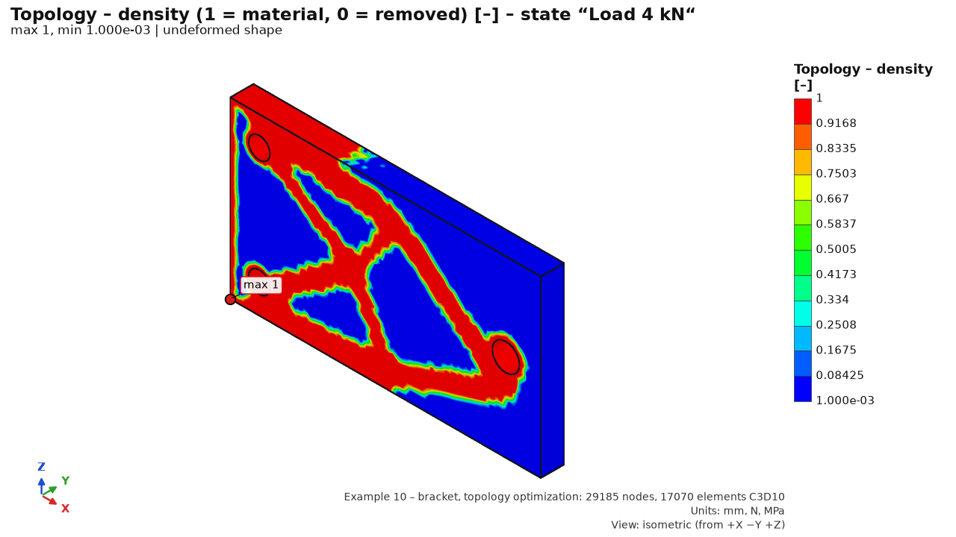

Reactions and equilibrium
- Reactions [N] per support (under the selection name): Fx, Fy, Fz – the force the support exerts on the model. For a cylindrical support only the constrained components (radial / tangential / axial).
- The sum of reactions must match the load – an input check (sense of force, gravity, correct face).
- Equilibrium check: imbalance … % = residual of forces and moments relative to the load. Normally 10⁻⁴ % or less; above 0.1 % the analysis ends with an error.

Export of results (CSV, VTU)
The Export (VTU, CSV)... button writes results to a folder (MCP: fea_results_export – same files and columns). All numbers start at 1 and match the solver input (CalculiX .inp), like “Node Number” in ANSYS or “Node / Element Label” in Abaqus: node number = *NODE, element number = *ELEMENT, part number = ELSET P<n>, case number = order of the load case (linear statics: the *STEP number).
File | Content
<study>_<NN>_<state>.csv | nodal values of state NN (01, 02 …): node_id, part_id, part, n_parts, x/y/z_mm, ux/uy/uz/umag_mm, sxx…szx_MPa, von_mises_MPa, s1–s3_MPa and other fields of the case (temperature_C, contact_pressure_MPa, contact_penetration_mm, contact_slip_mm, contact_shear_MPa, contact_status, contact_opening_mm, print_safety, print_index, stress_error_pct, peeq, topo_density)
<study>_K<NN>_<name>.csv | combination NN (study order) – columns as for a case; envelope: node_id, part, coordinates, governing_combination_number (position in the envelope list from 1), envelope value, governing_combination
<study>_nodal_all.csv | option All cases in one file: row = node × case, step_index and step_name first (combinations stay separate)
<study>_elements.csv | option Element table: element_id, part_id, part, element_type (C3D10), nodes n1–n10 in CalculiX order, centroid xc/yc/zc_mm, volume_mm3; for one selected case also nodal values averaged over the element (…_nodal_avg)
<study>_reactions.csv | reactions: step_index, step_name, selection, constraint_kind (fixed, displacement, cylindrical, remote_support, elastic), Fx–Fz and F_mag [N], Mx–Mz and M_mag [N·mm], mref_x/y/z_mm, result_kind, combination_index; a TOTAL row after each case
<study>_<NN>_<state>.vtu, .pvd | tet10 mesh with fields for ParaView; the .pvd collection has the cases as time steps 1, 2 … (combinations after them)

- Part of a node: a node on an interface of parts with a shared mesh belongs to the part with the lowest number; n_parts = number of parts sharing it (> 1 = interface). Duplicated nodes of an opened contact have alias_of_node_id (original node number).
- Reaction moments are about mref = centre of the mesh bounding box (same point as in the text summary). TOTAL = total reaction about this point from the equilibrium check. A node on an edge shared by two supports is in both selection rows but once in TOTAL, so TOTAL need not equal the sum of rows.
- Stresses are nodal (averaged by the solver); integration-point stresses are not exported. A missing value (case without stresses, point outside the body) = empty cell, not zero.
- CSV format: Excel = semicolon, decimal comma, UTF-8 with BOM (Czech Excel opens it in columns); Standard = comma, decimal point, UTF-8 (pandas, scripts, English Excel). Standard is the English default; the choice is remembered also for σ-vector and line plot exports. MCP defaults to standard (dialect="excel" switches).
- VTU: arrays NodeId (nodes), ElementId and PartNumber (elements) carry solver numbers from 1; ParaView’s “Point ID” / “Cell ID” start at 0. PartId = part number from 0; part names are in the PartNames array (FieldData).
- σ vectors (CSV): node_id, part, x/y/z_mm, principal (1–3), sigma_MPa, unit direction nx/ny/nz, type (tension / compression), step_name. Line plot (CSV): point, s, x, y, z, value, inside (1 = point in the material).
- Result tables (highest stresses, worst fatigue locations, mode shapes, section force, contacts, joints…) copy whole, with header, using Ctrl+C or right click → Copy table (paste into Excel cell by cell). Reactions are in the text summary; the reactions CSV is their table.

How to read the results
- Linear elasticity: stress above Re is fictitious (the material would yield). A local exceedance of Re in a singularity or small notch of ductile steel usually does not mean failure; exceedance over an area of the nominal cross-section does.
- Nominal vs. peak stress: for static loading of ductile metals, the stress in the cross-section away from notches and singularities governs. For fatigue and brittle materials, the peak in the notch (a real location, verified by convergence).
- Convergence: refine the governing location 2× and compare. If the value settles, it is correct; if it keeps growing, it is a singularity.
- Displacements are not very mesh-sensitive; a coarser mesh is enough for a stiffness check.
- Connections of parts without a contact pair are rigid (shared nodes); stress at a part interface is only indicative. Where contact pressure, opening or slip governs, define a contact and check with two μ values and a different stiffness K.
- Dynamics: resonance response is inversely proportional to damping (±50 %); where it governs, measure the damping.
- Printed parts: evaluate with 3D printing – safety factor, not von Mises against Re; for sustained loading also the creep case.
- Bolts and welds are evaluated in the Joints utilization dock, not by stress around the connection – see Joints.

In the examples

Example 1 – printed bracket
- Cases: Eye load 200 N, Self-weight and Eye load 200 N – creep 1000 h, 30 °C. Compare displacement and 3D printing – safety factor in the instant case and the creep case.
- The corner between plate and arm and at the rib has no fillet in the model: the highest von Mises there will probably be marked as a singularity “sharp inner edge”. The real concentration is in the eye under the bearing load.
- Edges of the screw holes (cylindrical support) give “support edge” or “near support” locations – the screws are rigid in the model.
- 3D printing – safety factor: the summary by part gives the min. safety factor, whether shell or core governs, and stress in the print axes. A section by the Y plane through the middle of the arm shows bending stress across the thickness.
- Reactions: Upper screw and Lower screw together carry 200 N vertically; Rear face transmits only the x-direction force. The ux = 0 support is two-sided – it also transmits tension, which a real support against a wall would not. Check the sign of the reaction in the upper part of the plate.

Example 2 – assembly
- Mechanical cases: Force on arm eye, Side force on post, Self-weight, Heating in operation, Bolt preload, Force on arm eye – creep 2000 h, 30 °C. Thermal: Heat: Operation – steady state and Heat: Ramp-up – 1 hour (Time field, snapshots every 600 s).
- In Heating in operation switch the quantity to Temperature – the field from which thermal stress is computed. Stress arises where expansion is restrained: at anchor holes (cylindrical support) and between parts with different temperature and expansion (steel × PLA).
- Bolt preload shows the bearing under heads and nuts; “bolt connection” locations are connection singularities – evaluate bolts in the Joints utilization dock.
- Roots and toes of fillet welds are sharp inner edges (singularities); welds are assessed in the Joints utilization dock.
- Side force on post: the sum of the Fx reactions of the anchor holes must be 250 N against the force direction (reaction = force of the support on the model).

Common problems
Message / symptom | Cause and solution
“The quantity is not available in the result (no printed part).” | 3D printing quantities exist only for studies with a printed part (a material with print properties).
“The case has no thermal load.” | Temperature quantity for a mechanical case without a Temperature load. Thermal analysis temperatures are in the “Heat: …” cases.
“Heat flux is stored only for the end of a transient case – choose the last time.” | For a transient case the flux is shown only at the last time.
The stress maximum grows with every refinement | A singularity (sharp corner, fixed support edge, point force). Evaluate away from it, add a fillet or a more realistic support.
Results disappeared (“Study changed – results discarded, recomputation needed.”) | Every study change discards results. Undo (Ctrl+Z) or run again. A saved .fea project contains the results.
Deformation looks absurdly large | Automatic scale magnifies deformation. For true shape choose 1×; read displacements from the legend.

Print detail (voxels)
The 3D printing model (shell + infill) does not see single beads. Voxel detail recalculates a small region around a critical place from the beads: perimeters, top / bottom layers, infill and thin regions set in the print settings. It uses hex8 C3D8I elements with solid extrusion material in the bead axes; boundary displacements come from the whole part. Open it in Results with Print detail (voxels)… (printed parts only).
INDICATIVE: bead paths come from the print settings, not slicer G-code, and boundary conditions from the homogenized model. The minimum at an integration point falls with refinement (voxel steps and bead corners are singularities); use the element average and the 1st percentile.

Procedure
1. Region centre: Lowest safety factor, Click in 3D, or coordinates. “automatic” = found during the analysis.
2. Size in print axes (default 6 × 6 × 4 mm), margin (carries boundary conditions, not evaluated), resolution w/2 (voxel = half the line width) or w/4 (~8× more voxels), load case, element.
3. Estimate size: voxel count, equations, memory, time. “NOT POSSIBLE” above 1.5 million equations or 80 % of free RAM. The region box is orange in 3D.
4. Run detail runs in the background; Cancel interrupts.

Result
- Layer section (Layer slider from the build plate): voxel type (perimeter red, layer orange, infill blue, thin region purple), safety factor (Tsai-Wu / Hill), line angle, von Mises, displacement, bead-axis stresses σ11 (along), σ22 (across), σ33 (normal to layers), τ12, τ13, τ23. Bead direction = dashes along the line.
- Table by load case: safety factor from average element stress (main value), 1st percentile, minimum at an integration point (*), homogenized safety factor in the same region, detail / homogenized ratio, average-stress difference over the region (boundary check, should be small), location of the minimum.
Verified with X1–X4 (homogeneous field, C3D8I bending, P2, path generator): python -m verification.voxel_cases.

Fatigue
Computes fatigue damage and life from the static results: stress in time is the sum of load cases multiplied by the load history, cycles are counted by rainflow and damage is accumulated by Palmgren–Miner with the material's S-N curve.

Principle
Each load case is a unit case. The load history (one block) gives the multiple by which each case acts in time, and the stress in a node is the superposition:
σ(t) = Σ f_{k}(t) · σ_{k} (linear elasticity; several channels on one case are added)
Example: case “Force 200 N” with a sine channel, mean 0.5, amplitude 0.5 = pulsating 0–200 N. The block repeats Design number of blocks times over the life.
1. Compute statics (Solve).
2. Enter the load history channels and the design number of blocks.
3. Choose method, mean stress correction, surface and S-N curve.
4. Click Run fatigue analysis.

Load history (one block)
Control | What it does | Typical value / note
Channel list | Channels as “case: sine, mean …, amplitude …, … cycles, phase …°” or “case: N points”. Click loads a channel into the form.
Load case | The case whose multiple the channel sets. | With bolts the list also contains “Bolt preload”.
Waveform | Sine, or Points (table / CSV).
Amplitude, Mean | Sine: f(t) = mean + amplitude · sin(2π · cycles · t / block length + phase). | Pulsating 0–1: mean 0.5, amplitude 0.5. Fully reversed ±1: mean 0, amplitude 1.
Cycles per block | Sine cycles in one block. | Default 1. Repetitions go in Design number of blocks; more cycles only add time points (24 per cycle) and slow the analysis (the critical plane warns above 2000 points).
Phase [°] | Phase shift of the sine. | Two channels of the same frequency at 90° = non-proportional loading (principal directions rotate).
Time / multiple table, + row, − row | Waveform points, linear between them. | At least 2 points; time in arbitrary units.
Import CSV… | Loads points from a file (see below).
Add channel / Save channel / Delete | Adds from the form; overwrites the selected channel; deletes it.
Design number of blocks | Repetitions of the block over the design life. | E.g. 1e6; 2e5 also accepted.
Block length | Time axis of the sine (period = block length / cycles). | Default 1; matters only when combining a sine with points.
Plot | Waveform of the multiples of all used cases within the block. | Check that it matches the intent.

CSV import
- Two columns time; multiple, or one column of multiples (time = row number). Header rows are skipped.
- The separator ; or tab takes precedence, so the comma is decimal (0;1,5). A comma separator applies only with a decimal point in the file or a text header (0,1.5).
- Commas only and no points (1,5) is ambiguous and rejected – use a semicolon or a decimal point.
Tip: a mean stress from permanent loads (bolt preload, self-weight, thermal stress) is a channel with a constant multiple of 1: Points (0; 1) and (1; 1).

Method and material
Control | What it does | Typical value / note
Fatigue method | S-N (stress-life) – stress amplitude against the S-N curve with Marin factors (high-cycle fatigue); ε-N (strain-life) – see ε-N method below. | S-N. ε-N for low-cycle fatigue with local yielding at notches.
Notch rule (ε-N) | Conversion of the elastic FE stress to the local elastic-plastic strain: Neuber (σ·ε = σ_el²/E) or Glinka (equal strain energy density). | Neuber (more conservative). Active only for ε-N.
Multiaxiality (method) | signed von Mises (sign of the dominant principal stress), max. principal stress (largest absolute value), critical plane. | Default signed von Mises. For shear, torsion and non-proportional loading use the critical plane.
Critical plane – Criterion | Findley (τa + k·σn,max, ductile), normal stress (rainflow σn, brittle), by material (grey cast iron → normal stress, otherwise Findley). | By material.
f₋₁/t₋₁ (S-N material) | Ratio of endurance limits in fully reversed tension / torsion of the material chosen for the S-N row; sets k of Findley. | Empty = √3 ≈ 1.732 (ductile steels: 1.6–1.8). Range (1; 2⟩.
Planes (coarse grid) | Planes on the hemisphere for the first search. | 100 ≈ 14° spacing; the three worst candidates are refined to about 1°.
Shear directions | Shear directions in the plane (Findley). | Default 12.
thorough search | 4× more planes and candidates. | About 3× slower; for verification.
Mean stress | S-N: no correction, Goodman, Gerber. ε-N: no correction, Morrow, Smith-Watson-Topper (SWT). | Goodman (conservative) / Morrow. Not used with Findley (the mean stress is in k·σn,max).
block repeats (close rainflow residue) | Unclosed half-cycles of the block join the next repetition. | On (correct for a repeated block).
Surface (ka) | Marin surface factor: polished, ground, machined / cold-drawn, hot-rolled, forged. | Machined; depends on Rm (Shigley).
Reliability (ke) | 50 / 90 / 95 / 99 / 99.9 / 99.99 %. | 50 % = mean S-N; 90 % → 0.897, 99 % → 0.814.
Diameter for kb | Size factor from the effective diameter [mm]. | ignore = 1. For 2.8–51 mm kb = 1.24·d^{−0.107}.
Other effects kf | Further factor (temperature, environment, experience). | 1.0
S-N for material | Material whose S-N is shown and edited. | Only materials of meshed parts (not beam-replaced bolts, nor excluded parts).
custom S-N (otherwise estimate from Rm) | Enables a custom curve SD, ND, k, k2. | Off = estimate.
SD, ND, k, k2 | Amplitude at the knee [MPa] (without Marin factors), cycles at the knee, slope above and below it. | k2 = 0 = endurance limit (no damage below SD); Haibach k2 = 2k − 1.
From PragTic database… | Literature fatigue properties (pragtic.com, J. Papuga) with sources. | See below.
“Used: …” line | S-N and Marin factors ka · kb · ke · kf = k used, and the source.

S-N estimate from Rm (without tests)
- Steel (E ≥ 150 GPa): Se' = 0.5·Rm at 10⁶ cycles (at most 700 MPa), 0.9·Rm at 10³, endurance limit below 10⁶ (Shigley).
- Aluminium (E 40–150 GPa): 0.4·Rm (at most 130 MPa) at 5·10⁸, no endurance limit (Haibach below the knee).
- Plastic: 0.25·Rm at 10⁶, k = 10 – indicative only; calibrate from tests.
Marin factors reduce the knee amplitude; in the Rm estimate the point 0.9·Rm at 10³ cycles remains. Both apply to a smooth specimen – the notch effect is in the FE stress (fine mesh at the notch).

ε-N method (strain-life)
- The elastic FE stress history (signed von Mises or max. principal stress; no critical plane) is converted by the notch rule to the local elastic-plastic strain on the cyclic Ramberg-Osgood curve; rainflow, the Coffin-Manson-Basquin curve and Palmgren–Miner give the damage.
- The parameters σ'f, b, ε'f, c, K', n' are estimated from Rm and E (Bäumel-Seeger uniform material law) – indicative, verify by tests. The “ε-N used” line shows the values. Measured parameters can be given only through the Python API or the study file (FatigueSettings.en_params, see Automation); the GUI and the MCP server have no input for them.
- Surface, reliability, size and other Marin factors and the S-N curve are not used (greyed out). Not available for 3D-printed parts.

PragTic database
The S-N from PragTic database dialog holds 647 literature records. Type any grade (12050, C45, 1.0503, AISI 1045, S45C…); equivalents are found through the grade converter. The Match column shows match, ≈ match (approximate equivalent) or similar (same family, similar composition). Only with S-N data (tension-compression / bending) hides records without fatigue data. The right side shows the full record with sources; choose an S-N variant (tension-compression limit, Basquin, bending limit) in S-N curve for analysis. also take over Rm and Re into the material overwrites the study material's Rm and Re (the mean stress correction uses Rm). Use S-N or double-click takes the curve over.
Data source and citation. The data belong to the author of the database: Papuga, J.: PragTic – material database of fatigue properties (Fatigue Data Repository). Czech Technical University in Prague, Faculty of Mechanical Engineering. https://www.pragtic.com/vmat.php. For each curve taken over, FEA Studio states the record number and the original source; the Word report adds the citation. Cite the database and the original source in your own documentation too.
The database is not distributed with the program (the author has not granted redistribution). For your own use download it from pragtic.com with python -m fea_core.fatigue.pragtic_fetch; fatigue works without it (estimate from Rm or a manual S-N).

Analysis and results
- Run fatigue analysis runs in the background. With proportional channels rainflow is computed once – under 1 s. The critical plane takes tens of seconds; with non-proportional loading and thousands of time points, minutes.
- The first run after start may be slower (kernel compilation).
- The fatigue result is not saved in the project (the settings are); any change of settings or study discards it.
Control / quantity | What it shows | Note
Damage D over design life (log₁₀) | log₁₀ D over the design number of blocks. | D ≥ 1 (log ≥ 0) = failure. Nodes without damage sit at the lower bound (6 orders below the maximum).
Life [blocks] (log₁₀) | log₁₀ of blocks to failure (D = 1). | Colours reversed: red = short life.
Fatigue safety factor (stress multiplier) | How much all stresses of the whole history could be increased for D = 1 at the design number of blocks. | Shown up to 10. Above 1 = acceptable.
Equivalent stress amplitude [MPa] | Largest equivalent amplitude at the node. | Critical plane: amplitude in the critical plane.
Table of the worst locations | 10 locations: x, y, z, total D, life [bl.], safety, plane normal (critical plane only). | Click a row: stress history plot and a marker in 3D.
Plot | Equivalent stress history at the node, cycles and max. amplitude Sa; for the critical plane σn and shear τ. | In 3D: purple = normal of the critical plane, turquoise = shear direction.
Summary below the table | Max. damage (PASS / FAIL, D < 1), min. life, min. safety, Method (report text), S-N used, warnings. | A click on the map acts as a probe.

How to read the result
- The result is the local stress of a smooth specimen. Do not judge worst locations in singularities (sharp internal corners, support edges) by the nodal value – refine, add fillets or use a notch method (see Results).
- Signed von Mises has an ambiguous sign for pure shear (σ1 = −σ3): use the critical plane for torsion and non-proportional loading.
- A nonzero prescribed displacement sits in every case and multiplies in superposition. Put it in a separate case and compute the others with zero displacement.
- Welds and bolts are assessed separately (FAT class, VDI 2230 σ_ASV) – Joints.
- Printed parts use the Hill equivalent in print axes (shell and core) with print S-N (indicative, after Ezeh & Susmel 2019; no Marin factors). The S-N box shows the print S-N directly (SD in XY and SD_z normal to layers); a custom S-N applies to XY, and without a k2 it continues with the print slope (plastics have no endurance limit). See 3D printing.
- Bearing load is not linear in force direction (pressure on the half of the hole facing the force): superposing cases with a bearing load gives a different stress than reality for a rotating force (warning).

Fatigue with contacts, from a mechanism and from dynamics
- Contacts (nonlinear): superposition does not apply. Fatigue is possible only from a step sequence (Contacts → Step sequence, cycles ≥ 2). The history is the ends of the steps of the last cycle (the first cycle with slip may differ); load channels are not used. The program checks that the response has stabilized between the last two cycles (change up to 0.1 %), otherwise add cycles. The course within a step is not considered. Branches (“cases separately”) end with an error.
- Mechanism: transferring the history from Motion creates unit cases (joint reactions, inertia) and history channels; fatigue then superposes as usual.
- Dynamics: fatigue from a sine sweep and spectral fatigue of random vibration (Dirlik, Tovo–Benasciutti, narrow-band) are set and computed in Dynamics; results appear as “Dynamics: …” items in Results. They need Rm (estimated S-N) or an entered S-N.

In the examples

Example 1 – printed bracket
- One channel: Eye load 200 N: sine, mean 0.5, amplitude 0.5, 1 cycles, phase 0° → pulsating 0–200 N, design number of blocks 1e5 (100 000 cycles).
- Proportional loading → instant analysis. The whole part is printed, so the Hill equivalent with print S-N applies – indicative; without test calibration not proof.
- Try: a Self-weight channel with constant multiple 1 (mean stress), or 1e6 blocks, and watch the safety drop.

Example 2 – assembly
- Two channels: Force on the arm eye sine 0–1 (pulsating 0–300 N) and Lateral force on the column sine ±1 (±250 N) at 90° phase; design number of blocks 2e5.
- Non-proportional → non-proportional loading. Compare signed von Mises and the critical plane (Findley) – for the S235 column and base (S-N estimated from Rm) they may differ; the purple segment shows the critical plane at the worst location.
- Bolt preload and thermal stress are not in the history; add channels “Bolt preload” and “Heating in operation” with constant multiple 1 to include them as mean stress.
- Weld roots and toes are singularities on the map; evaluate welds and bolts in the Joints – utilization dock.

Common problems
Message / symptom | Cause and remedy
“Compute statics first (Solve step) – the results have no mechanical load case.” | Fatigue needs static results; a heat-only study has no fatigue.
“Fatigue with contact / nonlinear analysis in branches is not available …” | A contact study computed case by case has no history. In Contacts define a step sequence with ≥ 2 cycles and recompute.
“Load case '…' is not in the results” | The channel refers to a renamed or deleted case. Delete and re-add the channel, or recompute statics.
“CSV cannot be loaded: CSV is ambiguous (a comma may be a separator or a decimal comma…)” | Save the CSV with separator ; (Excel in Czech does this itself) or with a decimal point.
“Rm of the material is needed for the S-N estimate” | Add Rm in Materials or enter a custom S-N.
“The ratio f₋₁/t₋₁ must be in the range (1; 2⟩…” | Findley does not suit brittle materials – choose the normal stress criterion.
“Critical plane with non-proportional loading and N time points is slow…” | Shorten the block: fewer cycles of the same shape, more repetitions (design number of blocks).

Word report
The Report… button (Ctrl+P) creates a technical report in Word (.docx): setup, mesh, results with figures, joint checks, fatigue, 3D printing, assumptions and warnings, with a pass / fail rating.

Procedure
1. Calculate statics (and heat). For fatigue in the report, calculate it first in Fatigue – the report uses the GUI result.
2. Click Report… in the top bar or press Ctrl+P.
3. Fill in the details, check the path, click Generate report.
4. It runs in the background (“Generating report…” in the status bar) and opens in Word when finished.
Without results the report holds only the setup (“Results are not available – the report will contain only the setup.”). A heat-only study gives a full thermal report.

Word report dialog
The top line says what the report will contain, e.g. “Load cases: 6 · thermal cases: 2 · joint checks: will be run · fatigue: no (Fatigue step)”.
Control | What it does | Typical value / note
Name | Heading and footer. | Prefilled by analysis type: “FE structural analysis”, “FE thermal analysis” (heat-only) or “FE structural and thermal analysis” – <study>.
Prepared by | Author (title block, document properties). | Remembered.
Company | Company in the title block. | Remembered.
Subject | Paragraph below the title block: subject, order, structure description. | Optional.
Conclusion | Your conclusion – last chapter; blank line separates paragraphs. | Empty = no Conclusion chapter.
Required safety factor to Re | Statics rating limit: PASS if min. Re/σ_vM ≥ value. | 0.1–10, default 1.0, last value remembered. Usually 1.5.
images (model, stress, displacement, safety factor) | Model images with loads (4 views) and result maps. | On; off is faster.
Keep images (folder <name>_obrazky) | PNGs saved next to the report in <name>_obrazky (like --keep-images). | Off, remembered. A foreign existing folder is never overwritten (_2… added).
detailed checks of each joint | Tables of all checks per bolt and weld (otherwise overview only). | On.
open in Word when finished | Opens the file in the associated program. | Remembered.
File, “…” | Path to the .docx. | Default: project folder, “<study>_protokol.docx”.
Generate report | Starts generation. | Missing joint checks run automatically.

Report contents
- Title block – study, geometry, company, author, date, program; subject.
- Summary – statics table by case: max. displacement, max. σ_vM, σ_vM away from singularities, min. safety factor to Re, imbalance, rating (k ≥ required). Thermal cases; joints (max. utilization), fatigue (max. D, min. safety factor), 3D printing (min. Tsai-Wu/Hill safety factor, without creep).
- 1 Analysis setup – parts (volume, mass from the mesh), materials with sources (printing: solid extrusion properties), supports with face areas, load cases and loads, bolts (designation, grade, grip length, preload), welds (a, length), thermal cases; a model figure per case.
- 2 Mesh and solver – element type, size, refinement, nodes, elements, DOF, min. scaled Jacobian with quality rating, solver.
- 3 Results – per thermal and load case: values, maxima locations with singularity classification, reactions (forces, moments), equilibrium check, safety factor to Re by part, maps of von Mises, displacement, safety factor.
- Bolted and welded joints – utilization overview, optional detailed checks (VDI 2230, EN 1993-1-8, EN 1993-1-9 / IIW).
- Fatigue – method (as in the Fatigue step), S-N curves with sources, worst locations, maps.
- 3D printing – settings, safety factor by part, creep; always a red warning about plastic creep.
- Contacts (if defined) – pairs with type, μ with source and purpose, K, λ, interference, formulation, step sequence; results per step, pressure and status maps, force–travel curves; always red warnings about nonlinear analysis, μ estimate, K/λ penalty and possible partial result.
- Dynamics (if enabled) – modes with effective mass, damping, excitation and test profile, FRF, envelopes, RMS and 3σ, spectral fatigue, shock and SRS, added mass; always a red warning about damping uncertainty (±50 %).
- Motion (mechanism) (if computed) – bodies, joints, drivers, largest joint reactions and their instant, driver forces and power, reaction plots, equilibrium and power balance, load cases transferred to FEA; always a red warning about rigid bodies, friction estimate and redundant constraints.
- Assumptions, limitations and warnings – linear elasticity, parts joined by a shared mesh (no contact pair), contact and dynamics assumptions where used, all analysis warnings.
- Conclusion – text of the Conclusion field.
Numbers follow the report language (decimal separator, ·10ⁿ, minus “−”). Reactions below 10⁻⁵ of the total load show as 0 (noise). The safety factor map is omitted if it is ≥ 10 everywhere.
Note: the report is a supporting document, not an automatic assessment. “PASS” rests on the maximum at a node and cannot tell if it is the governing location. Assess singularities yourself and state it in the Conclusion.

Without the GUI (command line)
report generates a report from a study (study.json) or a .fea project. A project with results is not recalculated; a study without results is calculated. Fatigue is calculated if the study has a load history; joints are checked.
.venv\Scripts\python.exe -m fea_core report projekt.fea -o protokol.docx --safety 1.5 --author "Name Surname" --company "Company name"
Option | What it does | Note
-o path.docx | Output file. | Default <name>_protokol.docx next to the source.
--safety 1.5 | Required safety factor to Re. | Default 1.0.
--title, --author, --company | Name, author, company.
--keep-images | Keeps PNGs in “<name>_obrazky” next to the report. | A foreign existing folder is never overwritten (_2… added). GUI: Keep images.
--no-images | No images.
--no-solve | Do not calculate a study without results – setup only.
--no-fatigue | Do not calculate fatigue.
--results results.npz | Use saved results.
--workdir folder | Working folder of the analysis.

MCP tool fea_report_word and other automation: Automation.

In the examples

Example 1 – printed bracket
- Summary: three cases (eye load 200 N, self-weight, creep case) and a 3D printing row with the min. safety factor. For PLA the safety factor to Re is indicative; the print safety factor governs.
- 3D printing chapter: 3 perimeters, gyroid 20 %, Tsai-Wu, creep 1000 h / 30 °C, red creep warning.
- The Fatigue chapter appears only if fatigue was calculated before generating.

Example 2 – assembly
- Setup adds tables of bolts (2× M6 8.8, preload) and welds (a = 4 mm), and a Thermal cases chapter with boundary condition figures.
- Results start with the thermal cases (balance, temperature map), then six mechanical cases including Bolt preload and the creep case.
- Bolted and welded joints fills in automatically; with detailed checks the report is much longer.

Common problems
Message / symptom | Cause and solution
“The report could not be generated: PermissionError …” | A file of the same name is open in Word – close it or rename.
“Open a model or project first.” | The report needs an open study.
Fatigue is missing in the report | Any change of fatigue settings or the study discards the GUI fatigue result. Recalculate; the dialog must show “fatigue: yes”.
“Report – warning: Figure … : …” in the log | A figure could not be rendered; the report is made without it. Retry, or without images.
FAIL rating because of a singularity | The summary also gives σ_vM away from singularities. Assess the location (Results) and justify it in the Conclusion.
The report did not open | Word or another .docx program is missing. The file exists – open it elsewhere (LibreOffice, Word Online).

Automation
Everything the GUI does is also available without it: the command line, Python scripts, an MCP server for AI assistants (Claude, Cursor), and a REST API for CAD adapters and other programs. The commands on this page can be copied.

Preparation
Run commands from the installation folder (e.g. C:\FEA Studio) with its Python. In PowerShell:
cd "C:\FEA Studio"
$env:PYTHONIOENCODING = "utf-8"
.venv\Scripts\python.exe -m fea_core --help
In cmd use set PYTHONIOENCODING=utf-8 instead. Without it Czech characters may be garbled.
Tip: a .fea project is a zip with study.json (input), model.step (geometry) and possibly results. For commands that need study.json, rename the project to .zip and extract it; study.json refers to model.step in the same folder.

Command line (python -m fea_core)
Command | What it does | Options
faces model.step | Lists parts (volume) and faces: index, type, area, centroid, normal – a basis for selections in a script. | --part NAME one part only
check study.json | Readiness check (as in Solve, without the rigid-body check). Return code 1 = errors.
run study.json | Mesh, thermal cases, statics; prints a JSON summary and saves results.npz and summary.json. | -o FOLDER (default <study>_run), -v CalculiX output
fatigue study.json | Fatigue from the study's load history: method, S-N, worst locations; saves fatigue.npz. | --results results.npz (no new analysis), --top 10, -o
detect model.step | Bolts (by name and shape) and welds (name, colour, layer, attribute). | --add study.json writes into the study; --accept-shape; --no-shape; --weld-color #rrggbb (repeatable)
joints study.json | Assessment of bolts (VDI 2230, EN 1993-1-8) and welds, as text. | --results results.npz, -o
report study.json | projekt.fea | Word report – see Report. | -o, --safety, --author, --company, --title, --keep-images, --no-images, --no-solve, --no-fatigue, --results, --workdir

Examples:
.venv\Scripts\python.exe -m fea_core faces model.step --part "Patka"
.venv\Scripts\python.exe -m fea_core check studie\study.json
.venv\Scripts\python.exe -m fea_core run studie\study.json -o studie\vypocet
.venv\Scripts\python.exe -m fea_core fatigue studie\study.json --results studie\vypocet\results.npz --top 20
.venv\Scripts\python.exe -m fea_core detect sestava.step --add studie\study.json
.venv\Scripts\python.exe -m fea_core joints studie\study.json --results studie\vypocet\results.npz
.venv\Scripts\python.exe -m fea_core report projekt.fea --safety 1.5 -o projekt_protokol.docx

Other commands
# GUI with an open file (like FEA Studio.bat)
.venv\Scripts\pythonw.exe -m fea_gui projekt.fea
# re-create the examples including results
.venv\Scripts\python.exe -m examples.create --solve
# verification problems (statics V1–V18, heat T1–T7, joints, printing, fatigue, beams, 2D, shells,
# contacts K…, dynamics Y…, mechanisms MB…)
.venv\Scripts\python.exe -m verification.run_all
# only selected problems
.venv\Scripts\python.exe -m verification.run_all V1 V7 K1 Y2 MB1
Verification problems compare results with analytical solutions and print an agreement table – useful after installation or an update.

Python script
Templates: examples\create.py and verification\. Faces are selected geometrically (find_faces: part, plane x/y/z, cylinder radius, normal, custom condition), not by index, so the script survives model changes in CAD.
from fea_core import materials as matlib
from fea_core.geometry import read_step
from fea_core.selectors import find_faces
from fea_core.study import Study, Fixed, Force, LoadCase, MeshSettings
from fea_core.solve import run_study
from fea_core.project import save_project
parts = read_step("konzola.step")
st = Study("Konzola", "konzola.step")
st.add_material(matlib.by_name("Ocel S235"), default=True)
st.add_selection("Vetknutí", find_faces(parts, x=0))
st.add_selection("Konec", find_faces(parts, x=200))
st.constraints.append(Fixed("Vetknutí"))
st.load_cases.append(LoadCase("Síla", [Force("Konec", [0, 0, -100])]))
st.mesh = MeshSettings(size=3.0)
res = run_study(st, "konzola_run", on_log=print, parts=parts)
s = res.steps[0]
print(f"max. displacement {s.umag.max():.3f} mm, max. von Mises {s.mises.max():.1f} MPa")
save_project("konzola.fea", st, "konzola.step", res) # open in the GUI
Run: .venv\Scripts\python.exe muj_skript.py. Units mm, N, MPa, t, s.

MCP server (AI assistants)
The MCP server exposes the whole workflow – geometry, face selections, materials, supports, loads, heat, mesh, analysis, results and PNG images, fatigue, joints, 3D printing, contacts, dynamics, mechanisms, calculators, Word report – to language models via the Model Context Protocol. An assistant can then, for example, “load bracket.step, fix the face x = 0, apply a 200 N downward bearing load to the eye, solve and show von Mises; are the maxima singularities?”.
# stdio – this is how the clients below launch it
.venv\Scripts\python.exe -m fea_core.mcp
# HTTP – one server with one shared study, URL http://127.0.0.1:8766/mcp
.venv\Scripts\python.exe -m fea_core.mcp --transport streamable-http
Options: --workdir FOLDER (default %LOCALAPPDATA%\FEAStudio\mcp, or FEA_MCP_WORKDIR), --host, --port, --token. HTTP default port 8766; REST uses 8765 – both can run together.
Warning: in HTTP mode one session (study, mesh, results) is shared by all clients – a second assistant sees and can overwrite the first one's work. For parallel independent work use another --port and --workdir, or stdio (each client has its own process). The tools read and write any path and run analyses, so without a token the server listens on 127.0.0.1 only; any other address (--host 0.0.0.0) requires --token (or FEA_MCP_TOKEN), and clients send Authorization: Bearer <token>.

Registration in all AI clients with one click
Double-click Register MCP.bat in the program folder to write the “fea-studio” server into all detected clients: Claude Desktop, Claude Code, Cursor, Windsurf, Antigravity, Gemini CLI, LM Studio, VS Code (Copilot) and Codex CLI. Originals are backed up (….fea-zaloha) and other settings kept. Then restart the clients. The installer does this too (disable with --no-mcp).
.venv\Scripts\python.exe -m fea_core.mcp.setup --dry-run # only show what will change
.venv\Scripts\python.exe -m fea_core.mcp.setup --remove # remove from all clients
Tip: trailing commas (VS Code mcp.json) are fine. A file that cannot be read (e.g. mcp.json with comments) is not overwritten and is listed – add the entry by hand per the examples below.

Claude Desktop
File %APPDATA%\Claude\claude_desktop_config.json (Settings → Developer → Edit Config):
{
"mcpServers": {
"fea-studio": {
"command": "C:\\FEA Studio\\.venv\\Scripts\\python.exe",
"args": ["-m", "fea_core.mcp"],
"cwd": "C:\\FEA Studio",
"env": {"PYTHONPATH": "C:\\FEA Studio", "PYTHONIOENCODING": "utf-8"}
}
}
}
Restart Claude Desktop after saving.

Claude Code
claude mcp add --scope user fea-studio -e PYTHONPATH="C:\FEA Studio" -e PYTHONIOENCODING=utf-8 -- "C:\FEA Studio\.venv\Scripts\python.exe" -m fea_core.mcp
The server name comes before -e; without --scope user the entry applies only in the folder where the command ran.

Cursor
File .cursor\mcp.json in the project, or %USERPROFILE%\.cursor\mcp.json – same content as Claude Desktop (without cwd). Antigravity: Manage MCP Servers → View raw config, same content.

What MCP offers
- Tools (186): study (fea_study_new/open/save/status); geometry and face selections (fea_geometry_find_faces returns ids Díl#i); materials; supports (fixed, displacement, cylindrical – also several holes in one selection, remote); loads (force, pressure, gravity, remote force, bearing load, temperature); thermal cases and conditions; mesh (fea_mesh_generate); check (fea_check_readiness, incl. rigid-body motion); analysis (fea_solve_run); results (fea_results_summary, _probe, _hotspots with singularity classification, _render_image); model image; fatigue; joints; 3D printing (fea_print_get, fea_print_set, fea_print_creep, fea_print_props, fea_print_calibrate – ISO 527 calibration, fea_print_render_shell – shell fraction image without analysis, fea_print_results, variants, sweep fea_print_sweep, advice fea_print_advice, build directions fea_print_rank_build_direction, presets fea_print_presets); report (fea_report_word); beams, 2D sections, shells, natural frequencies and buckling.
- Contacts: fea_contact_detect, fea_contact_set/list/remove, fea_contact_check, fea_contact_settings (formulation, interface meshing, NLGEOM, bolted joint interface as contact), fea_analysis_set_sequence (branches or step sequence, prescribed motion, cycles), fea_contact_results, fea_contact_render, fea_results_history (force–travel curve).
- Dynamics: fea_dyn_settings, fea_dyn_damping_set, fea_dyn_harmonic_set, fea_dyn_transient_set, fea_dyn_random_set, fea_dyn_shock_set, fea_dyn_prestress_set, probes fea_dyn_probe_add/list/remove, added mass fea_dyn_mass_add/list/remove, results fea_dyn_results, fea_dyn_frf_get, fea_dyn_render, fea_dyn_plot, test profiles fea_dyn_profile_presets.
- Mechanisms: bodies fea_motion_body_add/list/remove, joints fea_motion_joint_add/list/remove, fea_motion_joints_from_cad, fea_motion_force_add, fea_motion_driver_add, fea_motion_load_add, fea_motion_contact_add (Chrono), fea_motion_settings, fea_motion_check_dof, fea_motion_run, fea_motion_results, fea_motion_render, transfer to FEA fea_motion_export_loads.
- Calculators: fea_calc_snapfit, fea_calc_pressfit, fea_calc_hertz, fea_calc_friction, fea_calc_friction_library, fea_calc_mechanism, fea_calc_damping, fea_calc_drop.
- Asynchronous jobs: fea_job_start (kind solve = whole study like fea_solve_run, or motion) returns a job_id at once; fea_job_status (fraction 0–1, phase, time, last log lines), fea_job_cancel, fea_job_result. One job at a time; default time limits: linear 30 min, dynamics 2 h, contact 4 h, mechanism 1 h.
- Prompts: fea_setup_static_analysis, fea_setup_thermal_analysis, fea_mesh_convergence_check, fea_interpret_stress_results, fea_setup_contact, fea_setup_vibration_test, fea_setup_mechanism – prepared procedures.
- An assistant saves its study with fea_study_save as a regular .fea project (with results) – open and check it in the GUI.
Warning: an assistant may specify supports or loads differently from what you intended. Always check the input (model image with arrows, fea_study_status, or the project in the GUI), as you would any manual input.

REST API
An HTTP interface with the same tools as MCP (same names, parameters and error messages), for CAD adapters, scripts in other languages and internal applications.
# this computer only, port 8765
.venv\Scripts\python.exe -m fea_core.rest
# different port and a token
.venv\Scripts\python.exe -m fea_core.rest --port 8775 --token TAJNE_HESLO
# access from the network (only with a token)
.venv\Scripts\python.exe -m fea_core.rest --host 0.0.0.0 --token TAJNE_HESLO
- The default address 127.0.0.1 = this computer only. Any other address without a token is rejected.
- With a token (--token or FEA_REST_TOKEN) each request needs Authorization: Bearer <token>.
- Documentation of all endpoints and tools in the browser: http://127.0.0.1:8765/docs.
- One server = one open study. During an analysis other requests return 409 (busy); /api/status and fea_job_status, fea_job_cancel, fea_job_result always respond – so start long analyses asynchronously (fea_job_start).
Endpoint | What it does | Note
GET /api/status | Version, open study, busy, results, last import.
GET /api/tools | Tools with the JSON schema of their parameters.
POST /api/tools/{name} | Calls a tool; body = JSON arguments. | ?images=url|base64|both for images
GET /api/study | Current input (study JSON).
POST /api/import | Import of STEP + CAD metadata (multipart file, metadata). | Creates a study, matches parts by name, assigns library materials.
GET /api/files/{path} | Download from the working folder (PNG, .docx, .fea).
POST /api/open-gui | Opens a file (default the last import) in the GUI. | The GUI runs separately.

PowerShell example (import with curl.exe, not the alias curl; tools with Invoke-RestMethod):
Invoke-RestMethod http://127.0.0.1:8765/api/status
curl.exe -F "file=@drzak.step" http://127.0.0.1:8765/api/import
Invoke-RestMethod -Method Post -ContentType "application/json" -Body '{"x": 0}' `
-Uri http://127.0.0.1:8765/api/tools/fea_geometry_find_faces
Metadata format and a Python example: fea_core\rest\README.md.

CAD adapters
An adapter exports the model to STEP with body names, adds metadata (material and properties, colour, attributes) and sends them to the REST API. Without a running server it saves STEP + JSON to a folder and starts the GUI (variable FEA_STUDIO_HOME = installation folder). A material is assigned only if it matches the library (e.g. “S235”, “AISI 304”); generic names (“Steel”) are reported and not assigned.
CAD | Installation and use | Verification status
Autodesk Fusion | Copy the folder adapters\fusion\FEAStudio to %APPDATA%\Autodesk\Autodesk Fusion 360\API\AddIns\ (or Tools → Add-Ins → Scripts and Add-Ins → Add-Ins → “+”). Run the add-in; the Odeslat do FEA Studia (Send to FEA Studio) button is in the FEA STUDIO panel between INSERT and SELECT (SOLID, SURFACE, MESH, SHEET METAL… tabs) and in UTILITIES → ADD-INS. Settings in settings.json (template settings.example.json) or the variables FEA_REST_URL, FEA_REST_TOKEN, FEA_STUDIO_HOME. | Export and metadata verified on a real assembly; the toolbar button verified in live Fusion.

Metadata from Fusion also contain the joints (type, axis, limits); the Motion step proposes mechanism joints from them with From Fusion metadata… (not yet verified in live Fusion).
Procedure: start the REST server (python -m fea_core.rest), then the adapter in CAD. Parts keep the CAD names (for Fusion the occurrence name, e.g. “Deska:1”); metadata are matched by them.

Installation and modules
The program is installed by modules: a small base (the FEA core) and optional parts that can be added or removed at any time. Everything stays in the program folder (.venv, tools); no administrator rights are needed. Details: installer\README.md.
1. Extract FEAStudio-<version>.zip (Linux .tar.gz) to a permanent folder – not a synchronised one (OneDrive, Dropbox…).
2. Run Install FEA Studio.bat (Linux ./install.sh) and choose: minimal (core), standard (+ GUI, plots, Numba, PARDISO, beams, report, mechanisms), full (+ MCP/REST, NGSolve, hypre), or a custom selection. Without prompts: Install FEA Studio.bat --profile standard --quiet.
3. The installer downloads uv, Python 3.11, the locked packages and CalculiX 2.23, prunes unneeded files, creates shortcuts and the .fea association, and runs a verification analysis. Running it again is safe.
Module | What it adds
core | FEA core, command line, CalculiX, Gmsh, OpenCascade: statics, heat, frequencies, buckling, beams, 2D, shells, joints and welds, contacts and dynamics
gui, plots | graphical interface, plots
accel | Numba: fatigue, 3D printing, result images for MCP and the report
pardiso | Intel MKL: faster CalculiX (PARDISO); with the ngsolve module also NGSolve + PARDISO
beams, report | custom member cross-sections, Word report
motion | kinematics and dynamics of mechanisms (Exudyn) – Motion step, transfer to FEA, fatigue
chrono | body contact in a mechanism (Project Chrono, ~600 MB) – optional, in no profile; requires motion
native | opening Inventor parts and assemblies .ipt / .iam and Fusion designs .f3d / .f3z without CAD and without STEP export (optional, in no profile) – details
mcp | MCP server and REST API
ngsolve, hypre | optional solvers NGSolve + PARDISO (many cases at once) and NGSolve + hypre (large models); on Windows hypre needs Microsoft MPI with administrator rights – --msmpi during installation, the mpi command, or Tools → Program modules…
verify, docs | verification problems and MYSTRAN; building the PDF manuals (developers only)

.venv\Scripts\python.exe -m fea_core.modules # overview (✓ installed)
.venv\Scripts\python.exe -m fea_core.modules install motion # also installs dependencies
.venv\Scripts\python.exe -m fea_core.modules install chrono
.venv\Scripts\python.exe -m fea_core.modules remove report mcp
The same in the GUI: Tools → Program modules…. Without a module the program does not crash: the function that needs it reports “Module … is missing. Install it: python -m fea_core.modules install …” (e.g. without chrono the Chrono solver in Motion is greyed out). Other installer commands: python installer\fea_setup.py install | remove | list | slim | doctor | shortcuts | mpi | uninstall [--all]; uninstalling from the Start menu removes shortcuts and the extension; uninstall --all also removes .venv and tools.

Common problems
Message / symptom | Cause and solution
ModuleNotFoundError: No module named 'fea_core' | Python from outside the installation, or another working folder. Use .venv\Scripts\python.exe from the installation; in the MCP configuration set cwd and PYTHONPATH to the installation folder.
Garbled Czech characters in output | Set PYTHONIOENCODING=utf-8 (in the MCP env).
REST or MCP (HTTP) does not start – port in use | Another program or instance uses the port. REST default 8765 (used by CAD adapters), MCP HTTP 8766. Start with another --port (and set the same address in the adapter via FEA_REST_URL).
REST responds 401 / 403 | 401: token missing or wrong (header Authorization: Bearer …). 403: a request from an address other than 127.0.0.1 / localhost without a token, or from a web page (protection against browser abuse).
REST responds 409 | The server is meshing or computing. Wait (GET /api/status, field busy).
The adapter saves files to a folder instead of sending | REST is not running, or the adapter points elsewhere – start python -m fea_core.rest and check FEA_REST_URL.

